Mary’s Meanderings
We are all familiar with The 10 Commandments of God. I became curious about what commandments Jesus gave when He was here. After all, when talking about sin Jesus upped the bar when He said "You have heard it said...but I say". So, I did some googling and it appears that Jesus gave about 49 Commands which are as follows:
- Repent or turn your life around.
- Follow me or follow my example.
- Be happy if others put you down (Say what?) Yes, He tells us to rejoice if we are being put down because of Him.
- Let your light shine. In other words, do good works that radiate the Holy Spirit.
- Be reconciled. Reconcile with God and others.
- Do not lust. No sex outside of marriage.
- Keep your word. Keep your promises.
- Turn the other cheek. Do not retaliate.
- Go above and beyond. Go the second mile.
- Love your enemies. Be perfect. Pray for those who persecute and use you.
- Live generously and graciously but don't show off your generosity. Give anonymously.
- Lay up treasures in heaven. Do things that matter eternally.
- Seek God first. Seek God's kingdom.
- Judge not. Don't judge others. That right is reserved for God.
- Cast not pearls before swine. Don't reduce holy mysteries to slogans.
- Ask, seek, knock. Come to God freely and ask for what you need.
- Do unto others as you do unto yourself. Treat others as you would like to be treated.
- Choose the narrow way. Don't look for shortcuts to God.
- Beware of false prophets. Look for character, not charisma.
- Pray for laborers. Ask God for more helpers.
- Be wise as serpents. Be wise and inoffensive in the way you share your faith.
- Fear not. Don't be afraid. God is for you and with you always.
- Hear God's voice. Listen to it.
- Take my yoke. Cast your burdens onto Him.
- Honor your parents. Show respect to your parents.
- Beware of the leaven of the Pharisees and Sadducees. Beware of performance-based religion.
- Deny yourself. Don't run from sufferings.
- Despise not little ones. Be kind to children.
- Restore broken relationships. Handle conflict in a constructive way.
- Beware of covetous. Don't be greedy.
- Forgive others. 70 X 7=no limits to how often you forgive someone.
- Honor marriage. Don't split those whom God has brought together.
- Be a servant. Minister to others.
- Use the church for what it was intended. Be a house of prayer.
- Ask in faith. Don't doubt.
- Invite the outcast. Bring in the poor.
- Respect authority. Render to Caesar. Pay your taxes.
- Love God. Love the Lord with all your heart, soul and mind.
- Love others. Love your neighbor as yourself.
- Await my return. Be ready to go. Whether in death or at the Lord's return.
- Remember me. Take, eat, and drink (Holy Communion).
- Be born again. Start a new life.
- Keep my commandments. Don't walk into temptation.
- Watch and pray. Pray that you do not give into temptation.
- Feed my sheep. Care for other believers.
- Baptize my disciples. Baptize those who believe.
- Receive God's power. Let the Holy Spirit strengthen you and give you wisdom and courage.
- Make disciples. Teach others to live like Me.
- Honor God's law. Observe all things that I have commanded you.
To sum it all up, writer Dan Foster says "When one actually looks at the commands of Christ, you can't help but notice a few mega-themes: reconciliation and restoring broken relationships, treating people as we would like to be treated, regarding and serving all people - especially the unfortunate, being generous, not judging others and resting and trusting in the goodness of God."

Piper Leah Herzog was born March 29, 2023 to parents Katie Winkler Herzog and Nathan Herzog. She weighed 8 lbs. 2 oz. at birth and was 21 ¼ inches long. She is the fifth grandchild of Mary Winkler and the late Ed Winkler.

Bible Studies

A group of women meet on Thursdays at 6:30pm, and are led by Betty Winchell and Sara Ullman. Another group of women meet at 10:00am led by Pastor Ruthie, also on Thursdays.
There is always room for more to attend!

Titles of current & upcoming studies:
Our study on What Love Is: Letters of 1,2,3 John starts May 11th. Let Betty or Pastor Ruthie know if you need a book for this study. We would love to have you.

Men’s Bible Study, led by Pastor Don, meets Thursdays @ 6:30pm
They are studying the Book of Revelation.

Keep an eye out for announcements on our next studies. We would love to have you!
Fireside Chat
Fireside Chat with the Finance Chair
Dear friends,

As a fellow steward of God's creation, I want to thank you for helping to keep our finances up to date. The trustees had to make some building repairs this past month but, so far even those were able to be paid by reserves they had in their budget. One expense we have coming but we didn't put in the budget is the cost of moving expenses for our new pastor. She will be living in the parsonage of the Orrville church but we will be paying half the cost of her move because she will be spending half her time with our church. Since Ken and I made our last pastoral move to Rittman from Akron in 2008, costs have about doubled. It makes me happy to be retired and not still on the Conference move plan. That leads me to ask if you can give a few more dollars for the next month or two to help cover this extra expense. Ad. Council would appreciate it. Thanks for any help you can give to help keep us up to date on finances.
Blessings to all,

Martha Baillis, Finance Chair

MIDWEST MISSION
COMING TO
ANNUAL CONFERENCE
IN JUNE.
More information on Flood Buckets will be available soon on the church website, in the bulletin, and through announcements at Sunday services.

Trustee’s Corner

Items since last month:
- We replaced the floodlight bulb at the sign out front and the south steeple bulb on the roof - $40.
- Mark Turnbow refurbished the office computer with a new processor, hard drive, fans, software, and a larger monitor. He donated his labor - $1,506.
- Four narthex chandelier bulbs burned out. We replaced all bulbs with bright white LED bulbs, 100W equivalent.
- We replaced eight sanctuary chandelier bulbs that are frequently out but come on when touched. We used soft white 5W LED bulbs. So far, they are still on.
- PUCO will replace the gas meter. They are waiting for a welder.
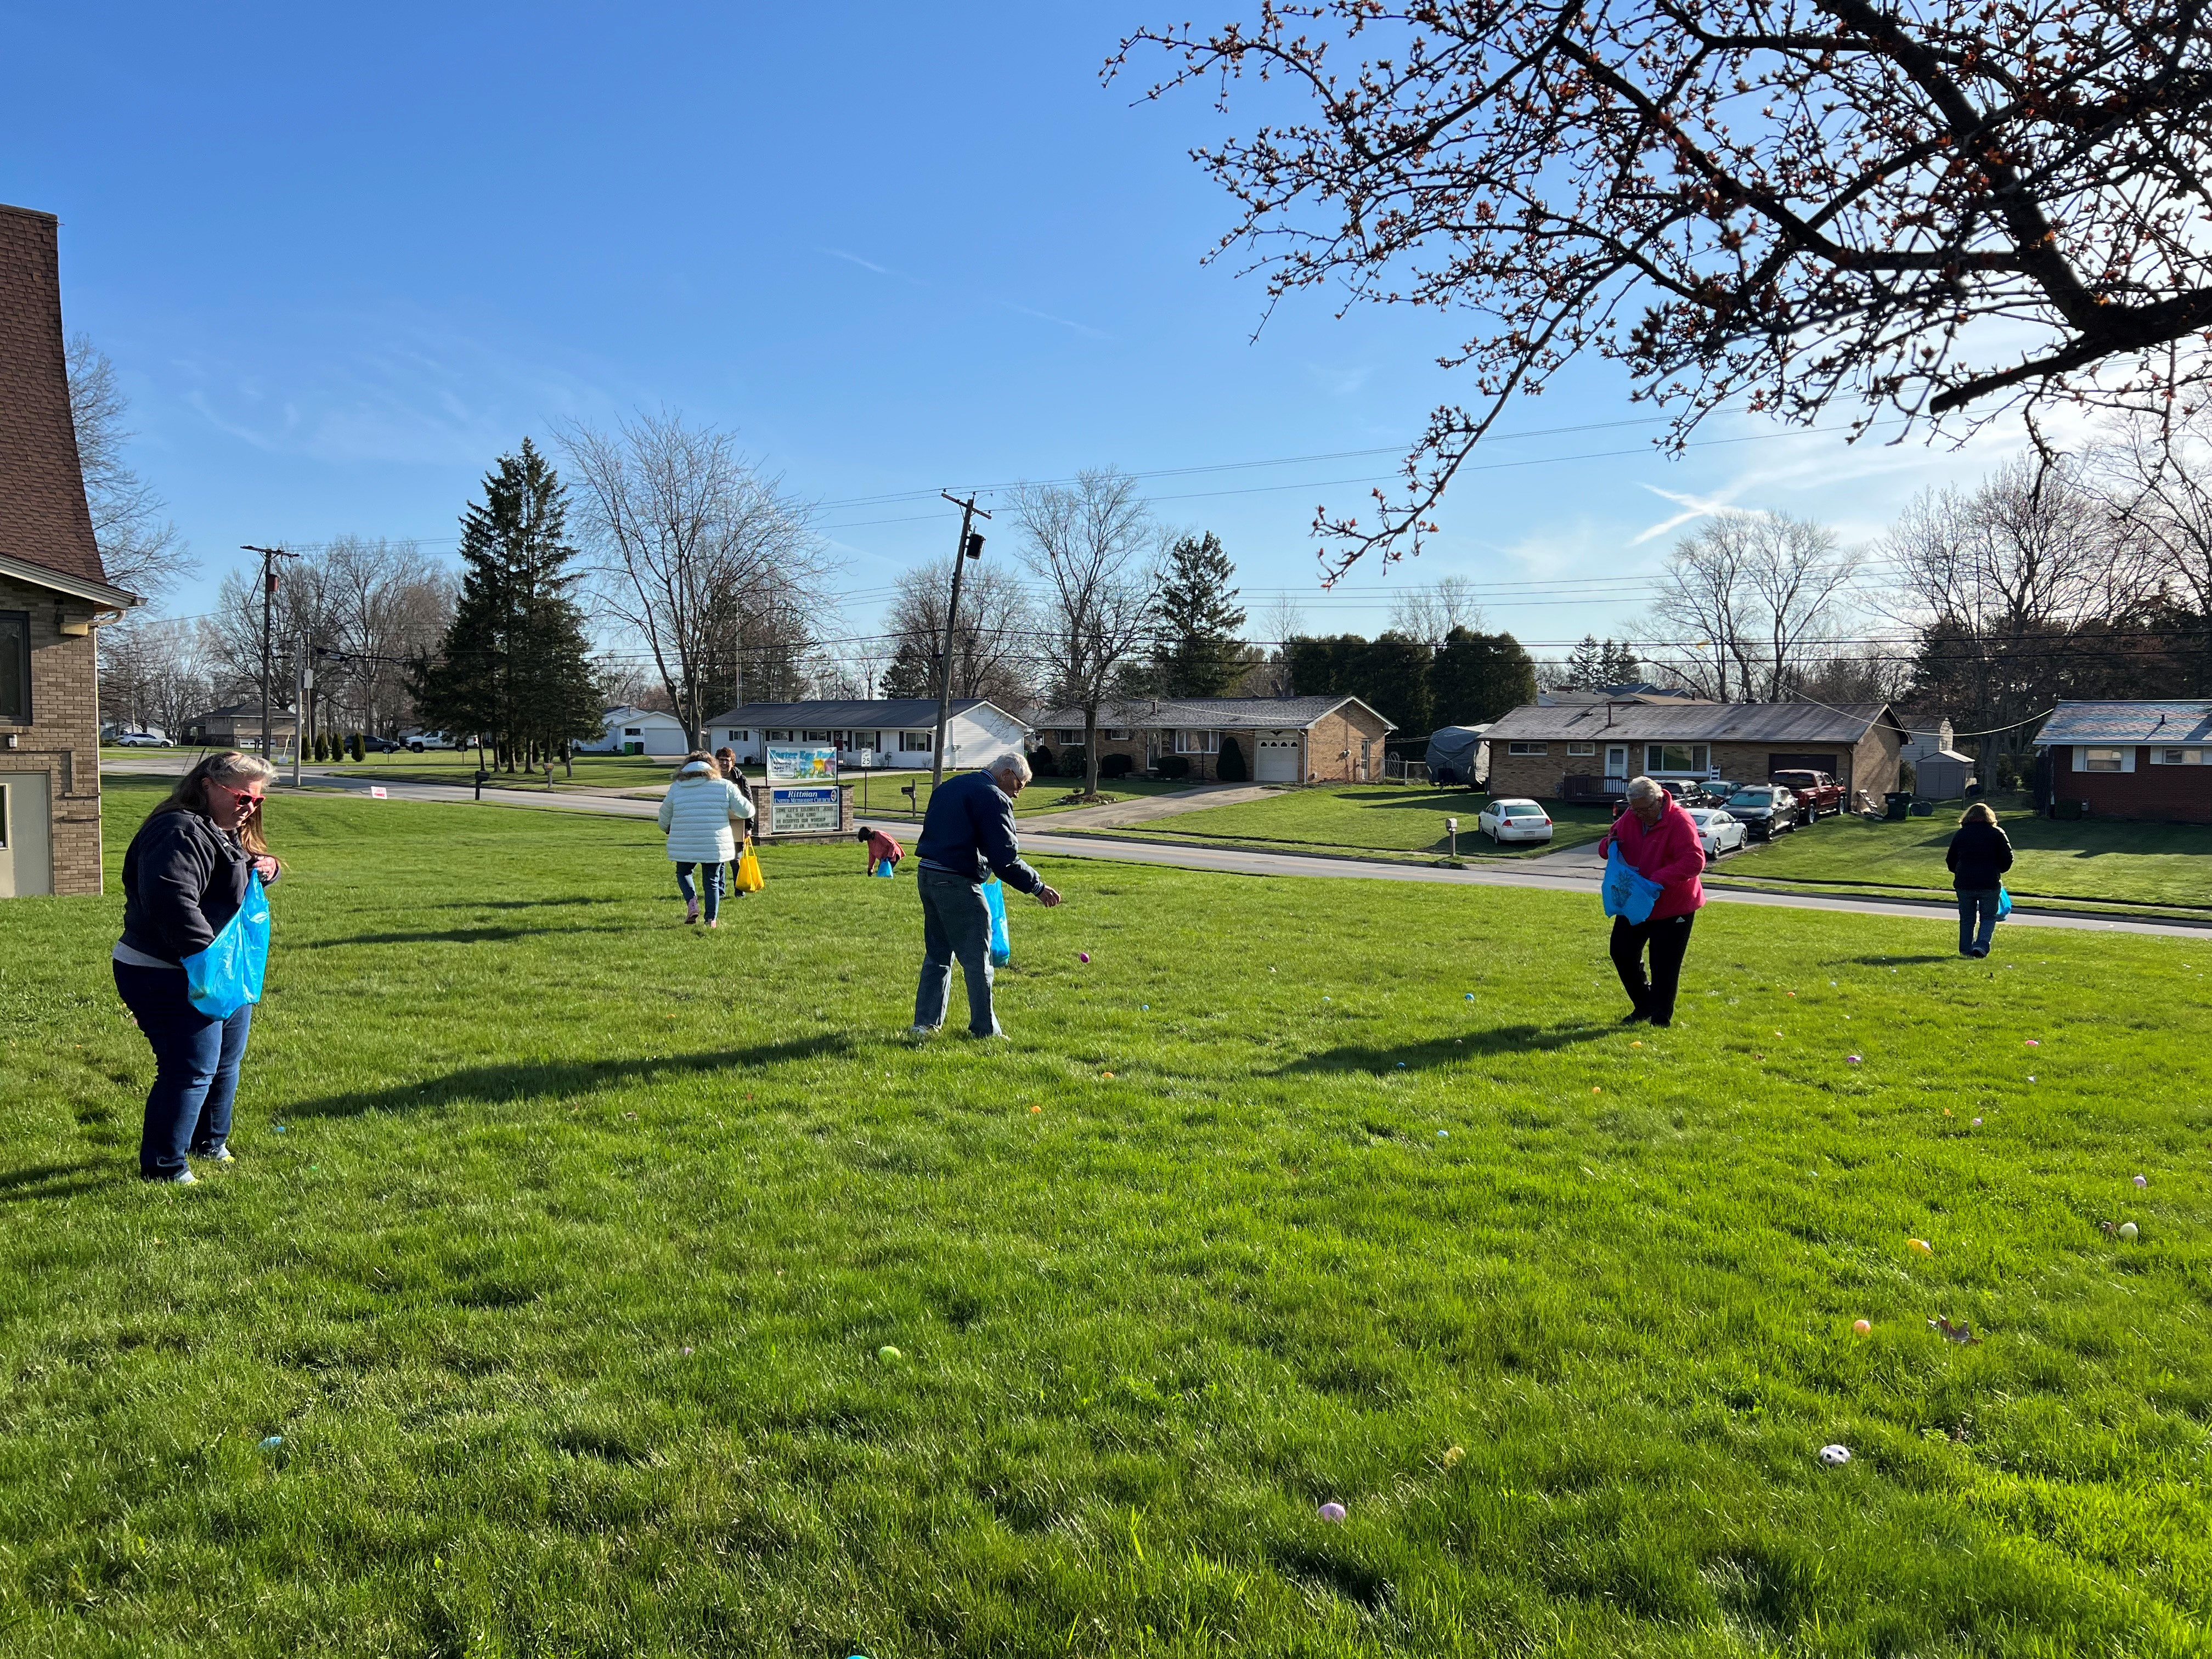
Our Easter Egg Hunt was great! The children enjoyed Story Time, hunting for Easter Eggs, and even won prizes. Thank you to everyone who helped make this event possible!

May
1st – Todd Lunter 8th – Amy Hutton
14th – Don Vohar 17th – Duane Hopton
19th – Adria Booth 20th – Spencer Stoll
23rd – Robin Kirkhart 27th – Melissa Hennie

May
20th – Brett & Heather Richards
27th – Mark & Lynn Turnbow
30th – Andy & Connie Baillis

Sunday School Teacher: “What must you do to receive forgiveness of sin?”

Student: “SIN”

Joys
Eric, Nicole Winkler’s brother – out of the hospital, & doing rehab at parents’ home
Annibale & Mohr families, Mary Lynn – improving and healing
Lydia Stahl continues improving
Anita Vohar continues improving
Brooke Britton – safe travels in and from Mexico
Safe travel for many!
Concerns
Ullman Family – the passing of jack Austin W. – Leg Amputation
Becky King – Summa Rehab Hospital, recovery from broken wrist & pelvis after a fall
Laiken (Sheila Stoll’s great-granddaughter) – diagnosed with Type 1 diabetes
May Revival Fall Women Rekindled Day
Ken Zollinger – health Connie Baillis’ grandma - heart
Dave Smith’s mother, Mary – recovery from cancer surgery
Tia Imhoff McGee’s family – recovery of her children after brain surgery
Brianne Savage – shoulder injury Chase Savage– recovery from surgery
Lydia Stahl – continued recovery Prayers for Megan
Denny Vadini (Carol & family) – cancer Chris B.’s father – Hospice care Vicky, Mary W.’s ex-sister-in-law – cancer
Margaret Moedt’s great- nephew – surgery recovery
Anita (& Don) Vohar – health, continued recovery

“Christ Shares A Meal”

Our April Food Pantry/Community Dinner went really well. We had 24 families (3 new families), 55 people, and 30 sets of food.

We are so grateful for all who provide food, and those who come and do all that is needed. It is difficult for a few to do it all. The next Food Pantry/Dinner is Wednesday, May 17th from 4:00-5:30 p.m. for serving and food pantry pick-up. Clean-up lasts for as long as we have work to do. However, currently, the majority of our helpers are members of our choir & praise band, so they have to leave no later than 6:00 to practice, so we need others to stay if the clean-up isn’t finished. The more helpers we have, the less time is taken to do the work! We have a great time of fellowship & food through this time of service, too!

“For I was hungry and you gave me food, I was thirsty and you gave me drink, I was a stranger and you welcomed me, I needed clothes and you clothed me, I was sick and you looked after me, I was in prison and you came to visit me.”
– Matthew 25:35-36

This past month we had a visit from Wayne County Soil and Conservation, we completed the letters of the alphabet, and we (teachers) completed final assessments on all the children.
As we look forward to May, we will be having Mrs. Tyler’s parents come as our special musical guests on the 4th, the pre-k class will be visiting a kindergarten classroom at Rittman Elementary on the 9th, and the children will be having their graduation celebration on the 11th. It is so hard to believe that the end of the school year is here!
We are currently accepting enrollment for the 2023-2024 school year. All paperwork can be found online, including the handbook. Larissa has done a fantastic job keeping everything updated on the website, she’s even added a few pictures!

Finally, we would like to thank all of you for your support of the preschool program. If it were not for you, we would not be here!
The Library
Our church library has some very good books for you to read and return when you are done. There is no time limit on how long you can keep them.
The library is open when the church is.
Rittman is getting a new library. You probably have seen the construction on North Main Street. It is being funded by the Wayne County Public Library. The city of Rittman is not funding it. Plans are for the new library to open this Fall. The old library on Ohio Ave. will become Rittman’s City Hall.

Dick Baker –dialysis treatments
Harry & Nancy Britton - health Nancy (& Butch) McMillan - health
Richard Isaac (former crossing guard) - health
Sheila Stoll’s friends Gary & Cindy – facing serious illness
Pastor Don’s step-dad in care center (Due to come home Mar.3rd) & mom - health Rae & Duane Smith
Paula Burkhart - health Ana McClain’s Grandpa Tim
Pam Hartman – dialysis treatments Those with RSV, Flu, & Covid
Leigh Litman’s sister, Loretta – recurrence of cancer
Pat Meglich & Robin Kirkhart - health Judy King (Becky’s mom)
Dorothy & Dick Gillman John Lunter Pat Seiler
Lovell, Bruce Lindenmuth’s sister – cancer Josie Denham – heart problems Debbie Baker (& her husband, Rev. David Baker) – stroke recovery & cancer
Pastor Joyce Williams (& Jack) – cancer
Disaster & Violence victims Traveling mercies
Ukraine/Russia War Our country & area communities
Our sympathy to family & friends of:
The father & sister of Jeff Kelly (Winchells’ friend)
Pamela Killinger (mother-in law of Tiffany [Yoss] Killinger)
Betty Gift
Those in Care Centers
Apostolic Christian Home - Anne Salyer, & Ruth Schumacher
Autumnwood Care Center - Marcy Taylor
Liberty Residence II - Pauline Rastorfer
Windsor House @ Doylestown - Paula Burkhart
Wooster Brookdale Senior Living - Marilyn Hofacre
“Kindness – since our world needs more of it – is not optional. Anything that needs to be said can be said with kindness. Any tough position we need to take can be taken with kindness. No exceptions.”
H. Lerner, Ph.D.

Safety Village Helpers Needed!

The program, Safety Village will be May 30th and 31st, 8:30 a.m. – 12:00 p.m. Tuesday and Wednesday mornings.
It is a program, sponsored by the Rittman United Methodist Church and the Rittman Delta Arts Club. It is for children who will be going to kindergarten in August in Rittman Schools.
There is a great need for volunteers to help. Children are in small groups and the volunteers take them to different programs. The Firemen, Policemen, EMS, School Bus Driver and a ride in the bus, Crossing Guard, City Manager, and Mayor will come to the Safety Village. There will be people from the Rec Center to give water safety. There is a time to make crafts that are safety signs. The children will learn their addresses, phone numbers, and how to be safe when riding in a vehicle.
The Fellowship Hall will be turned into a small village with streets and buildings. They have cars or trucks to ride and learn how to be safe.
With all this happening, many helpers are needed to help in many very simple ways. Please call the church office or Sheila Stoll (330-925-3591) to share your time with a child and be a helper.

Thank God for Our Families
~By Rob Blezard
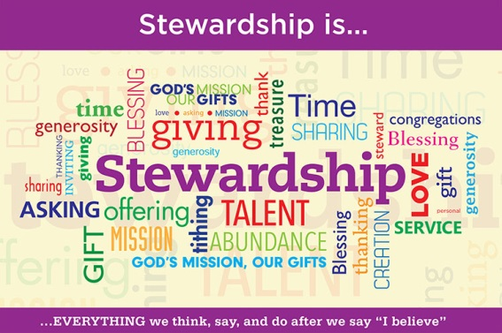
[Jesus was dying on the cross.] When Jesus saw his mother and the disciple whom he loved standing beside her, he said to his mother, “Woman, here is your son.” Then he said to the disciple, “Here is your mother.” -John 19:26-27
This month we celebrate the mothers and mother figures, and then in June we celebrate our fathers and father figures. What a wonderful opportunity to honor the strong bond between parents and children. How strong? The first use of the word “love” in the Bible, Genesis 22:2, describes the connection between Abraham and his son, Isaac.
Family is a cherished gift from God that we are entrusted to treasure, love and nourish. As parents, we are responsible for raising children to become healthy adults. And as children, we are responsible for caring for our aging parents.
As Jesus indicates in the passage above, there need not be a blood connection for a parent-child relationship. In Matthew 12:46-50, Jesus redefines family, saying that all who love and follow him are mothers, brothers, sisters, fathers. So, all of us are parent, child and sibling to one another. Now THAT’S some family!
As we honor the mother and father figures this spring, we can also challenge ourselves to be better stewards of the family bonds God has given us. We can explore how we can support families in our personal circles, our congregation and community – especially families that are troubled by great need, crises or dysfunction.
God ordained families to be the fundamental unit of human life. We can be good stewards of family relationships by caring for one another and helping everyone to grow into the faith family God intends.

Copyright ©2018 Rev. Robert Blezard. Reprinted by permission. Pastor Blezard works as content editor for www.stewardshipoflife.orgs and serves as pastor of St. Paul’s Lutheran Church, Aberdeen, MD.

Mother
celebrate Jesus through the messages of Holy Week and Eastertide! He has fulfilled many of the prophecies about Him, but remember that He is still coming again which will fulfill the final prophecies!
We have reason to rejoice in the trying times of life. The world definitely isn’t perfect. Isn’t it a good thing that we aren’t supposed to be following the things of this world! However, Jesus is perfect! So, let’s follow Him and let Him shine out of our words and actions! Matthew 5:16 (NKJV) says, “Let your light so shine before men, that they may see your good works and glorify your Father in heaven.”
Blessings,
Pastor Ruthie Trigg

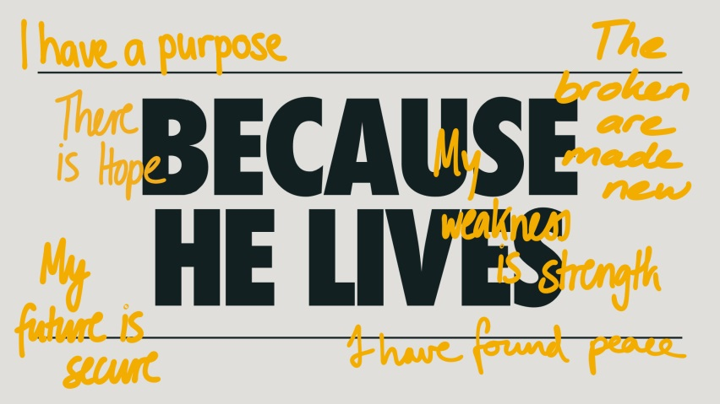
There is a word in the English language in which the first two letters signify a male, the first three letters signify a female, the first four signify a great man and the whole word, a great woman. What is the word?
Heroine

Why is Sunday School Important?
I grew up going to Sunday School in this church. When I was younger, I didn’t think I really needed to go. And, honestly, sometimes I didn’t want to be there. I didn’t understand the importance of it, especially when I thought I already knew what I was being taught. I thought, “What’s the point?”
“If I don’t go, maybe I can get an extra hour of sleep!”
I am going to be honest; I still have those thoughts sometimes. I find it even harder now to go to Sunday School because I don’t have a class with people my age. However, I have realized a few things since attending as an adult.
No matter how much we think we know about a topic or story in the Bible, there is always more to learn. I have been very surprised by some of the nuances in the Bible that I have overlooked because it’s a story I know well. Having a specific time to take a deeper look at the Bible is never a bad thing.
Discussion with other Christians is not only important but vital for spiritual growth. Everyone has a different perspective. When we get together, we are able to share and compare what we have gained from a topic. Each conversation can be a knowledge-expanding experience if we let it.
At the very least (or maybe the very most), we get to spend more time with God. Every moment spent with God is never a moment wasted. We have to make the choice to prioritize that time, and Sunday School is a great opportunity to do so.
We have a couple of Sunday School classes currently going, and you are welcome to join those. If you would like to start your Sunday School class back up, please do so! If you aren’t sure what to study, we have options in the church library. You could also choose a book of the Bible to study for a month (or more)!
Let’s get excited about Sunday School again!
-Larissa Richards
Announcements / Keep Watch

May Revival with Rev. Ron Heasley:
Sunday, May 7th – 10a.m. & 7p.m.
featuring The Tyler’s at 7p.m.
Monday, May 8th – 7p.m.
featuring Our Own Rittman UMC
Sandy Batson and Larissa Richards
Tuesday, May 9th – 7p.m.
featuring The Water Church Praise Band
May 13th: 11a.m. – Canal Spring District Conference
@ Centenary UMC
May 20th: 6p.m. – Church Bonfire
October 21st: 8 a.m. Check-in, 9:00 a.m. start –
Women Rekindled
with speaker Robyn Dykstra

“Hope is the oxygen your soul breathes.”

Bonnie Gray
Author

Easter Holy Week has come and gone once again! It doesn’t seem possible how fast time is flying past. However, let’s remember that Easter doesn’t just stop on Easter Sunday. Eastertide is the most important time in our church year! It is a time to reflect on what happened during Jesus’ Passion Week, and most importantly to reflect on the hope that the Resurrection of Jesus means for us and all people. Eastertide is 50 days, beginning with Easter Sunday and ending with Pentecost Sunday.
There were many events that happened during this time. Jesus rose from the dead to walk among His disciples appearing at times in ways that were hard for them to understand. They didn’t always recognize Him at first. He spent that time reaffirming the lessons that He had taught them before He died on the cross. And when He was ready, He ascended into heaven. Then He sent the Holy Spirit to be with all of His disciples throughout our days here on earth.
This is the time for us to think about all of the messages that He left us with; to give us healing, transformation, strength, hope, assurance, purpose, joy, and peace. Let’s continue to
 | 1 | 2  6:30pm –  Prayer Circle  @ home | 3  11:00am – Prayer Circle  @ home  6:00pm – Choir Practice  7:00pm – 2:11 N. Practice | 4  National Day of Prayer  NO Women’s & Men’s Bible Studies | 5 | 6
7 Holy Communion  9:00am –  Sunday School  10:00am –  Worship Service  7:00pm – Revival | 8  7:00pm – Revival | 9  6:30pm –  Prayer Circle  @ home  7:00pm – Revival | 10  11:00am – Prayer Circle  @ home  6:00pm – Choir Practice ??  7:00pm – 2:11 N. Practice | 11  10:00am –  Women’s Bible Study  6:30pm –  Women’s & Men’s  Bible Study | 12 | 13  Canal Spring District Conference @ Centenary UMC – 11am
14  Mother’s Day  Pennies From Heaven  9:00am –  Sunday School  10:00am –  Worship Service | 15 | 16  6:30pm –  Prayer Circle  @ home  6:30pm – Set-up for Food Pantry/ Community Dinner  7:00pm – Admin.  Council Mtg. | 17  11:00am – Prayer Circle  @ home  4-5:30pm – Food Pantry/  Community Dinner  6:00pm – Choir Practice  7:00pm – 2:11 N Practice | 18  10:00am –  Women’s Bible Study  6:30pm –  Women’s & Men’s  Bible Study | 19 | 20  6:00pm – Bonfire
21  9:00am –  Sunday School  10:00am –  Worship Service | 22 | 23  6:30pm –  Prayer Circle  @ home  7:00pm – Trustee’s Meeting | 24  11:00am – Prayer Circle  @ home  7:00pm – 2:11 N Practice | 25  10:00am –  Women’s Bible Study  6:30pm –  Women’s & Men’s  Bible Study | 26 | 27
28  9:00am –  Sunday School  10:00am –  Worship Service | 29  Memorial Day  Office Closed | 30  6:30pm –  Prayer Circle  @ home | 31  11:00am – Prayer Circle  @ home  7:00pm – 2:11 N Practice
May
Sunday Monday Tuesday Wednesday Thursday Friday Saturday
Offering Tabulators

Robin Ryland

Rittman United Methodist Church
211 North Metzger Avenue
Rittman, OH 44270
Return Service Requested

POINTS to PONDER
April 2023
Vol. 55 No. 5
Ruthie Trigg, Pastor
www.rittmanumc.org
330-925-4015
pastor@rittmanumc.org
office@rittmanumc.org

UPCOMING EVENTS
Sun. May 7th:
10:00am – Revival Day 1 pt. 1
7:00pm – Revival Day 1 pt. 2
Mon. May 8th: 7:00pm – Revival Day 2
Tue. May 9th: 7:00pm – Revival Day 3
Sat. May 13th: 11:00am – Canal Spring
District Conference @ Centenary UMC
Sun. May 14th: Mother’s Day
Tue. May 16th: 6:30pm – Set-up for Food
Pantry/Community Dinner
Tue. May 16th: 7:00pm – Admin. Council
Meeting
Wed. May 17th: 4-5:30pm – Food Pantry /
Community Dinner
Sat. May 20th: 6:00pm – Bonfire
Tue. May 23rd: 7:00pm – Trustee’s
Meeting
Mon. May 29th: Memorial Day
(Office Closed)

Sunday School @ 9:00am
Worship Service @ 10:00am
Office Hours
8:30am – 1:30pm
Mondays -Thursdays
Living Our Faith through Word and Action

We serve
a Risen Savior!

Motherhood
Mother’s Day – No job can compete with the responsibility of shaping and molding a human being.
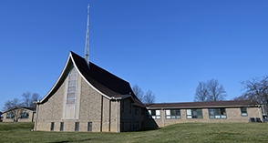
Appreciate
this Memorial Day for all who have served this country to keep our freedom.

Rittman United Methodist Church Points to Ponder – May 2023
Volume 55 – Issue No. 5
Ruthie Trigg, Pastor
Sheila Stoll, Editor

You did it!
Celebrate this time with all the 2023 graduates.

