Fireside Chat
Fireside Chat with the Finance Chair

Dear friends,

As we come to the end of the first half of the year, I want to report the good news that we are up to date with all bills, and apportionments are paid up to date. This is a good place to be as Pastor Ruthie’s retirement approaches and we end our time with her and we start our time with Pastor Kristen Buchs.
Looking ahead I see some costs going up that we didn’t see coming when we made our budget projections for 2023 in the fall. Things may be getting tighter. Gas and electric are going to be higher for all of us – in our homes and our church. Soooo, as you plan your summer vacation or weekends away with your kids or grandkids or camping in your RV, don’t forget to send your offering to the church before you leave town. Have a good time and keep up with us on the church’s Facebook page while you are gone at our new time of 10:30 a.m. on Sundays. Then when you get home, share your fishing stories with us in church.
With joy in my heart for you,

Martha Baillis, Finance Chair

MIDWEST MISSION
COMING TO
ANNUAL CONFERENCE
IN JUNE.
The Personal Dignity Kits we are making for Midwest Mission will be dedicated in church June 4th and taken to Annual Conference by our delegates later that week. The list of items in the kits is on the table in the Narthex, and there is a box for the kits beside the table.
Mary’s Meanderings

This month we will be undergoing a transition. A transition is a period of change. There are many transitions in life: moves, progressing in school, living on your own, marriage and having children, divorce, death of a loved one. The transition phase of labor in having a baby can be the most intense and painful.

We have enjoyed eight good years with Pastor Ruthie. She has navigated us through the years of the Covid Pandemic. She has faithfully served our congregation with her caring attitude and people skills. She introduced the Connect Program, an afterschool program for children of the community and Teen Connect for the High School youth. During her time here she completed the required work to become ordained as a pastor in the United Methodist Church. Covid was not kind to her as she ended up being diagnosed with long covid with its many side effects. But she has soldiered on in her ministry to our church. We congratulate her in her Retirement and wish her nothing but the best in this next chapter of her life.

The SPPRC committee and the Transition Team have been busy in all the details involved in the process of going from one pastor to another. Because of the current size of our congregation and the effect that has on church finances, we are going to be sharing our new pastor with Trinity United Methodist Church. Sharing one pastor in two different cities requires negotiation, compromise and even some sacrifice. To ease into our new schedule upon the arrival of our new pastor we will start having our Sunday worship services at 10:30am beginning June 4. We will be having a celebratory sendoff party for Pastor Ruthie on June 25 from 2:00 to 4:00pm. All are welcome to that and you can respond to the event on our Facebook page or by letting the office know.

We have much work to do to prepare for our new pastor including "cleaning house" and if you have time and opportunity to go through old boxes and clear the clutter just let the office or someone on the SPPRC committee know. Many hands and able bodies make light work.

Our new pastor is Pastor Kristen Buchs. She comes to us from Clarksfield & New London and will be dividing her time between Orrville and Rittman. We will be having a Celebratory welcome party for her on July 9 after the worship service. As we all probably know what it feels like to be the "new kid on the block" let us welcome her with thoughtfulness and open arms. We are all the church. Each of us brings our unique gifts and talents to offer as our living sacrifice to God.

No one really likes change but it is inevitable. As we bathe Pastor Ruthie, Pastor Buchs, Trinity United Methodist Church and our church in prayer let us pray for a smooth transition.

Bible Studies

A group of women meet on Thursdays at 6:30pm, and are led by Betty Winchell and Sara Ullman. Another group of women meet at 10:00am led by Pastor Ruthie, also on Thursdays.
There is always room for more to attend!

Titles of current & upcoming studies:
Our study on What Love Is: Letters of 1,2,3 John started May 11th. Let Betty or Pastor Ruthie know if you need a book for this study. We would love to have you.

Men’s Bible Study, led by Pastor Don, meets Thursdays @ 6:30pm
They are studying the Book of Acts.
Keep an eye out for announcements on our next studies. We would love to have you!
Trustee’s Corner

Items since last month:
- Columbia Gas moved the meter to outside the boiler room per new PUCO requirement; also, they ran new 1¼” plastic line to the church from across the street (at no cost to RUMC)!
- We changed two more Ballasts in the Social Hall lights, plus one new West Preschool Room.
- We changed filters in front of the Sanctuary Heat/AC Units and Social Hall A/C.
- The Parsonage small bathroom ceiling fan is repaired. There is also a new grill and a painted light fixture.
- The city replaced the broken Water Shutoff Valve at the street.
- We purchased 2 Japanese Maple Trees for beside the entryway.
- The quote for doing preschool bathroom and playroom floors is $3,190. This will come from the Preschool Grant.
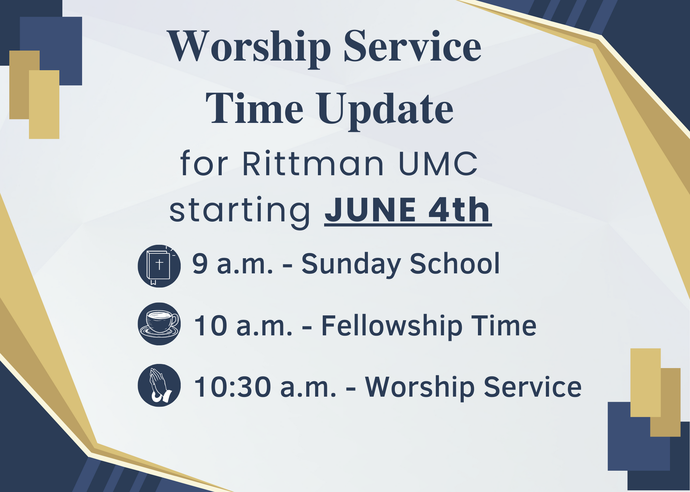

“Christ Shares A Meal”

Our May Food Pantry/Community Dinner went really well. We had 30 families (3 new families), 61 people, and 31 sets of food.

We are so grateful for all who provide food, and those who come and do all that is needed. It is difficult for a few to do it all. The next Food Pantry/Dinner is Wednesday, June 21st ^{from} 4:00-5:30 p.m. Clean-up lasts for as long as we have work to do. However, currently, the majority of our helpers are members of our choir & praise band, so they have to leave no later than 6:00 to practice, so we need others to stay if the clean-up isn’t finished. The more helpers we have, the less time is taken to do the work! We have a great time of fellowship & food through this time of service, too!

Thank you very much for the donations of empty containers for take home food from church dinners.
The supply is very good. No more are needed at this time.

June
1st – Bruce Lindenmuth 2nd – Dick Baker
Dawn Hennie Rachel Ramsier
8th – Harry Britton 17th – Matthew Richards
23rd – Sandy Gasser 26th – Pat Seiler
29th – John Lunter

June
6th – Bob & Lisa Hartman 10th – Don & Ruthie Trigg
12th – Bill & Lori Ullman 13th – Bruce & Ruthanne
Lindenmuth
14th – Matt & Amy Hutton 22nd – Rod & Judy Britton
26th – Lee & Betty Winchell
A shut mouth gathers no foot.

“He that keepeth his mouth keepeth his life: but he that openeth wide his lips shall have destruction.”

Proverbs 13:3

Joys
Brenda Cook – improving
Becky King is back as secretary and doing well!
Hannah and those on the Spain Mission Trip
Eric, Nicole Winkler’s brother – home on his own & doing well, back at work
Annibale & Mohr families, Mary Lynn – improving and healing
Anita Vohar continues improving
Safe travel for many!
Concerns
Melissa A. – healing from meniscus tear Austin W. – Leg Amputation
Claire (Brenda Cook’s granddaughter) – healing from surgery
Laiken (Sheila Stoll’s great-granddaughter) – diagnosed with Type 1 diabetes
Fall Women Rekindled Day
Judy King (Becky’s mom) Ken Zollinger – health
Dave Smith’s mother, Mary – recovery from cancer surgery
Tia Imhoff McGee’s family – recovery of her children after brain surgery
Brianne Savage – shoulder injury Chase Savage– recovery from
surgery
Prayers for Megan Josie Denham – heart problems
Denny Vadini (Carol & family) – cancer Chris B.’s father – Hospice care Vicky, Mary W.’s ex-sister-in-law – cancer
Margaret Moedt’s great- nephew – surgery recovery
Dick D. – ICU Donald S. - cancer

On May 11th, we held our graduation ceremony in the social hall, which was filled with our preschoolers’ loved ones. We had 6 children who graduated from preschool to pre-k and 9 that graduated pre-k and will be attending kindergarten in the fall. Each child received a certificate of completion for their respective class. We also presented Bibles to the 9 children who will be attending kindergarten in the fall.
We would also like to thank Dana for providing cookies for the graduation ceremony and for her dedication to the children throughout the school year. She has been a wonderful addition to our program!
We currently have 11 children enrolled for the upcoming school year with hopes that we will receive more over the summer. If anyone knows a child who is of preschool age, please let them know that we are accepting enrollment for the fall. All paperwork needed for enrollment can be found on the church website under the preschool tab.
We are planning to have our Open House on Thursday, September 7th and our first day will be Tuesday, September 12th. We would again like to thank each of you for your continued support.

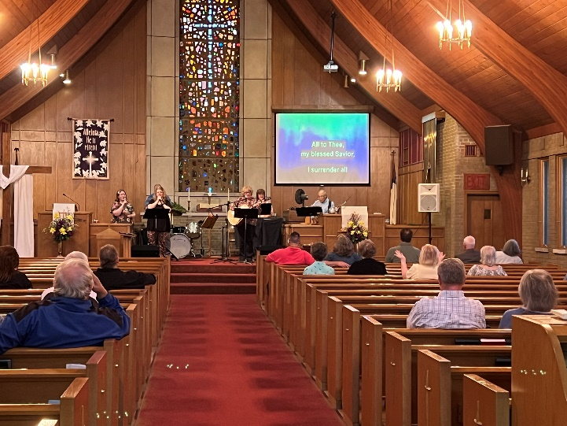
Revival was an incredible time! Thank you so much to Rev. Ron Heasley for speaking, to all the musicians who led us in worship each day, and everyone else who made the May Revival happen. A special thank you goes out to Betty Winchell for making the May Revival possible! We all appreciate and see the hard work you are doing. Thank you so much!

of Mount Union and any team playing against Alabama (sorry Bama fans!).

My closest family members are my parents, Bob and Bobbie Buchs. Dad will be 91 in June and mom was 90 in April. I am so blessed that they are still very much a part of my life! I never had a family of my own, so I am very close to my younger sister Tracy and her husband Scott, who live in Bainbridge, Ohio, and their three grown boys – Zach (33), Cody (29), his newly wedded wife Alexa, and Matt (26) – who all live in the Cleveland area. I also adore my cat, Meow Kittie (and yes, that is her name!).

The classes I've most enjoyed in the Course of Study are Worship and Sacraments, Congregational Care, Theological Heritage IV: Wesleyan Movement and Bible III: Gospels.

The top five greatest strengths I have as a pastor, according to Strength Finders, are positivity, empathy, achiever, developer, and responsibility. My greatest strengths as a pastor, according to the folks in my current congregations, are: commitment to the church and local community shown by active participation/involvement in church events and community outreach projects, enthusiasm, relating to children, encouraging congregational involvement in all areas of ministry and mission, organization and attention to detail.

I cannot begin to tell you how excited I am to meet and get to know all of you! In the meantime, I will be praying for Pastor Ruthie and her husband as she begins her retirement and I will be praying for all of you at Rittman UMC as we begin our journey together with God in July!

In Christ,
Pastor Kristen Buchs

Anita (& Don) Vohar – health, continued recovery
Harry & Nancy Britton - health Nancy (& Butch) McMillan - health
Richard Isaac (former crossing guard) - health
Sheila Stoll’s friends Gary & Cindy – facing serious illness
Pastor Don’s Mom - health Duane Smith
Paula Burkhart - health Ana McClain’s Grandpa Tim
Pam Hartman – dialysis treatments Those with RSV, Flu, & Covid
Leigh Litman’s sister, Loretta – recurrence of cancer
Pat Meglich & Robin Kirkhart - health
Dorothy & Dick Gillman John Lunter Pat Seiler
Lovell, Bruce Lindenmuth’s sister – cancer
Debbie Baker (& her husband, Rev. David Baker) – stroke recovery & cancer Dick Baker –dialysis treatments
Pastor Joyce Williams (& Jack) – cancer
Disaster & Violence victims Traveling mercies
Ukraine/Russia War Our country & area communities
Our sympathy to family & friends of:
The father & sister of Jeff Kelly (Winchells’ friend)
Pat Dressler
Rae (Marinello) Smith
Cassie Combs (Richards’ family friend)
Those in Care Centers
Apostolic Christian Home - Anne Salyer, & Ruth Schumacher
Autumnwood Care Center - Marcy Taylor
Liberty Residence II - Pauline Rastorfer
Windsor House @ Doylestown - Paula Burkhart
Wooster Brookdale Senior Living - Marilyn Hofacre

The Visitor

One day a man went to visit a church. He got there early, parked his car, and got out. Another car pulled up and the driver got out and said, “I always park there! You took my place!”

The visitor went inside for Sunday School, found an empty seat, and sat down. A young lady from the church approached him and stated, “That’s my seat! You took my place!”

The visitor was somewhat distressed by this rude welcome, but said nothing. After Sunday School, the visitor went into the sanctuary and sat down. Another member walked up to him and said, “That’s where I always sit! You took my place!”

The visitor was even more troubled by this treatment, but still said nothing.

Later as the congregation was praying for the presence of Christ to dwell among them, the visitor stood up and his appearance began to change. Horrible scars became visible on his hands and on his sandaled feet. Someone in the congregation noticed him and called out, “What happened to you?”

The visitor replied, as his hat became a crown of thorns and a tear fell from his eye, “I took your place.”
--- Rev. Randall S. Lehman, Wooster

Place yourself in Jesus Christ – now is the time –
tomorrow may be too late.

Getting to Know You Rittman UMC!

Grace and peace to you, Rittman UMC, from God our Father and from the Lord Jesus Christ! My name is Kristen Buchs and I will have the blessing, privilege and honor to serve as your pastor beginning July 1, 2023. Pastor Ruthie graciously asked if I would be willing to share a little about myself so that you could begin to get to know me before my arrival in July. So, here’s a little information about me and some of my favorite things…

My favorite color is purple.

My favorite season is Fall.

Some of my favorite foods are my mom’s chili, my sister Tracy’s Christmas sugar cookies, my friend Lynn’s homemade cranberry bread and Irish soda bread, ice-cream, anything salted caramel, and anything with cheese – mac and cheese, grilled cheese sandwiches with tomato soup, charcuterie boards – seriously, anything with cheese and the more cheese, the better!

When I travel or go on vacation, I like to go to the Holy Land, especially areas around the Sea of Galilee. I’ve been to Israel three times and I am looking forward to going back. Closer to home, I love to visit Lake Erie’s shores and islands. Catawba, Lakeside, Marblehead, Port Clinton and Kelley’s Island are some of my favorite places.

A favorite movie of mine is It’s a Wonderful Life. My favorite series is The Chosen. I’m not just a fan – I am fanatical about that show!

A favorite music genre is Christian music. It’s pretty much all I listen to any more. Favorite artists include Casting Crowns, Mercy Me, Matthew West and Maverick City Music. Favorite songs, in addition to ones by the artists listed, are Alive by Natalie Grant and Rattle by Elevation Worship.

The sports teams I root for are the Cleveland Indians – oops, Guardians! – (I’m sorry, but they will always be the Indians to me), the Browns, the Buckeyes, the Purple Raiders

I will still be your pastor until the end of June, and then your new pastor will be Pastor Kristen Buchs (pronounced Books). Thankfully many of us have been able to meet her due to the new transitioning process of the Conference. I have found her to be a very pleasant, God-filled, and God-led woman. We will be working together over the next month or so to bring a smooth transition for the church family, including Pastor Kristen. My prayers and hopes for you all is that you welcome her into your hearts and lives as your new pastor, and work with her in serving the Lord, as you have with me.
We still have time to talk about the transition ahead of us and the feelings that we are all dealing with. Don’t hesitate to talk with me and/or Pastor Kristen about those feelings. Starting July 1st, Pastor Kristen will be your pastor, and I will be supporting her in every way possible. Over the next year I will not be in Rittman or approaching any of you personally, so that she has the year to form relationships within the church family. Love her as you have loved me. You will all be in my prayers. Blessings & Love,
Pastor Ruthie Trigg
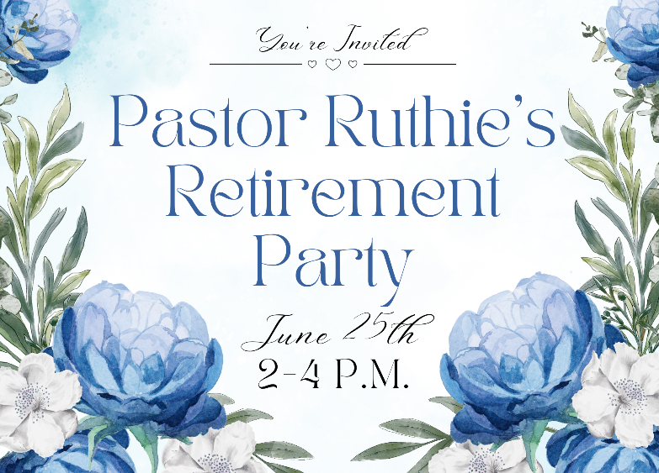

Vote for Larissa Richards
Larissa Richards has made it to the 2nd round of the You, God’s Music Showcase! Voting for this round ends June 4th. The top 25 will move on to the Semifinals! She wants to thank everyone who has supported her and gotten her this far in the competition. The Semifinals voting will start June 17th. Keep voting to make sure Larissa continues on! You can vote directly at this link for the 2nd round:
https://yougodsmusic.org/music-video/my-jesus-by-larissa-richards/
You can also vote by donating a love offering and marking it for Larissa Richards – You, God’s Music.
Can you solve this riddle?

For years you have us all
then, one by one, we fall.
No matter what you do, you lose us.
Even if you keep us, you lose us.

Reinforcements arrive,
more white coats like us,
who won’t be pushed around,
who mean to stand their ground!

Answer – baby teeth

All This Day
“All this day I am going to be a child of God. His love is round about me. Underneath are the everlasting arms. I am going to be honest and true in all events of life and I believe that to those who love God all things work together for good. I am going to rise above all worry, fretting, fear and hatred, and live in an atmosphere of spiritual serenity. Behind all that comes, God’s love and wisdom will be present to strengthen and sustain.”
Albert W. Palmer

“Hope is contagious. Your actions will inspire others.”

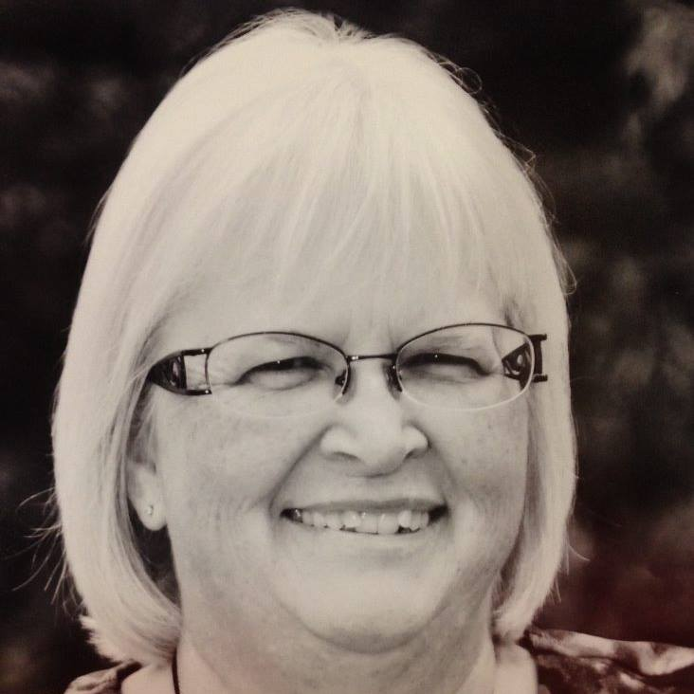
Announcements / Keep Watch

Don’t forget to fill out your Contact Information Update Packet and return it to the office!
Link to fill it out online: https://forms.gle/13gzRsRwtL6EKTpe6

June 4th: Worship time changes to 10:30 a.m.

June 7th: Clergy Executive Session (for Annual Conference)

June 8th – 10th: Annual Conference
at the John S. Knight Center in Akron

June 25th: Rev. Ron Heasley will be Guest Preaching at 10:30 a.m.
Pastor Ruthie’s Retirement Party: 2 – 4 p.m.

July 2nd: Pastor Kristen Buchs’ First Sunday

July 9th: Carry-in Welcome Party for Pastor Kristen after church

October 21st: 8 a.m. Check-in, 9:00 a.m. start –
Women Rekindled
with speaker Robyn Dykstra
Dear Rittman United Methodist Church Family,

This letter is one of the hardest that I have ever had to write, because it is really difficult to say goodbye. It is hard to believe that I’ve been your pastor for the last 8 years! In that fact we have traveled through many experiences together with the Lord. Those experiences have been both good and bad, but we have definitely grown through them all, and I love and appreciate all of you. Thankfully this goodbye isn’t forever, because we with God’s grace will see each other in the future, whether on this earth or in heaven with Him. Only the Lord knows the answer to when and the where. It has been a joy in serving this church family, and you will always have a place in my heart.
We have served the Lord together is so many ways over these 8 years, through the Worship, Sunday School classes, Bible Studies, Choir, Praise Team, Preschool, special services, Food Pantry & Community Dinners, Operation Christmas Child, Christmas Baskets, Christmas Caroling, RittmanCARES, CONNECT and Teen CONNECT, MidWest Mission Distribution Center donations, Steve Semler’s Mission: Fishers of Men, the Landerholms’ mission in Hungary, Bloodmobile, Computer training for the community, card ministry, caring for the buildings and lands, and serving on leadership teams; along with the many fellowship events of the Easter Egg Hunt, Trunk or Treat, Bonfires, and eating out together. I’m sure I’ve forgotten some, but these show how active we have been through these 8 years. I pray that you continue to be just as faithful, and even more so, as you continue fulfilling your commitment to Christ and following the leading of the Holy Spirit.

June
Sunday Monday Tuesday Wednesday Thursday Friday Saturday
Offering Tabulators

Sandy Gasser
 |  |  |  | 1  6:30pm –  Women’s & Men’s  Bible Study | 2 | 3
4 Holy Communion  9:00am –  Sunday School  10:30am –  Worship Service | 5 | 6  6:30pm –  Prayer Circle  @ home  6:30pm –  Preschool Meeting | 7  11:00am – Prayer Circle  @ home  6:00pm – 2:11 N. Practice  Clergy Executive Session | 8  6:30pm –  Women’s & Men’s  Bible Study  Annual Conference | 9 | 10
11  Pennies From Heaven  9:00am –  Sunday School  10:30am –  Worship Service | 12 | 13  6:30pm –  Prayer Circle  @ home  7:00pm – Admin.  Council Mtg. | 14  11:00am – Prayer Circle  @ home  6:00pm – 2:11 N Practice | 15  6:30pm –  Women’s & Men’s  Bible Study | 16 | 17
18 Father’s Day  9:00am –  Sunday School  10:30am –  Worship Service | 19 | 20  6:30pm –  Prayer Circle  @ home  6:30pm – Food Pantry Setup | 21  11:00am – Prayer Circle  @ home  4-5:30pm – Food Pantry/Community Dinner  6:00pm – 2:11 N Practice | 22  6:30pm –  Women’s & Men’s  Bible Study | 23 | 24  10:00am –  Oakhill Meeting  Fellowship Hall
25  9:00am –  Sunday School  10:30am –  Worship Service  2-4pm – Pastor Ruthie’s Retirement Party | 26 | 27  6:30pm –  Prayer Circle  @ home  7:00pm –  Trustee’s Meeting | 28  11:00am – Prayer Circle  @ home  6:00pm – 2:11 N Practice | 29  6:30pm –  Women’s & Men’s  Bible Study | 30

Rittman United Methodist Church
211 North Metzger Avenue
Rittman, OH 44270
Return Service Requested

POINTS to PONDER
June 2023
Vol. 55 No. 6
Ruthie Trigg, Pastor
www.rittmanumc.org
330-925-4015
pastor@rittmanumc.org
office@rittmanumc.org

UPCOMING EVENTS
Sun. Jun. 4th: New 10:30 a.m.
Worship Time!
Tue. Jun. 6th: 6:30pm – Preschool Board
Meeting
Wed. Jun. 7th: Clergy Executive Session
Thu. Jun. 8th – Sat. Jun. 10th: Annual Conference at the John S. Knight Center
Tue. Jun. 13th: 7:00pm – Admin. Council
Meeting
Sun. Jun. 18th: Father’s Day
Tue. Jun. 20th: 6:30pm – Set-up for Food
Pantry/Community Dinner
Wed. Jun. 21st: 4-5:30pm – Food Pantry /
Community Dinner
Sat. Jun. 24th: 10:00am – Oakhill Meeting
Fellowship Hall
Sun. Jun. 25th: 2-4:00pm – Pastor Ruthie’s
Retirement Party
Tue. Jun. 27th: 7:00pm – Trustee’s
Meeting
Sunday School @ 9:00am
Worship Service @ 10:00am
Office Hours
8:30am – 1:30pm
Mondays -Thursdays
Living Our Faith through Word and Action

We serve
a Risen Savior!

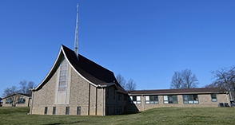

Rittman United Methodist Church Points to Ponder – June 2023
Volume 55 – Issue No. 6
Ruthie Trigg, Pastor
Becky King, Larissa Richards, Sheila Stoll – Editors

“May the God of hope fill you with all joy and peace in believing, so that by the power of the Holy Spirit you may abound in hope.”
Romans 15:13

