We watched a 30-minute video about *Faith Working thru Love* by Dr. David N. Field and were given a book by the same title.  It is a resource for United Methodist teaching in the basics of our faith.  He mentioned how Faith is the porch, Repentance is the door and Salvation is the house.  He also talked about Integrated Holiness-how holiness is personal and social.  There is not personal holiness that is not social and no social holiness that is not personal.  Religion lies in the heart but branches out to go about doing good.  It is in seeking the welfare of others that we are personally transformed.  The business sessions of the day were about the resolutions put forward.  In total there were 4 resolutions that were voted upon.  1. Human rights of Palestinian children, which passed.  2. Calling a special Annual Conference for Disaffiliating churches, which was tabled until Saturday and then voted down.  3. Supporting of the Christmas Covenant which allows different cultures to establish their own practices, which passed.  4. Against hate crimes, which passed.  We were then presented information on Lighthouse Churches which were established for those whose churches have disaffiliated but they personally want to remain UMC.  Next was the celebration of the retirement of 40 pastors of which Pastor Ruthie and her husband, Don, were on the stage and honored by the Bishop.  You can see pictures of this on the website eocumc.com.   Also approved was the re-districting of the East Ohio Conference from 10 districts, which we currently have down to 4 districts effective January 1, 2024.  There will be two district superintendents serving each of the new districts.

Saturday morning worship was with Dr. David A. Palmer.  He talked about the practice of perseverance.  Have perseverance in trusting in God.  Ezekial is known as the persevering prophet.  He said that God would give people a new heart.  With God all things are possible.  God gives us strength to overcome weakness and a rope to overcome despair.  He challenged us to be Christ's representatives.  The business session contained a Board of Laity Report, Deaconess/Home Missioner Celebration, Commissioning of a Home Missioner and Ecumenical Partnerships.  Another business session covered Benefits, fixing of appointments, and Council on Finance & Administration.  A 5% salary increase was approved.  Individual churches vary on the amount of pastors' salaries and benefits.  Over 1/3 of churches have disaffiliated from

our East Ohio Conference.  The General Conference of the worldwide United Methodist Church will be April 23-May 3, 2024 in Charlotte, North Carolina.

I would also like to extend a heartfelt good-bye and wish you well to Pastor Ruthie and a warm welcome to Pastor Kristin Buchs who will begin here and in Orrville on July 2!

**Bible Studies**

**A group of women meet on Thursdays at 6:30pm, and are led by Betty Winchell and Sara Ullman.**

**There is always room for more to attend!**

**Titles of current & upcoming studies:**

**Our study on Romans will start in August. 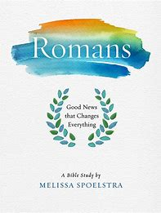 Let Betty know if you need a book for this study. We would love to have you.**

**Men’s Bible Study, meets Thursdays @ 6:30pm and will start back up in August. They will be studying Before Amen by Max Lucado.** 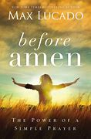

**Keep an eye out for announcements on our next studies. We would love to have you!**

 **July**

1st – Dale Stahl 2nd – Eleanor Yoss

8th – Nancy Booth 10th – Matt Seiler

13th – Tina Richards 13th – Sandy DiMascio

15th – Danny Keifer 16th- Dana Dysinger

20th- Lisa Hartman 23rd- Fred Winkler

24th- Ty Ramsier 25th- Bailey Yoss

27th- Bob Hartman

 **July**

1st – Joe & Holly Staley 11th – Mike & Debbie Knapic

14th – Brent & Sarah Edington

29th – Butch & Nancy McMillan

I hate it when I can’t figure out how to operate the iPad and my tech support person is asleep. He’s 5 years old and it’s past his bedtime.



Ruthie's retirement has forced us to speed our plans up a bit and work at a plan that we think can work for us and our sister church, Orrville Trinity, whose pastor was moving to a larger church that was in need of a pastor. I am reminding you that you are still needed to help answer the call to make disciples with your prayers, your presence, your gifts and your service. We must all be in God's service to make this happen here and now in Rittman. Join me in keeping on keeping on!

Blessings,

 Martha Baillis. Finance Chair

**Mary’s Meanderings**

The 54th session of the East Ohio Annual Conference is in the books.  It was attended from our church by Pastor Ruthie, Betty Winchell and myself.  Pastor Ruthie had an extra day for clergy on Wednesday and Betty and I attended Thursday, Friday and Saturday.  It was my first time and it was like 3 days back at school or a new job.  It was at the John S. Knight Center in Akron, Ohio.  Thursday began with a worship service including Holy Communion.  Former clergy, spouses and laity leaders, and family members now in the Church Triumphant were recognized.  Next on the agenda was the Opening Business Session introducing resolutions and including instructions on how to work the voting devices.  This was followed by the Board of Trustee/Corporate Meeting and local church disaffiliation vote.  Nine churches are closing.  We can't focus on getting back to normal because "there was never a normal".  Our mission is yet alive.  Our African Dorm campaign made 1.5 million dollars.  It will house 90 female students per year who would otherwise not get to attend school.  The dormitory is scheduled to be completed this year.  There was another business session after lunch with an Episcopal Address for our Bishop Tracy S. Malone.  Next was a speaker on the Commission on the Status and Role of Women, followed by collection of an offering to be divided 1/3 to Heart 4 the City, 1/3 to Volunteers in Mission Teams, and 1/3 to the Bishop's Discretionary Fund.  Speakers spoke on Multicultural Ministries Movement and Equitable Compensation.

Friday began with morning worship with our District Superintendent Angela Lewis preaching, which we shared with our congregation last Sunday.  She spoke of David and how he personifies who the church is and who the church together is with one accord because of the presence of the Holy Spirit.  And how any movement begins with prayer and then goes out into the community.



*Fireside Chat*

Fireside Chat with the Finance Chair

Dear Friends,

Have you ever started a project that never seems that it gets done when you're done? Let me give you an example. Ken and I had ideas about what we could do around our house to make it truly ours. First, we put in our vegetable garden. After the first little one, bigger was better and we needed to make a compost bin for all the scraps of yard waste. We liked the blueberries that the former owner put in for decoration and color in the back corner of the yard, but the tree mixed in with them had to go because it shaded the blueberries. I've come to the conclusion that gardens make better friends than tall fences. I can still see Ken and Bob Frase taking a break from gardening out back, leaning on their hoes exchanging gardening tips; or Judy's dad, Gene, coming up with just the right tool to solve the tree in the berry patch problem when he saw Ken’s was not doing the job.

We liked to sit on the patio outside the family room and eat supper or just sit and talk until the bugs started eating us. We bought a "shade house" that solved the bug problem but it didn't fit on the patio very well and made mowing and getting to the grill harder. So, we decided to build a deck with easy access to the patio doors (no steps down which had been a problem in using the patio when Ken's mom lived with us). We put that on hold when we bought our motor home and made our trip out West. Ken's health began to deteriorate and that became the center of our attention, but we still dreamed about the next step in the big plan.

After his death I began to work on finishing the plan so I could take care of it on my own. The big bushes around the house had to go. Ken could reach them to trim them but I couldn't. Andrew and Connie borrowed her dad's truck and a chain and pulled them out in the front. That left a clean slate. It also left signs that the aluminum siding needed help. Replacing that was added to my list of things to do. I have spent the last 6 or 7 years now on the project and I think the outside is almost completed. A.J. and I have one more project for the patio and that is putting the second bench (We did the first one in May) together. The landscaper I have been working with is satisfied that I can now take care of things myself until the next tree trimming is due.

So, what does this have to do with our church? Well, we had big plans and then Covid came along and we have had to sit back and re-plan where we are going with our finances in light of reduced numbers in active members. Our goal to make disciples for Christ and to reach out in our community to do this has not changed, but how we can best do this is still evolving.

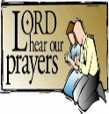 **Joys**

Welcome Pastor Kristen

Congratulations Pastor Ruthie

Brenda Cook – improving

Hannah and those on the Spain Mission Trip

Annibale & Mohr families, Mary Lynn – improving and healing

Anita Vohar continues improving

Safe travel for many!

**Concerns**

Nancy Mc. – in Wadsworth Altercare

Pastor Ruthie – pain & recovery

Celia T. – heart surgery, in ICU

Claire (Brenda Cook’s granddaughter) – healing from surgery

Laiken (Sheila Stoll’s great-granddaughter) – diagnosed with Type 1 diabetes

Fall Women Rekindled Day Lucy S. – back & neck

Judy King (Becky’s mom) Ken Zollinger – health

Dave Smith’s mother, Mary – recovery from cancer surgery

Tom W. (Pam H’s caseworker) - cancer

Josie Denham – heart problems

Dale S. brother-in-law – stage 4 cancer

Denny Vadini (Carol & family) – cancer

Chris B.’s father – Hospice care Vicky, Mary W.’s ex-sister-in-law – cancer

Margaret Moedt’s great- nephew – surgery recovery

Dick D. – ICU Donald S. - cancer

Anita (& Don) Vohar – health, continued recovery

Harry & Nancy Britton - health

Richard Isaac (former crossing guard) - health

Sheila Stoll’s friends Gary & Cindy – facing serious illness

Pastor Don’s Mom - health Duane Smith

Paula Burkhart - health Ana McClain’s Grandpa Tim

Pam Hartman – dialysis treatments Those with RSV, Flu, & Covid

Leigh Litman’s sister, Loretta – recurrence of cancer

Pat Meglich & Robin Kirkhart - health

Dorothy & Dick Gillman John Lunter Pat Seiler

Lovell, Bruce Lindenmuth’s sister – cancer

Debbie Baker (& her husband, Rev. David Baker) – stroke recovery & cancer Dick Baker –dialysis treatments

Pastor Joyce Williams (& Jack) – cancer

Disaster & Violence victims Traveling mercies

Ukraine/Russia War Our country & area communities

**Our sympathy to family & friends of:**

Dick Davis – Bruce L’s. friend

Garry Moore – Pam H’s father

**Those in Care Centers**

*Altercare Wadsworth – Nancy McMillian*

*Apostolic Christian Home -* Anne Salyer, & Ruth Schumacher

*Autumnwood Care Center -* Marcy Taylor

*Liberty Residence II -* Pauline Rastorfer

*Windsor House @ Doylestown -* Paula Burkhart

*Wooster* *Brookdale Senior Living* - Marilyn Hofacre



I decided to quit calling the bathroom “John” and re-named it “Jim.” I feel so much better saying I went to the Jim this morning.

**Trustee’s Corner**



Items since last month:

* Matt McClain planted out Japanese maple trees by entryway – Professional Job!
* Cleaned old records and boxes from preschool playroom closet to accommodate new flooring – Ruthie, Joanna, Sheila & Larissa.
* Installed (10) new 10-year smoke detectors in parsonage.
* Rod repaired one lavalier system & purchased two new transmitters; now have (4) systems, both lapel & earpiece microphones.
* Bob Hopton cleaned & waxed social hall kitchen floor.
* Rufeners installed new flooring & baseboard in preschool playroom & both restrooms - $3,390, cost covered by preschool grant.
* J & M Stump grinding removed both entryway stumps, $115; spread dirt & chips, seeded the area.



Be decisive. Right or wrong, make a decision. The road is paved with flat squirrels who couldn’t make a decision.



**“Christ Shares A Meal”**

**Our June Food Pantry/Community Dinner went really well. We had 27 families (3 new families), 65 people, and 31 sets of food.**

**We are so grateful for all who provide food, and those who come and do all that is needed.  It is difficult for a few to do it all. The next Food Pantry/Dinner is Wednesday, July 19th from 4:00-5:30 p.m. Clean-up lasts for as long as we have work to do. However, currently, the majority of our helpers are members of our choir & praise band, so they have to leave no later than 6:00 to practice, so we need others to stay if the clean-up isn’t finished. The more helpers we have, the less time is taken to do the work! We have a great time of fellowship & food through this time of service, too!**

**Thank you very much for the donations of empty containers for take home food from church dinners.**

**The supply is very good. No more are needed at this time.**

“If My people who are called by My name will humble themselves, and pray and seek My face, and turn from their wicked ways, then I will hear from heaven, and will forgive their sin and heal their land.”

**2 Chronicles 7:14**



Father,

We seek Your sovereign blessing on our nation. Forgive us for our shortcomings and for the times when we have failed you. Draw us back to Your love and strengthen us as a nation to serve and honor You in all that we do. May we forever be faithful to the calling that You have given us. We respectfully and humbly give thanks for Your continued blessing.

Jack Countryman

Publisher – Thomas Nelson

From “If My People” Booklet

Children’s Message

**Sunday, July 5th, 2020**

**Pastor Ruthie Trigg**

This is the weekend that we celebrate the freedom that we have in the United States. It has been won by the many men and women who have fought for it. Our country was declared free in 1776 on July 4th by the signing of the Declaration of Independence. Independence is another word for freedom. We were free from the control that England had over us. And military people continue to fight for our freedom. There are some that die fighting, and that is the price for our country’s freedom. That’s a very high price to pay.

But we have an even more important kind of freedom. Do you know who gives us freedom from sin? … It is Jesus. He died so that we could be free from sin. And His life is price for our personal freedom. That’s an even higher price, because His life was the life of God’s Son.

When we accept Jesus into our hearts, we are to do our best to live the way that He would live. If we do that, we won’t do wrong things, and we can show Jesus that we are thankful for the price that He paid for us. We can also be thankful that Jesus came back to life, so that we can have life forever with Him.

**Let’s pray…**

Dear God,

We thank you for the price that was paid for the freedom of our country, for those men and women who gave their lives so that we can be free. And thank you for Jesus, Your Son, and the price that He paid by dying on the cross for our freedom. And thank you for bringing Him back to life so we can live forever with Him. In Jesus’ name we pray, Amen.

***A Tribute to Dan Baker:***

When I think back to my younger years of attending Youth Fellowship or fondly known as “YF,” I had such a wonderful experience learning about Christ with my peers which was led by an exuberant adult- Danny Baker.  I remember being allowed to call him Danny instead of Mr. Baker.  I remember the perfect combination of planned activities, such as games or playing shuffle board in the fellowship hall, and then heading to the “llama room” for worship in song, prayer, and a lesson.  Danny always had his guitar and we sang songs like *It Only Takes a Spark*and *They Will Know we are Christians by Our Love*.

We learned about serving others by making cookies and creating cards for shut-ins, fundraising through paper drives on Saturday mornings- filling his little blue Honda full of old newspapers, and annual overnight Rock-a-Thons.  We all loved the “longest sundae” made in a roofing gutter.

There was no idea too big for Danny.  He was willing to try just about anything that we youth, were excited to plan.  We would discuss the idea 9 months in advance, begin organizing 9 weeks before the event, gather materials in 9 days, panic in 9 hours, and execute success in 9 minutes every time.  He had a way with things coming together and facilitating people working together.

God blessed Danny with so many gifts in which he used well to glorify and serve our Lord.  He blessed so many of us and helped to mold and shape us to use our gifts to continue the work that he began so long ago.  Thank you, Danny Baker for your dedication, endless patience, and for modeling how much joy it brings to be a disciple and servant for Christ.

 -*Sandy Gasser*

**Stewardship of Civility – Rob Blezard**

There used to be a wise saying about arguments that helped keep things civil. One party or the other would say, “I disagree with what you say, but I defend with my life your right to say it.”

That sounds downright quaint in today’s climate, where partisans are more likely to say, “I disagree with what you say, and you are evil and have no right to that opinion!”

This month, as we celebrate Independence Day, we can relish the freedoms we take for granted, including freedom of speech, religion, and assembly.

At the same time, as Christians we remember Jesus’ commands not only to love our neighbors as ourselves (Mark 12:31) but also to do unto others as we would have them do to us (Matthew 7:12). The “neighbors” and “others” certainly include those who hold different ideas on issues of the day.

How can we celebrate our freedom of expression in the context of Jesus’ commands?

* Listen carefully, being open to another person’s ideas.
* Respond thoughtfully and calmly, citing facts to support your argument.
* Do not attack the person, only the ideas.
* If things get too heated, discontinue the discussion.
* Remember the wise old saying, “I disagree with what you say, but I defend with my life your right to say it.”

Thanks goes to the 7 ladies who helped with the historical materials of our church: sorting, organzing, and packing in more secure boxes. This was done in 2 mornings this month in the basement’s sewing room. Doing this was Joanna S., Dana D., Robin R., Dee F., Sharon C., Martha B., and Sheila S. The week before, Pastor Ruthie and Joanna S. removed the boxes from the shelves in the pre-school’s playroom and took them to the basement. Our church’s history on paper is stored away for another 90 years.

We are stewards of our relationships with our neighbors. As followers of Jesus, we can be stewards of civility and lead our country to calmer, more amicable times.

*Copyright ©2023 Rev. Robert Blezard. Reprinted by permission. Pastor Blezard works as content editor for* [*www.stewardshipoflife.org*](http://www.stewardshipoflife.orgs) *and serves as pastor of St. Paul’s Lutheran Church, Aberdeen, MD.*

**A Church Garden:**

**Three rows of squash**

1. Squash indifference.
2. Squash criticism.
3. Squash gossip.

**Four rows of turnips**

1. Turn up for meetings.
2. Turn up with a smile.
3. Turn up with a visitor.
4. Turn up with a Bible.

**Five rows of lettuce**

1. Let us love one another.
2. Let us welcome strangers.
3. Let us be faithful to duty.
4. Let us truly worship God.
5. Let us give liberally.

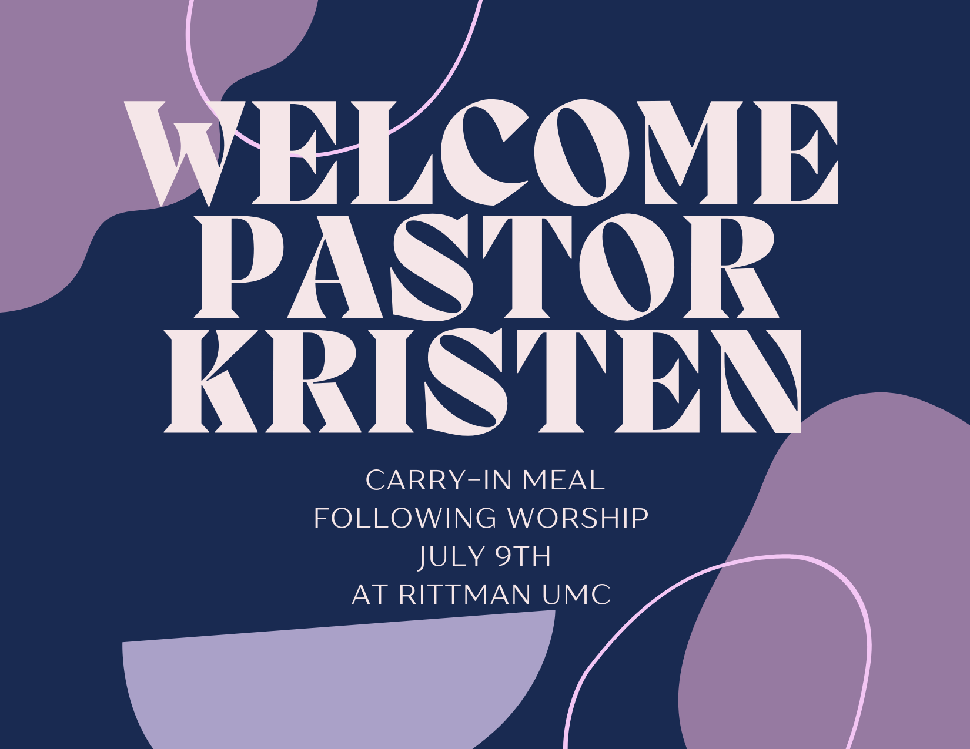

Welcome

**Announcements /** **Keep Watch**

**Don’t forget to fill out your Contact Information Update Packet and return it to the office!**

**Link to fill it out online**: <https://forms.gle/13gzRsRwtL6EKTpe6>

**July 2nd**: Pastor Kristen Buchs’ First Sunday

**July 9th**: Carry-in Welcome Party for **Pastor Kristen** after church

**October 21st**: 8 a.m. Check-in, 9:00 a.m. start –

Women Rekindled

with speaker Robyn Dykstra

Pastor Kristen Buchs

**Full-Time Local Pastor**

**Personal Background**

Kristen is very close with her family, including her parents and her sister’s family.

**Education**

Currently in Course of Study

**Missional Match**

Experience in multi-point assignments

Passionate about Mission & Outreach

Demonstrated gifts of Pastoral Care

**Appointments**

Sycamore & Union Salem (FL) 2018-2021

Clarksfield & New London (FL) 2021-Present

**Theology**

I struggle in finding my own words to adequately express my theology, so I borrowed the words of some of my favorite theologians: John Wesley: “In essentials, unity. In non-essentials, liberty. In all things, charity.” Brennan Manning: “Define yourself radically as one beloved by God. This is the true self. Every other identity is illusion. God’s love for you and his choice of you constitute your worth. Accept that, and let it become the most important thing in your life.” AND “The greatest single cause of atheism in the world today is Christians; who acknowledge Jesus with their lips, walk out the door, and deny him by their lifestyle. That is what an unbelieving world simply finds unbelievable.” Dietrich Bonhoeffer: “Salvation is free, but discipleship will cost you your life.” Henri Nouwen: “Jesus calls us to seek unity in and through Him. When we direct our inner attention not first of all to each other, but to God to whom we belong, then we will discover that in God we also belong to each other.”

** July**

**Sunday Monday Tuesday Wednesday Thursday Friday Saturday**

|  |  |  |  |  |  |  |
| --- | --- | --- | --- | --- | --- | --- |
|  |  |  |  |  |  | **1** |
| **2 Holy Communion**  **Pastor Kristen’s 1st Sunday**  *9:00am –*  Sunday School  *10:30am* –  Worship Service | **3** | **4**  **OFFICE CLOSED**  ***HAPPY 4TH OF JULY*** | **5**  *11:00am* – Prayer Circle  **@ home**  *6:30pm* – 2:11 N. Practice | **6**  ***NO***  **Women’s & Men’s**  **Bible Study** | **7** | **8** |
| **9 Pennies from Heaven**  *9:00am –*  Sunday School  *10:30am –*  Worship Service  Carry-in dinner for Pastor Kristen after service | **10** | **11**  *6:30pm* –  Prayer Circle  **@ home**  ***7:00pm* – Admin.**  **Council Mtg.** | **12**  *11:00am* – Prayer Circle  **@ home**  ***NO* 2:11 N Practice** | **13**  ***NO***  **Women’s & Men’s**  **Bible Study** | **14** | **15** |
| **16**  *9:00am –*  Sunday School  *10:30am –*  Worship Service | **17** | **18**  *6:30pm* –  Prayer Circle  **@ home**  ***6:30pm* – Food Pantry Setup** | **19**  *11:00am* – Prayer Circle  **@ home**  ***4-5:30pm – Food Pantry/Community Dinner***  ***NO* 2:11 N Practice** | **20**  ***NO***  **Women’s & Men’s**  **Bible Study** | **21** | **22** |
| **23**  *9:00am –*  *Sunday School*  *10:30am –*  *Worship Service* | **24** | **25**  *6:30pm* –  Prayer Circle  **@ home**  ***7:00pm*** –  **Trustee’s Meeting** | **26**  *11:00am* – Prayer Circle  **@ home**  ***NO* 2:11 N Practice** | **27**    ***NO***  **Women’s & Men’s**  **Bible Study** | **28** | **29** |
| **30**  *9:00am –*  *Sunday School*  *10:30am –*  *Worship Service* | **31** |  |  |  |  |  |



**How many people signed the Declaration of Independence on July 4th?**

2 men:

1. John Hancock, President of Congress
2. Charles Thompson, Secretary of Congress

The others signed August 2, 1776.

**Offering Tabulators**

**Dale Stahl**

**Lydia Stahl**

Rittman United Methodist Church

211 North Metzger Avenue

Rittman, OH 44270

Return Service Requested

**POINTS to PONDER**

**July 2023**

Vol. 55 No. 7

Kristen Buchs, Pastor

www.rittmanumc.org

**330-925-4015**

pastor@rittmanumc.org

office@rittmanumc.org

**UPCOMING EVENTS**

***Sun. July 2:* Pastor Kristen’s 1st Sunday**

***Tue. July 4th* OFFICE CLOSED**

**HAPPY 4TH OF JULY**

***Sun. July 9th:* Carry-in Dinner for Pastor Kristen after worship service**

***Tues. July 11th: 7:00pm* – Admin. Council**

**Meeting**

***Tue. July 18th: 6:30pm* – Set-up for Food**

**Pantry/Community Dinner**

***Wed. July 19th: 4*-5:30pm – Food Pantry /**

**Community Dinner**

***Tue. July 25th:* 7:00pm – Trustee’s**

**Meeting**

**Sunday School** **@ 9:00am**

**Fellowship @10:00am**

**Worship Service @ 10:30am**

**Office Hours**

8:30am – 1:30pm

Mondays -Thursdays

*Living Our Faith through Word and Action*



Blessed is the nation whose God is the Lord!

Psalm 33:12

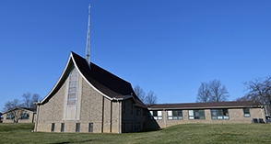

***Rittman United Methodist Church*** Points to Ponder – July 2023

Volume 55 – Issue No. 7

Kristen Buchs, Pastor

Becky King, Larissa Richards, Sheila Stoll – Editors

**Old Ragged Flag – by Johnny Cash**

I walked through a county courthouse square, on a park bench, an old man was sittin' there. I said, "Your old court house is kinda run down.” He said, "Naw, it'll do for our little town.” I said, "Your old flag pole is leaned a little bit, and that's a Ragged Old Flag you got hangin' on it.”

He said, "Have a seat,” and I sat down. "Is this the first time you've been to our little town?" I said, "I think it is." He said "I don't like to brag, but we're kinda proud of That Ragged Old Flag."

“You see, we got a little hole in that flag there when Washington took it across the Delaware. And it got powder burned the night Francis Scott Key sat watching it writing ‘Oh Say Can You See’. And it got a bad rip in New Orleans, with Packingham & Jackson tugging at its seams.”

“And it almost fell at the Alamo beside the Texas flag, but she waved on though. She got cut with a sword at Chancellorsville, and she got cut again at Shiloh Hill. There was Robert E. Lee and Beauregard & Bragg, and the south wind blew hard on That Ragged Old Flag.”

“On Flanders Field in World War I she got a big hole from a Bertha Gun. She turned blood red in World War II. She hung limp and low by the time it was through. She was in Korea, Vietnam. She went where she was sent by her Uncle Sam.

She waved from our ships upon the briny foam. And now they've about quit wavin' back here at home. In her own good land here she's been abused, she's been burned, dishonored, denied and refused.

And the government for which she stands is scandalized throughout out the land. And she's getting threadbare wearin' thin. But she's in good shape, for the shape she's in. ‘Cause she's been through the fire before and I believe she can take a whole lot more.

So we raise her up every morning, take her down every night. We don't let her touch the ground, and we fold her up right.

On a second thought, I DO like to brag,

'Cause I'm mighty proud of that ragged old flag.”

**Submitted by Reah Lunter in 2017**