by talking to Him or showing hospitality to Him. We can hear His voice through reading Scripture. "If the Spirit's words never wound us and then heal us, we are not hearing His voice." We can heed the Holy Spirit by taking His promptings to apply a specific part of Scripture to a specific part of our life. We will seek to do good and avoid what God hates so as not to offend Him. The Holy Spirit comes to give us grace, which we in turn extend to others. With His Spirit indwelling us we can have heaven's happiness in life, no fear of death, and happiness with Him for eternity.
So, I am eternally grateful to the Holy Spirit of the living God for taking up residence in a mere mortal such as myself and for inspiring much-needed work to be done, and for providing pleasant weather for a celebration.

Administrative Council Meeting Highlights
(You can find the full Administrative Council Meeting packet on the hallway bulletin board by the office.)
SPRC: (Mary W.)
- Still working on Pastoral Transition Checklist notebook.
- Pastor Ruthie's Retirement Open House was held Sunday, June 25 from 2 pm – 4 pm.
- We welcomed Pastor Kristen Buchs with a Carry-in Dinner on Sun., July 9 after the worship service.
- Becky King has officially ended her employment here.
- Mary W. made a motion that we hire Larissa Richards as church secretary. As of August 1, 2023, Larissa will work 8 am-1 pm Mon-Fri. The motion was approved.
- Charge Conference will be Sat., October 28. More info to follow. Paperwork for the conference is due to District Office by October 1.

Finance: (Sherri/Joanna)
- To see the approved Finance Reports, check the Administrative Council packet on the Bulletin Board in the hallway by the office.
Pastor Kristen:
- Offered list of sermon titles/themes/hymns/scripture with the right to change.
- Asked us to think about one combined service with Orrville at 10 AM in months with 5 Sundays which adds up to 4 times at the most.
- Will be at Open M for an Open House on August 19.
- Will be on vacation on Sun., August 20.
- Will be at Lakeside Mon.- Thurs. on August 20-23 at a meeting of Local Pastors.
- Will share more on Love Inc. of Wayne County as she learns more.
Preschool: (Betty W.)
- Spending the rest of the grant and putting stuff in place.
Missions: (Martha B.)
- Updating missionaries on bulletin board map.
Funeral Dinners: (Joanna S.)
- Needs someone to take leadership of the committee.
Inspections: (Betty W./Bruce L.)
- Who inspects fire extinguishers and fire alarm? Bruce will check on the requests.
Adjournment
- Remember Joyce Williams in prayer. She is still in the hospital and was unable to complete surgery. She is physically, emotionally, and spiritually drained.
- Next meeting will be Tuesday, August 8, 2023 @7:00 pm. Everyone is invited!
- Joanna Shankland as substitute secretary
Bible Studies

A group of women meet on Thursdays at 6:30 p.m. and are led by Betty Winchell and Sara Ullman.
There is always room for more to attend!

Titles of current & upcoming studies:

Our study on Romans will start in August. Let Betty know if you need a book for this study. We would love to have you.

Men’s Bible Study meets Thursdays @ 6:30 p.m. and will start back up in August. They will be studying Before Amen by Max Lucado. 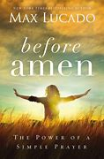
Keep an eye out for announcements on our next studies. We would love to have you!
Three Simple Rules:
- Do good.
- Do no harm.
- Stay in love with God.

Yesterday – Today – Tomorrow

Mary’s Meanderings

This month is going to be brief because, once again, I am at the deadline. It was a gift to not have Women's Bible Study this month. As much as I love it, the time spent was used this month to catch up on projects at home. My son turned 40 in July and his wonderful wife planned a great party. They asked to have it at my home, which required me to step it up in housework and yardwork. Thankful for all their help, we put many hours into whipping it into shape. And our efforts were rewarded by a delightful birthday party. Different generations and people from my son's past and present blended nostalgia with the energy and enthusiasm of the children.

My writing this month was planned to be on the Holy Spirit. He moves at His will. People complain about spending time on the internet, but there is so much to learn and grow from the good information that is available and can counter all the negativity and tragic news that we are surrounded by daily.
Just a few gleanings from gems I found-We need to be sensitive to the Holy Spirit and learn to flow with Him. Flow is defined as, “to move freely from place to place in a steady unbroken stream, like a river.” The Holy Spirit flows wherever He pleases and does not belong to any one denomination. The Catholic Church, the mainline Protestant Churches, the Pentecostals, and the independent evangelical churches do not own the Holy Spirit.

If we are a born again, bought by the blood believer, the Holy Spirit is living inside of us. Can you even believe that? God Himself is at work and living within our spirit. Pretty sobering and gives pause to consider the words that come out of our mouths, the choices we make, and the actions we take. Richard Scribbs, one of the great Puritan theologians said when the Holy Spirit moves in "for a house for Himself, He doth also become unto us a counselor in all our doubts, a comforter in all our distresses, a solicitor to all duty, a guide in the whole course of life, until we dwell forever with Him in heaven, unto which His dwelling here in us doth tend." Scribbs goes on to say that we can entertain the Holy Spirit

Fireside Chat

Fireside Chat with the Finance Chair
Dear Friends,
Don't forget your church giving when you go on vacation. Our bills still come in the summer even if you don't. We've done well since the first of the year and kept the checking account from going in the red. We don't want to change that now.
Now I want to talk to you with my second hat on. There was a time when Ken was serving here in 1985-1990 when a large part of our budget was missions. Now all of those missionaries have retired and passed the torch and missions are often passed on and supported by a few rather than the church as a whole. For the past several years, I have co-chaired the mission committee with Sandy Gasser and she has taken on most of the work for our local missions. One of the big things she has gotten us to be involved with is Christmas Shoe boxes for Samaritan's Purse. If you watched Christmas in July on Hallmark this past month you know the Christmas season will be here before we know it. School will soon be starting and it's time to shop for school and art supplies at discounted prices at Walmart and Target just to name two that are having sales in early August, and Ohio is giving a tax break one weekend on such supplies. I had a reason to go shopping recently in Kohl's and found "Elmo" of Sesame Street fame among the book characters in a rack by the checkout lines. He came home to go in a shoebox as a huggable "WOW" toy for a small child and was only $5.00. (I love a good bargain!) I no longer have to buy supplies for my children, but it is a good time to buy school and craft items and begin thinking about a "WOW" gift for a Christmas child's shoe box. If you can't do one by yourself, maybe you can join with a friend or two to make one. I have enjoyed shopping for these shoe box gifts and reading about the joy they bring to the children who get them. (See the Samaritan's Purse summer 2023 Prayer Point magazine on the Mission Bulletin Board outside the office - pages 36 - 41) The boxes to be filled aren't due to be presented in the church until late October or early November so you don't have to spend lots all at once if you are doing a box. Start now and spread it over several months. And have fun being a giving arm for Christ.
Martha Baillis.
for Missions and Finance Committees

August
1st – Sally Schwab 5th – Trevor Knapic
25th – Elizabeth Booth 27th – Larissa Richards

August
16th – Mickey & Joanna Shankland
17th – Barry & Shirley Youmans

Our days are identical suitcases – all the same size – but some people can pack more into them than others.

“Be very careful, then, how you live – not as unwise but as wise – making the most of every opportunity.”
Ephesians 5:15-16 (NIV)

Joys
Joyce W. updated off of hospice care!
Welcome Pastor Kristen
Hannah and those on the Spain Mission Trip
Annibale & Mohr families, Mary Lynn – improving and healing
Anita Vohar continues to improve
Safe travel for many!
Concerns
Dale S. – recovery from surgery
Pastor Joyce Williams (& Jack) – cancer & surgery recovery
Celia T. – heart surgery, in ICU
Claire (Brenda Cook’s granddaughter) – healing from surgery
Laiken (Sheila Stoll’s great-granddaughter) – diagnosed with Type 1 diabetes
Fall Women Rekindled Day Lucy S. – back & neck
Kathy (Heather R.’s friend) – breast cancer Ken Zollinger – health
Dave Smith’s mother, Mary – recovery from cancer surgery
Tom W. (Pam H’s caseworker) - cancer
Josie Denham – heart problems
Dale S. brother-in-law – stage 4 cancer
Denny Vadini (Carol & family) – cancer
Chris B.’s father – Hospice care Vicky, Mary W.’s ex-sister-in-law – cancer
Margaret Moedt’s great-nephew – surgery recovery
Dick D. – ICU Donald S. - cancer
Anita (& Don) Vohar – health, continued recovery
Can you name three consecutive days without using the words Wednesday, Friday, and Sunday?

Answer at the bottom of the Bible Studies page

Trustee’s Corner

Items since last month:
- Anchor Plumbing rebuilt the parsonage shower valve - $206.
- Sandy Gasser weedeated around the church, sign, and poles out front.
- Herb Jones sprayed weeds in shrubs multiple times.
- Brad Batdorf repainted social hall beams, labor & materials $3250.
- Dale & Lydia planted 22 hostas & lily plants along west social hall
- Prepped & painted both preschool restrooms; Lydia, Betty, BEL & grandson.
- Replaced sink faucets in women's/handicap restroom.

The carry-in dinner for Pastor Kristen was great – delicious food as always. Thanks to all who organized it.

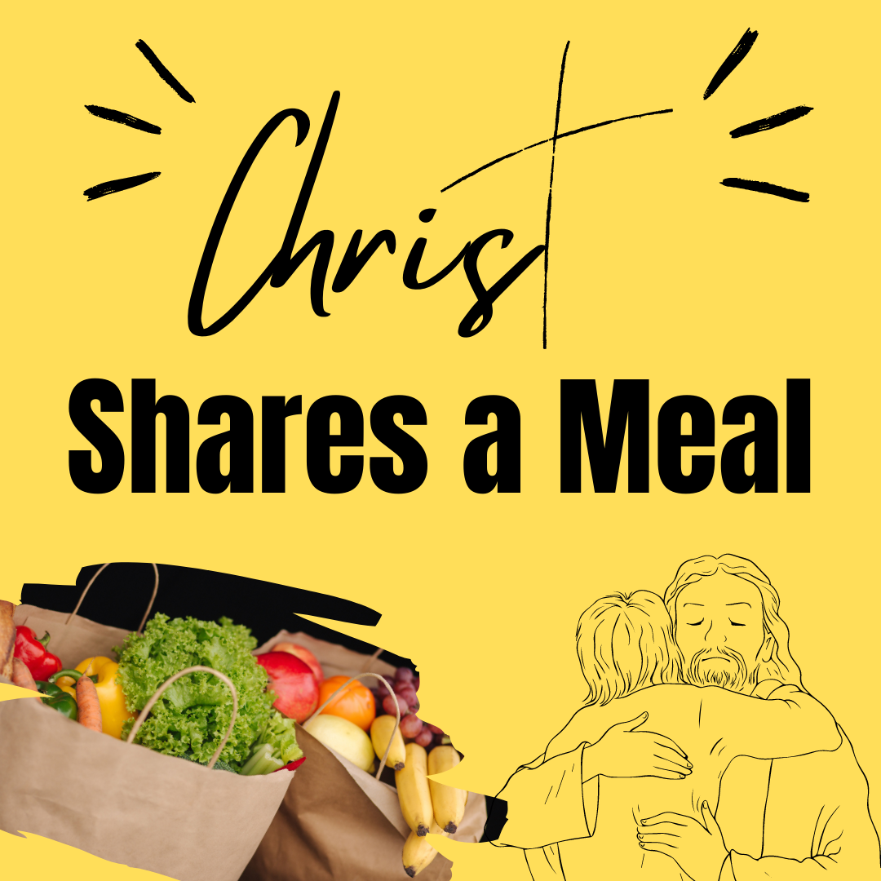
Food Pantry

Our July Food Pantry/Community Dinner went very well. We had 24 families (4 new families), 44 people, and 28 sets of food.
A special thank you goes out to everyone who showed up for the special meal this month. We appreciate everything you all have been doing for this ministry!
That being said, it is difficult for a few to do it all. The next Food Pantry/Dinner is Wednesday, August 16th from 4:00-5:30 p.m. Clean-up lasts for as long as we have work to do. However, currently, the majority of our helpers are members of our choir & praise band, so they have to leave no later than 6:00 to practice, so we need others to stay if the clean-up isn’t finished. The more helpers we have, the less time is taken to do the work! We have a great time of fellowship & food through this time of service, too!

Harry & Nancy Britton - health
Sheila Stoll’s friends Gary & Cindy – facing serious illness
Duane Smith – health Ana McClain’s Grandpa Tim
Pam Hartman – dialysis treatments Those with RSV, Flu, & Covid
Leigh Litman’s sister, Loretta – recurrence of cancer
Pat Meglich & Robin Kirkhart - health
Dorothy & Dick Gillman John Lunter Pat Seiler
Lovell, Bruce Lindenmuth’s sister – cancer
Debbie Baker (& her husband, Rev. David Baker) – stroke recovery & cancer Dick Baker –dialysis treatments
Disaster & Violence victims Traveling mercies
Ukraine/Russia War Our country & area communities
Our sympathy to family & friends of:
Linda Nolt – Rittman Cares Director

Those in Care Centers
Altercare Wadsworth – Nancy McMillian
Apostolic Christian Home - Anne Salyer, & Ruth Schumacher
Autumnwood Care Center - Marcy Taylor
Liberty Residence II - Pauline Rastorfer
Windsor House @ Doylestown - Paula Burkhart
Wooster Brookdale Senior Living - Marilyn Hofacre
“Do not be anxious about anything, but in every situation, by prayer and petition, with thanksgiving, present your requests to God.”
Philippians 4:6

Mosaic
Isaiah 57:15
For this is what the high and exalted One says—
he who lives forever, whose name is holy:
“I live in a high and holy place,
but also with the one who is contrite and lowly in spirit,
to revive the spirit of the lowly
and to revive the heart of the contrite.

Ryan Stevenson’s song “Mosaic” has such a beautiful message…
Sometimes we reflect on our mistakes and think it is impossible for God to save us. We have lied, we have hurt the people we love the most, or maybe have made a really bad decision.
We start to believe the lies that we tell ourselves:
“I have done too much for God to help me.”
“I am not worth God’s love.”
“God shouldn’t waste His time on someone like me.”
The Bible tells us a different story. You have messed up. We all have, but God will not leave you. God is with you. He will heal you. He forgives you.
There is beauty underneath the ashes of your decisions. There is redemption.
God will take every broken frame and shattered place in you. Instead of throwing you away, He cleans up every jagged shape and perfectly puts a work of art together.
By asking God for forgiveness, and forgiving yourself, you can become one of God’s perfect mosaics. He will shine His light through your fractured lines. And by doing so, you can shine His light on others. He will not waste a single experience that you have lived.
You are a brand-new creation. You are a colorfully, shining mosaic. Go and shine on others.
- Larissa Richards

That was the issue with the rich man in Mark 10:17-27. Deeply religious, he nonetheless worries about eternal life. The “one thing” he lacks, Jesus tells him, can be satisfied by selling what he has and giving to the poor. Generous giving would break the bond that money has over him and help re-center him on loving God and loving neighbor.
Generosity is the spiritual prescription Jesus gives the rich man, and it’s the one for us, too.
The primary goal of our church’s financial stewardship should not be to fund the church, but rather to break the chains that money may have on our hearts and souls. By giving generously we can help the church, our neighbor, and ourselves. We can learn what it is to be free to love God with all our hearts and our neighbor as ourselves.

Copyright ©2023 Rev. Robert Blezard. Reprinted by permission. Pastor Blezard works as Content Editor for www.stewardshipoflife.orgs and serves as pastor of St. Paul’s Lutheran Church, Aberdeen, MD.

Greater than Anything

“Great is the Lord and most worthy of praise;
his greatness no one can fathom.”
Psalm 145:3

So, you have a problem and you can’t think about anything else. Day and night that one thing is on your mind as you try to decide what to do about it. That one stressful thing affects every area of your life. You are so caught up in that, you can’t see any good anywhere else. Perhaps you have forgotten the truth in this verse – the God you worship, the God who loves you, is most worthy of praise – your praise.
Nothing is greater than He is. In fact, no one can begin to understand His greatness. He is greater than whatever problem you’re facing, so talk with Him about it and ask for His help. He can help – and He will.
Carolyn Larsen
Devotions for Women

speaks to the importance of educating our children, “Train up a child in the way they should go; even when they are old, they will not depart from it.”
God honors and supports our search for knowledge and wisdom. He is the source of all the wisdom we need to live life abundantly. We just need to ask Him for it as James 1:5 reveals, “If any of you lacks wisdom, let them ask God, who gives generously to all without reproach, and it will be given them.”
As we begin this school year, let’s ask God for His wisdom, guidance, and blessing on all our children and their parents, our teachers, our administrators, our bus drivers, and our staff as they begin their educational journey together!
- Pastor Kristen Buchs
The Problem (and Power) of Money
~By Rob Blezard
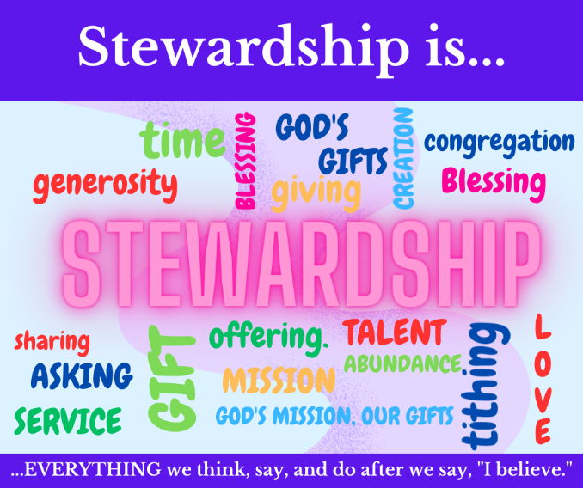
[Jesus told the rich man] “You lack one thing; go, sell what you own, and give the money to the poor, and you will have treasure in heaven; then come, follow me.” When he heard this, he was shocked and went away grieving, for he had many possessions. … [Jesus taught the disciples,] “It is easier for a camel to go through the eye of a needle than for someone who is rich to enter the kingdom of God.” –Mark 10:21b-22, 25

At a Bible study, a man of means asked, “Why does Jesus hate money so much?” His family saw their money as a good thing, and he earnestly wanted to understand why Jesus seems to speak negatively of wealth again and again.
In fact, Jesus talks about money more than nearly anything else. Interestingly, for all his talk about money, he never asks for it. And he never condemns it. Instead, Jesus warns us about the corrupting influence of money.
Wealth poses spiritual risks. Jesus teaches that money has the power to turn us inward – away from loving God with all our heart and loving our neighbor as ourselves. It confuses our values and direction.
All of us want full lives brimming with security, relationship, joy, peace, and love – but money can ensure us none of those things. They are the fruits of loving God with ALL our strength and of loving our neighbor as ourselves. Wealth can get in the way.

A Letter from Pastor Kristen

It is hard for me to believe that it has been a month and more since my move to Orrville to begin serving God, the congregations, and the communities of the two churches of my new appointment – Orrville Trinity and Rittman UMC.
I want to express my heartfelt thanks to all of you for welcoming me so warmly and whole-heartedly into your worship, your lives, and this beautiful church! You have no idea how you touched my heart with your overwhelming acts of kindness and love: the numerous cards I found waiting for me in my mailbox welcoming me and then wishing me a happy birthday, the abundant and delicious carry-in meal (and the leftovers provided to me afterward that fed me for three days!), the patience you’ve shown as I get to know how things are done here (you have a LOT going on!) and as I get to know you AND your names (thank you for wearing the name badges!), the information you’ve shared in answer to the multitude of questions I’ve asked (and there will be more to come!), all the advance work put in by the transition and leadership teams to make the change in pastors as smooth and as painless as possible, the ready words of encouragement and support and the smiling faces that greet me whenever I walk into a room, a meeting or an event.
I am so tremendously blessed by God and by all of you! Thank you, again, for welcoming me and accepting me as you have while I get to know all of you. I believe our journey together is off to a good start – thanks be to God! And I can’t wait to see what He has planned for us to do as our journey together with Him continues in the months ahead.
Love in Christ,
Pastor Kristen
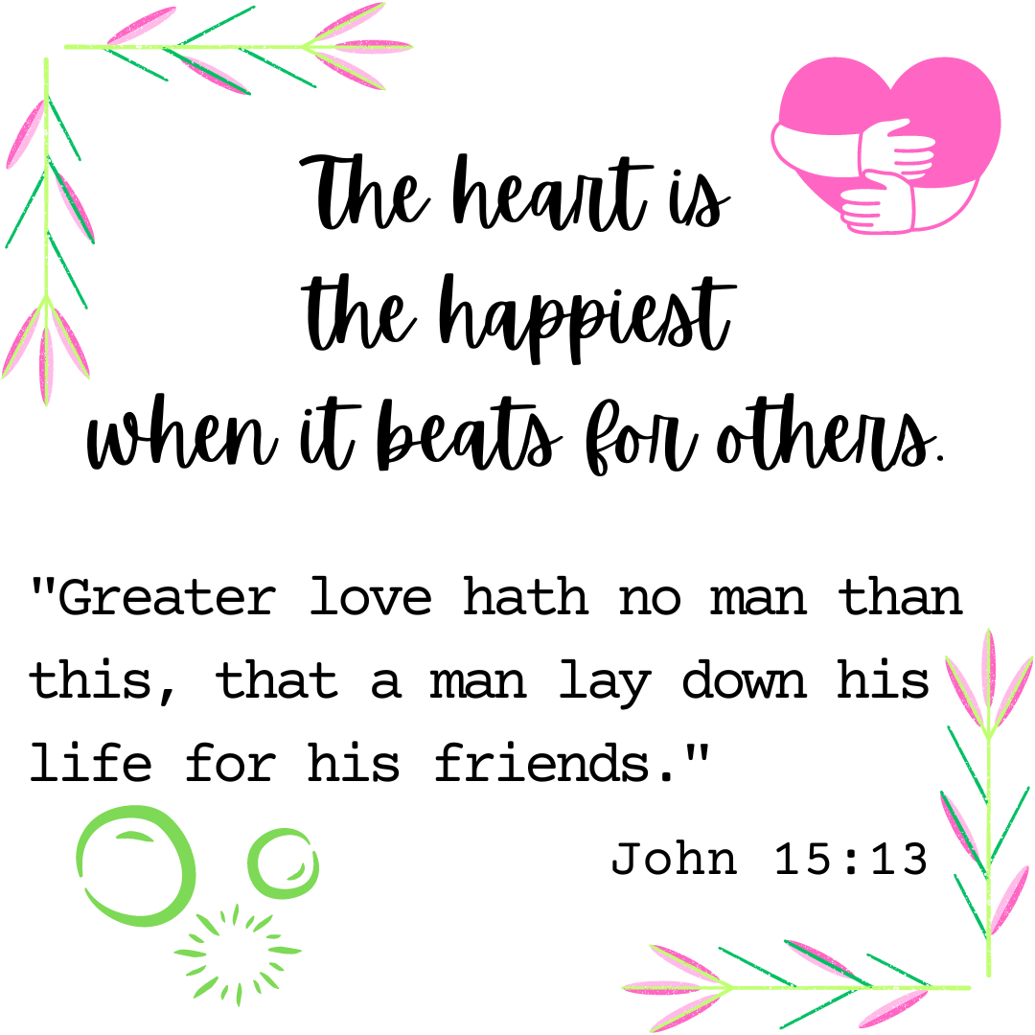

Announcements / Keep Watch
Office hours will be changing starting August 1st. We will be open Mondays-Fridays, 8 a.m. – 1 p.m.

Don’t forget to fill out your Contact Information Update Packet and return it to the office!
Link to fill it out online: https://forms.gle/13gzRsRwtL6EKTpe6

August 8th: 12-6 p.m. Red Cross Blood Drive

August 29th: SPRC / DS Consult Paperwork Due

October 21st: 8 a.m. Check-in, 9:00 a.m. start –
Women Rekindled
with speaker Robyn Dykstra

It’s getting to be that time of year again! The time when yellow buses appear weekday mornings and afternoons, 20 MPH school zone lights are flashing, and crossing guards don their neon vests. When pencils, pens, binders and backpacks overflow their usual aisle and demand a section of their own at the store. When parking lots, vacant all summer, are packed with vehicles and empty playing fields are suddenly alive with people and activity. It is a time of new beginnings, new opportunities, and new friendships. A time of anticipation, excitement, and challenges. Yes, school will soon be back in session for the 23/24 term!
I was one of those kids who loved going back to school in the Fall! I could spend hours shopping for school supplies – searching for the perfect lunchbox, color-coordinated folders and notebooks for each class, finding the best pencil case and the pens, pencils and markers to fill it. Then it was time to search for the outfit that would make just the right statement and create the perfect first impression I wanted to make on the first day of school… I am blessed with two of the most patient parents who ever lived!
I don’t think we truly appreciate school until we leave it. What a gift to be able to spend so many hours each day focused on learning, on acquiring knowledge, wisdom, relationship skills, and life experience that will benefit us for the rest of our lives! There is a difference between knowledge and wisdom - knowledge gives you information; wisdom tells you what to do with it.
The Bible has much to say about the importance of education, knowledge, and wisdom. Ecclesiastes 7:12 says, “For the protection of wisdom is like the protection of money, and the advantage of knowledge is that wisdom preserves the life of the one who has it.” Proverbs 19:20 tells us to “Listen to advice and accept instruction, that you may gain wisdom in the future,” and Proverbs 22:6

August
Sunday Monday Tuesday Wednesday Thursday Friday Saturday
Offering Tabulators

Lori Ullman
 |  | 1  Office Hours Change  6:30pm –  Prayer Circle  @ home | 2  11:00am – Prayer Circle  @ home  6:30pm – 2:11 N. Practice | 3  6:30pm – Men’s & Women’s Bible Studies | 4 | 5
6 Holy Communion  9:00am –  Sunday School  10:30am –  Worship Service | 7  7:00pm – SPRC Meeting | 8  12-6pm – Red Cross  Blood Drive  6:30pm –  Prayer Circle  @ home  7:00pm – Admin.  Council Mtg. | 9  11:00am – Prayer Circle  @ home  6:30pm – 2:11 N. Practice | 10  6:30pm – Men’s & Women’s Bible Studies | 11 | 12
13 Pennies from Heaven  9:00am –  Sunday School  10:30am –  Worship Service | 14 | 15  6:30pm –  Prayer Circle  @ home  6:15pm – Preschool  Board Meeting  6:30pm – Food Pantry Setup | 16  11:00am – Prayer Circle  @ home  4-5:30pm – Food Pantry/Community Dinner  6:30pm – 2:11 N. Practice | 17  6:30pm – Men’s & Women’s Bible Studies | 18 | 19
20  9:00am –  Sunday School  10:30am –  Worship Service | 21 | 22  6:30pm –  Prayer Circle  @ home  7:00pm –  Trustee’s Meeting | 23  11:00am – Prayer Circle  @ home  6:30pm – 2:11 N. Practice | 24  6:30pm – Men’s & Women’s Bible Studies | 25 | 26
27  9:00am –  Sunday School  10:30am –  Worship Service | 28 | 29  SPRC / DS Consult Paperwork Due  6:30pm –  Prayer Circle  @ home | 30  11:00am – Prayer Circle  @ home  6:30pm – 2:11 N. Practice | 31  6:30pm – Men’s & Women’s Bible Studies

Rittman United Methodist Church
211 North Metzger Avenue
Rittman, OH 44270
Return Service Requested

POINTS to PONDER
August 2023
Vol. 55 No. 8
Kristen Buchs, Pastor
www.rittmanumc.org
330-925-4015
pastor@rittmanumc.org
office@rittmanumc.org

Sunday School @ 9:00am
Fellowship @10:00am
Worship Service @ 10:30am
UPCOMING EVENTS
Tue. Aug. 1st: Office hours change to
Monday-Friday, 8 a.m. – 1 p.m.

Mon. Aug. 7th: 7:00pm – SPRC Meeting

Tues. Aug. 8th: 12-6pm – Red Cross
Blood Drive
7:00pm – Admin. Council
Meeting

Tue. Aug. 15th: 6:15pm – Preschool Board
Meeting

Tue. Aug. 15th: 6:30pm – Set-up for Food
Pantry/Community Dinner

Wed. Aug. 16th: 4-5:30pm – Food Pantry /
Community Dinner

Tue. Aug. 22nd: 7:00pm – Trustee’s
Meeting

Office Hours
8:00 a.m. – 1:00 p.m.
Mondays – Fridays

Living Our Faith through Word and Action

LET GOd work!

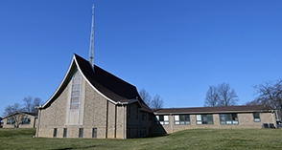
Rittman United Methodist Church Points to Ponder – August 2023
Volume 55 – Issue No. 8
Kristen Buchs, Pastor
Larissa Richards, Sheila Stoll – Editors

“And then You shine Your light through my fractured lines. Nothing was wasted. You made a mosaic. A fascinating sight in my Father's eyes, a brand-new creation. You made a mosaic!”
-Ryan Stevenson, “Mosaic”

