their head in front of the pop counter today." If it didn't happen, he was going to kill himself that night. It is okay to ask God to make Himself known.
We have the Old Testament, the New Testament, and the You Testament. When something goes well say "Isn't God so good?" People will generally agree. Just tell them what God has done in your life. It's not our job to save others. It's our job to plant seeds. Throw seeds
around. We can go ahead and ask for blessings. What God gives to us takes nothing away from others. An experience of victory gives us courage and confidence.
The Northside Praise Band was amazing and we had the privilege of hearing the personal testimonies of two of the singers, one whom we have been praying for at our church since her devastating diagnosis of inoperable brain cancer. We are beyond grateful for them to step in when our own praise band was not going to be available. We are thankful to everyone in our church who supported us and helped us in this endeavor. We have a clean and better organized building, Yay! We had a total of 108 in the building that day who either attended, were vendors, in the band, or manned the kitchen.
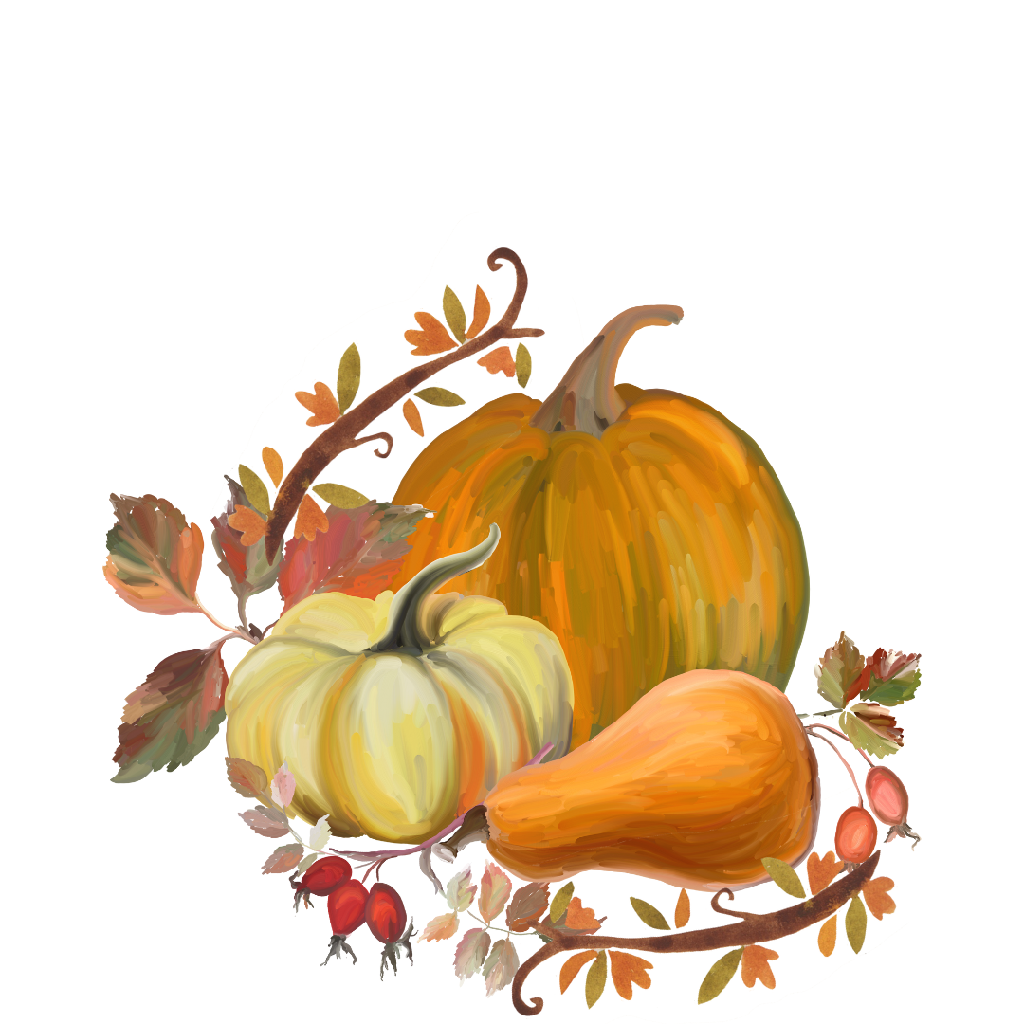
We have posted comments from the attendees in the narthex of the church. None of which could have been more well-spoken than the one Pastor Kristin shared from a member of our sister church in Orrville which stated "Thank you for the most organized, thought out, decorated, detailed event I have had the pleasure of attending. I was blessed in many ways and so glad I was able to go. God is so good." And one from a member of our church "Brenda could open a decorating supply store."
Set my soul afire, Lord, and renew the love I had for you in the beginning. Rekindle the gift of God that is within you. 2 Timothy 1:6a

Administrative Council Meeting Highlights
(You can find the full Administrative Council Meeting packet on the hallway bulletin board by the office.)
Finance: (Sherri L. / Joanna S.)
- You can find the full financial report in the meeting packet on the hallway bulletin board
Pastor Kristen:
- All Saints Sunday will be pushed to November 5th.
  - We will also be having communion and two baptisms this day.
- Pastor Kristen will be in Delaware, Ohio for class on October 13th and 14th.
- Monday, November 20th at 7 p.m., RUMC will be hosting the Community Thanksgiving Service.
  - The Ministerial Association would like a meal of some kind. Soups and bread will be offered.
    - The meal will be at 6 p.m.
  - We will have a Community Choir.
- George Langley from Calvary’s Love was contacted again. May 5th is a possibility. This will be scheduled.
- We will be moving forward with Love Inc.’s contract to use their services as helpful services for those in need who call in.
Preschool: (Lydia S.)
- Preschool Sing is November 19th.
- There is a Preschool meeting on October 24th.
- There are 16 students.

Missions: (Larissa R.)
- Operation Christmas Child will be launching October 22nd.
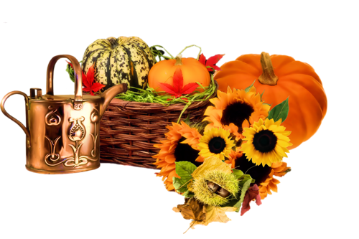
Next meeting will be Tuesday, November 14, 2023 @ 7:00 p.m.
Larissa Richards, Secretary
We want to take a moment to express our heartfelt gratitude for all of your invaluable contributions and support during Women Rekindled. Without your dedication and hard work, our event would not have been as successful as it was.
The success of any event relies on the collaborative efforts of many, and we are truly humbled by the commitment and enthusiasm demonstrated by each and every one of you. Your contributions, whether big or small, played a vital role in making Women Rekindled a memorable and outstanding occasion.

We want to specifically thank the following individuals and groups:
- Trustees: for their support, guidance, and efforts throughout this whole process
- The Church family: for your enthusiasm and aid in making this event possible
- Robyn Dykstra and her team: Their hearts are on fire for God. Their knowledge and experience guided us in creating Women Rekindled.
- Northside Praise Team: Their testimonies and music touched and impacted so many. We thank them for leading us in a powerful and energetic time of worship.
- The Vendors: We thank them for being willing to support Women Rekindled by coming to the event and bringing such beautiful products.

Your hard work, dedication, and enthusiasm are truly appreciated, and it was an absolute pleasure working with each of you. The positive feedback we have received from attendees and participants is a testament to your outstanding efforts. You can see some of the comments hanging up in the Narthex.
Women Rekindled would not have been such a success without your support, and we hope that we can continue to collaborate on future projects and events. Your involvement has made a significant difference, and we are immensely grateful for your commitment to our cause. Your kindness and generosity will not be forgotten.
Warm regards,
The Women Rekindled Team

We would like to extend a special thank you to Brenda and Mary for all of their time and hard work that they put into making Women Rekindled such an amazing event. The hours of planning, decorating, and organizing are truly appreciated. You both are so special to this church family and have truly blessed us all with your talents.

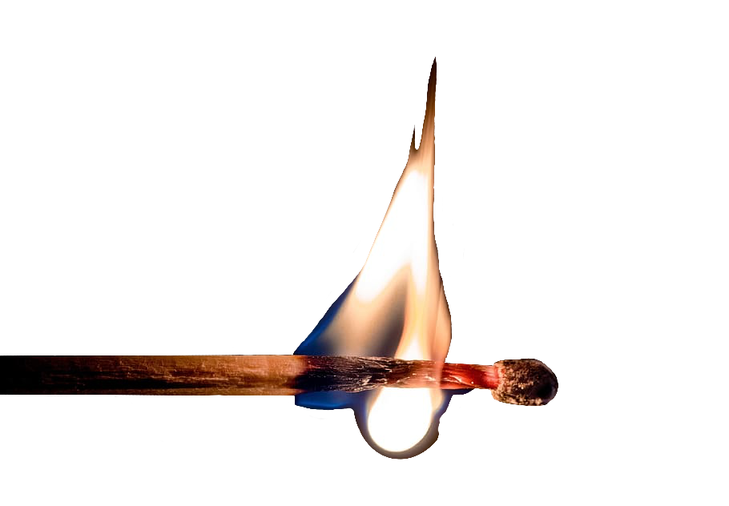
Mary’s Meanderings

Women Rekindled
Where do I begin? Praise the Lord we did our first ever women's retreat! As Brenda said to me, "It's been like planning a wedding." I have to agree. It all started about a year ago after attending Brenda's second and my first Women Anew event featuring Robyn Dykstra. Brenda asked me if I thought we could do something like this at our church. I don't even remember my response at that time. The real work started the beginning of this year when we contacted Robyn and she said she would love to come. So, after praying for God to open doors or slam them shut we began inquiring through the proper channels at our church. And bam! one door after another opened before our amazed eyes. It could only have been inspired and directed by God. Hosting events has always been stressful for me. Public speaking was out of Brenda's comfort zone and is still a little nerve-wracking for me.
A few nuggets from our day:
Robyn spoke three times in the course of our day with her. She first stated that everyone has a story and began to share hers in the humorous and delightful way that only she could do. Former Playboy Bunny, married four times-one divorce, twice widowed, and now happily married to Mr. 4-Ever for 22 years. She has written her story in a book called The Widow wore Pink.
Her second session was about prayer. She said we should pray big, bold, specific prayers. She taught us the STP prayer. Three things to say to God are 1. Sorry, 2. Thank you, 3. Please. I think you get the idea-confession, thanksgiving, supplication. Another which I'm sure many of us knew-ACTS, standing for Adoration, Confession, Thanksgiving, Supplication. And a third suggestion-Try praying God, I acknowledge You for 1 minute. See what God speaks to your heart. Speak your confession out loud. When your ears here what your heart says, you are not likely to commit that sin again.
Thirdly, Robyn taught about conversational witnessing or sharing of the gospel. God will prompt us and we will should have stark-raving obedience to Him. Do what He tells you to do as soon as you can do it. The most striking example of this was a true story about someone she knew who was driving home from work and kept hearing "Go to the store and stand upside down in front of the pop stand. She thought to herself "This is crazy" but proceeded to the store, walked in and stood on her head in front of the pop. The man working there asked her what she was doing and she told him that God had told her to do this. He opened the drawer behind the counter, pulled out a gun, and set it on the counter. He told her that he was so depressed that he had said, "God, if you are real, have someone come in and stand on
Fireside Chat

Fireside Chat with the Finance Chair
Dear family and friends,

By the time you read this, we will be on the way to having the 2023 apportionments paid in full. Well, somewhere along the way this year we had volunteers working in the office and the plan of the finance committee didn’t get communicated for the reporting in the bulletin. The committee knew we had things under control so there would not have to be a big push at the end of the year. We found out that if we sent our apportionments in at the end of the month, they didn’t get posted as a January payment so we were always a month behind. If we collected till the end of the month, we felt desperate in December to make the end-of-the-year payment. When Ken was still pastoring, he and the finance committee of our last church went on the 10-month payment plan. By the end of June, we had paid half of the yearly amount owed, and each month after we were on the way to having apportionments paid off early – before the end-of-the-year rush of December to get all the Conference reporting done. It also meant that we had money in January to pay some yearly one-time payments such as licensing agreements for various internet services. I convinced our finance committee to try it last year. So as we make our November payment here this month, our apportionments will be paid for the rest of the year.
I hereby applaud you for your generous and regular monetary giving for all 12 months which allows us to be able to keep bills paid, the building to be kept in repair and the work of the Lord to be done through RUMC here and around the world.
Praise God for all our blessings,

Martha Baillis, Finance Chair
What did one pumpkin pie say to the other? "You wanna piece of me?"

Joys
Denny V. is in remission after many years of cancer! | Annibale & Mohr families, Mary Lynn - Improving

Concerns
Mark T. – bone healing | Simeon – major surgery
Doris (Lydia S.’s brother-in-law’s sister) – bone cancer | Duane H. – cancer surgery difficulties
Pam H. – kidney dialysis / health | Jeff B. – health
Jake H. – renewed life | Terry I.’s son – renewed life
Dale S. – recovery from surgery | Celia T. – heart surgery, in ICU
Anita (& Don) V. – health, continued recovery | Jerry C. – health
Fall Women Rekindled Day | Angie R. – health
Lucy S. – health | Laiken (Sheila S.’s great-granddaughter) – Type 1 diabetes
Dave S.’s mother, Mary – recovery from cancer surgery | Tom W. (Pam H.’s caseworker) – cancer
Josie D. – heart problems | Dick D. – ICU
Donald S. – cancer;  Lizzie S. – strength | Dale S.’s brother-in-law – stage 4 cancer
Denny V. (Carol & family) – cancer | Chris B.’s father – hospice care
Vicky, Mary W.’s ex-sister-in-law – cancer | Kathy (Heather R.’s friend) – breast cancer
Connie (Mark T.’s friend) – CT scan results | Margaret M.’s great-nephew – surgery recovery
Sheila S.’s friends, Gary & Cindy – facing serious illness | Harry & Nancy B. – health
Ken Z. – health | Duane S. – health, surgery
Ana M.’s grandpa, Tim | Leigh L.’s sister, Loretta – recurrence of cancer
Pat M. & Robin K. – health | Dorothy & Dick G.
John L. | Pat S.
Lovell, Bruce Lindenmuth’s sister – cancer | Debbie B. (& her husband, Rev. David Baker) – stroke recovery & cancer
Dick B. – dialysis treatments | Disaster & Violence victims
Traveling mercies | Ukraine/Russia War
Katrina’s Parents | Our country & area communities
Those with RSV, Flu, & Covid | Israel & Palestine

Our sympathy to the family & friends of:
Mary Smith
Eleanor Yoss
Jay Wolf

Those in Care Centers:
Altercare Wadsworth – Nancy McMillian
Apostolic Christian Home – Anne Salyer , Ruth Schumacher, & John Lunter
Liberty Residence II – Pauline Rastorfer
The Avenue, Wooster – Marilyn Hofacre
Westview Manor, Wooster – Dick & Dorothy Gillman
Windsor House @ Doylestown – Paula Burkhart
“"Now faith is confidence in what we hope for and assurance about what we do not see." Hebrews 11:1

Trustee’s Corner

Items since last month:
- Herb J. sprayed weeds growing up through the mulch.
- Randy and Julie had a 220 V line installed in the parsonage garage for the hot tub they installed on the patio.
- Brenda and Danny cleaned up the area behind the dumpster.
- Brenda trimmed the trunks of trees in the front yard.
- The drive belt was replaced on the church mower with great difficulty by Chad G., Bruce L., and Herb J.
- There was a meeting for the new sign out front. The new quote has gone up since the last quote five years ago. It is about $30,700 now.
- Women Rekindled is at 65 registered. If 150-200 is not reached, the rest of the payment will be covered through the Memorial Fund.

My body sometimes feels sore, but it works.
My wallet isn’t full, but my stomach is.
I don’t have everything I want, but I have everything I need.
My life isn’t perfect, but I am happy.
Thank You God!

“Christ Shares a Meal”
Our October Food Pantry/Community Dinner went very well. We had 23 families, 47 people, and 28 sets of food.
It is difficult for a few to do it all. The next Food Pantry/Dinner is Wednesday, November 15th from 4:00-6:00 p.m. There is a need for helpers to carry out food bags for the people who come. We would appreciate any additional help that you can give! Clean-up lasts for as long as we have work to do. However, with the majority of our helpers being members of our choir & praise band who have to leave no later than 6:00, we need others to stay if the clean-up isn’t finished. The more helpers we have, the less time is taken to do the work! We have a great time of fellowship & food through this time of service, too!
If you are heading in the wrong direction God allows U-turns.
November
13th – Pam Hartman 15th – Andrea stahl
23rd – kaitlin stayer 24th – Janice wagner
25th – Dorothy gillman 26th – Madalyn allen
27th – brett Richards 29th – mary ann allen

November
2nd – Chris & taylor kubilus

What did the turkey say to the computer?
Google, google!

Bible Studies
A group of women meet on Thursdays at 6:30 p.m. and are led by Betty Winchell and Sara Ullman.
There is always room for more to attend!
We will be starting In the Middle of the Mess by Sheila Walsh this month. Let Betty know if you need a book for this study. We would love to have you.
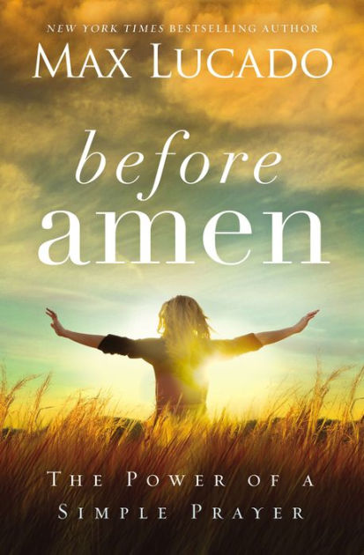Men’s Bible Study meets on Thursdays at 6:30 p.m. They will be studying Before Amen by Max Lucado.
Keep an eye out for announcements on our next studies. We would love to have you!
Thank you, God, for joy in my soul for guiding, for healing, for making me whole. For unexpected pleasures, dropped from above, for unlimited measures. Of caring and love.

Thank you for your vibrant presence too, in the thoughtful comments of others who make me feel special and worthwhile … for a friendly hug, and a loving smile!

I will not wait for a certain time, and I’ll dedicate each day that’s mine, to expressing thanks to God... this way each day will be Thanksgiving Day!

together with Christ and with those who have gone before us, united in love as one family in Christ, around His table, forever enjoying His heavenly banquet for all of eternity. I look forward to sharing a seat at Christ’s table with all of you the first Sunday of every month!
– Pastor Kristen Buchs
*This Holy Mystery: A United Methodist Understanding of Holy Communion. Copyright 2003, 2004 The General Board of Discipleship of the United Methodist Church, PO Box 340003, Nashville TN 37203-0003. Ruth C. Duck, Worship for the Whole People of God, 2nd ed. (Louisville: Westminster John Knox, 2021).

During the month of October, we focused on 5 letters (uppercase, lowercase, and sounds), patterning, counting, number recognition, and fine motor skills with the children. We also had our picture day on the 19th and our fall celebration on the 26th.
We have working with the children to get them prepared for our Preschool Sing that will be held on Sunday, November 19th. This year’s group of children are a little quieter than previous years, so please be understanding if the program isn’t as long as in the past or if we are not singing as many verses of some of the songs.
We wanted to thank you all in advance for participating in the gift card sale. The gift cards should be in before Thanksgiving.

Thanksgiving to God is the first theme and a theme that should be at the center of every celebration of Communion. As we share this meal together, we give thanks for Christ’s presence with us at His table and in every moment of our everyday lives. We give thanks for God’s love and grace throughout history, resulting in the ultimate the gift of His Son, Jesus, whose death and resurrection overcame the power of sin and death so that our relationship with God could be restored. The second theme is one of fellowship. “Holy Communion is the communion of the church – the gathered community of the faithful, both local and universal.”* The sacrament, though deeply meaningful to the individual celebrating it, is much more than a personal event. When we celebrate Communion, not only do we come together to share the meal with Christ, but with His body, the church.
The third theme present in Holy Communion is one of remembrance. When we celebrate Communion, we remember Christ’s last meal with His disciples and honor His command to “do this in remembrance of me” (Luke 22:19 NIV). Yet this shared meal is much more than mere remembrance and commemoration. According to Duck, remembrance, from the Greek word anamnesis, “means not only reflecting on the past but also re-presenting the past so that we experience the living presence of Christ.” Christ is present in the here and now, with us, at His table, just as He was present at the Last Supper with His twelve disciples. “This dynamic action becomes re-presentation of past gracious acts of God in the present, so powerfully as to make them truly present now. Christ is risen and is alive here and now, not just remembered for what was done in the past.”*
The fourth theme present is one of sacrifice. Holy communion is a type of sacrifice and a re-presentation, not a repetition, of the sacrifice of Christ. “Christ’s atoning life, death, and resurrection make divine grace available to us. We also present ourselves as sacrifice in union with Christ to be used by God in the work of redemption, reconciliation, and justice.”* As Christ offered Himself for us as a once and for all time sacrifice we, in turn, offer our lives to Christ so He can use us as a means to transform the lives of others.
In her book Duck writes, “Openness to the transforming work of the Spirit at the Table and in the world is another central [and the fifth] theme of Holy Communion.” Holy Communion is a vehicle of God’s grace through the action of the Holy Spirit. During the sacrament, we open ourselves to the work of the Holy Spirit in and through us, as we ask God for His Spirit to be “poured out” upon the elements and ourselves, transforming us. In the ritual, together, Christ’s church asks that the bread and wine, “be for us the body and blood of Christ, that we may be for the world the body of Christ, redeemed by His blood. By Your Spirit, make us one with Christ, one with each other, and one in ministry to all the world” (United Methodist Hymnal).
“Finally,” Duck writes, “Eucharist is a rehearsal of the world as God has created it to be. […] The meal is a foretaste of shared life in community where all are welcome and all share the gifts of life. […] We celebrate Eucharist so that we can taste God’s future.” Holy Communion is the means whereby we celebrate in this life what we look forward to in the next – sitting down
Dear Church Family,
Goodbyes are always difficult, but this one is a little more so than the rest. When I came to this church, I was 6 or 7 years old. You all have watched me grow up and helped raise me, and I wouldn’t be the person I am today without each and every one of you.
Without the Rittman United Methodist Church family, I would be a completely different person. It was at this church that I learned about my love for Contemporary Christian music. I joined the Praise Band at 11 years old. I fell in love with hearing Kayla sing and playing with Jeff, Andy, and Dave. It has fostered within me a love for music that I did not know could exist.
Betty and the children’s choir also helped me learn about my love for music. I had some of the most fun in that choir room.
I want to thank Robin, Betty, Mary, Bruce, Lee, and anyone else who has led me at any point in my Sunday School classes. I have learned to love studying the Bible, and that love will stay with me for the rest of my life.
The choir here has been one of the most special activities to be a part of. Each of you in the choir is so special to me. Thank you for not getting too upset whenever I make my funny faces.
To all of the Bible Study ladies, you have shaped me into the woman I am today. You have guided me and supported me every step of the way. Thank you thank you thank you for being there for me.
Thank you to Pastor Kristen for being such a positive light. I haven’t known you long, but you have already taught me so much.
One last special thank you goes out to Taylor. You are going to do such an amazing job in the office. I know you are going to help this church grow. I not only am confident that you will take care of everything in the office in a way that will please everyone, but I also know that I have made a new friend in you. Thank you!
I could go on forever thanking every person in this church because each of you has shaped me in some way (but I only have one page, so I guess I’m going to have to stop here). I love you all and will miss you so much! I will see you all soon!
- Larissa Richards

Happiness comes when we stop wailing about the troubles we have, and offer thanks for all the troubles we do not have.

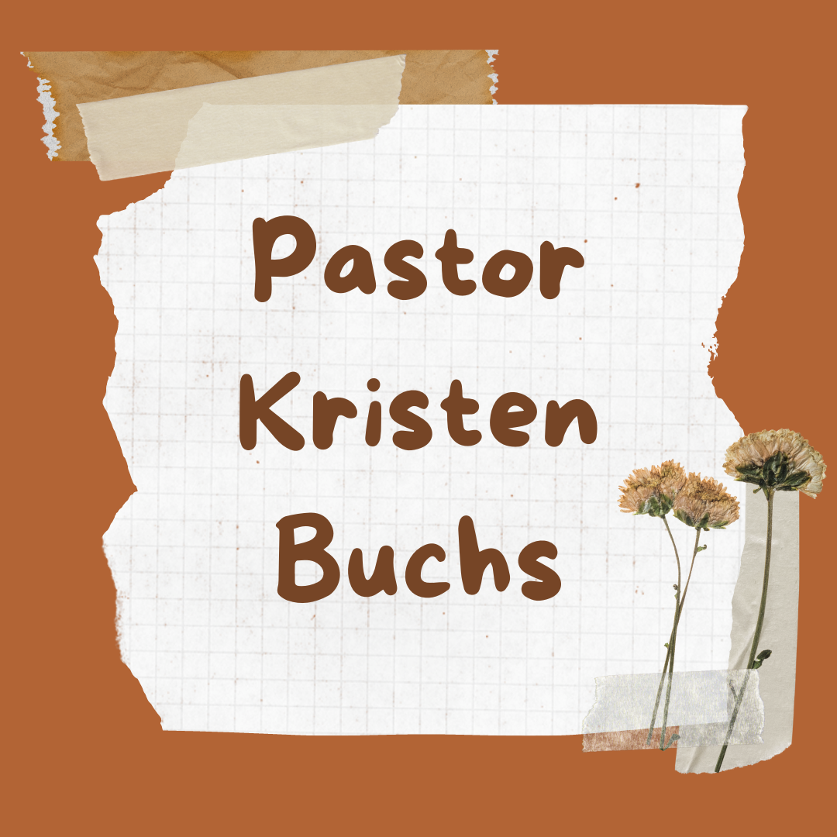
On the first Sunday of every month, United Methodists celebrate the sacrament of Holy Communion. However, this meal is much more than a simple remembrance of Christ’s last meal with His disciples before His death and resurrection. Today we will look at the six major themes present in Holy Communion: thanksgiving, fellowship, remembrance, sacrifice, action of the Holy Spirit, and eschatology, according to This Holy Mystery: A United Methodist Understanding of Holy Communion, which was adopted by the 2004 General Conference of The United Methodist Church. But first, what is a sacrament? In her book, Worship for the Whole People of God, author Ruth C. Duck writes, “In a classic definition ascribed to Augustine, a sacrament has been called an outward and visible sign of an inward and invisible grace.” John Wesley, in accordance with Anglican beliefs, endorsed Augustine’s definition and “viewed the sacraments as [a] crucial means of grace, ‘an outward sign of inward grace, and a means whereby we receive the same,’” according to By Water and the Spirit, A United Methodist Understanding of Baptism. It is in the celebration of the sacraments that believers have the most tangible experience of faith, since the celebration of the sacraments involves actual, physical elements: water in the sacrament of Baptist; bread and wine, or juice, in Holy Communion. For these reasons, and others, the sacraments play a major role in Christian ministry and worship. The fact that Jesus Christ Himself received the sacrament of baptism and instituted the sacrament known as Holy Communion give these rites their significance. Baptism initiates us into Christ’s church and the Lord’s Supper sustains and nourishes our faith as we journey through life together as His body, the church.
Christmas Baskets Schedule

November 17th – 8:00 or 9:00am start sorting canned goods

November 27th – December 8th – Phone calls for Christmas baskets

December 9th – 8:00am Sorting Presents

December 10th – Toy Sorting After Church

December 11th – 7:00pm Wrap Toys

December 13th – Fill Boxes with Goods

December 16th – 8:00am Christmas Baskets
I believe we can all agree with Duck who writes “sharing meals is a central theme in the Gospels,” and “was at the heart of the day-to-day ministry of Jesus and of the earliest church.” Jesus’ disciples had seen Him bless and break bread time and time again during the three years they lived together, at meals in many different settings and with widely diverse groups of people. The church has continued to celebrate this meal and has sought to strengthen the connection between the sacraments and everyday life. In other words, Jesus is present with us not only when we celebrate the sacrament of Holy Communion at church; the sacrament reminds us that He is present with us in our daily lives and whenever we sit down to share a meal together. Christ Himself invites us to the table which is open to all people; our sin reserves us a seat at His table.

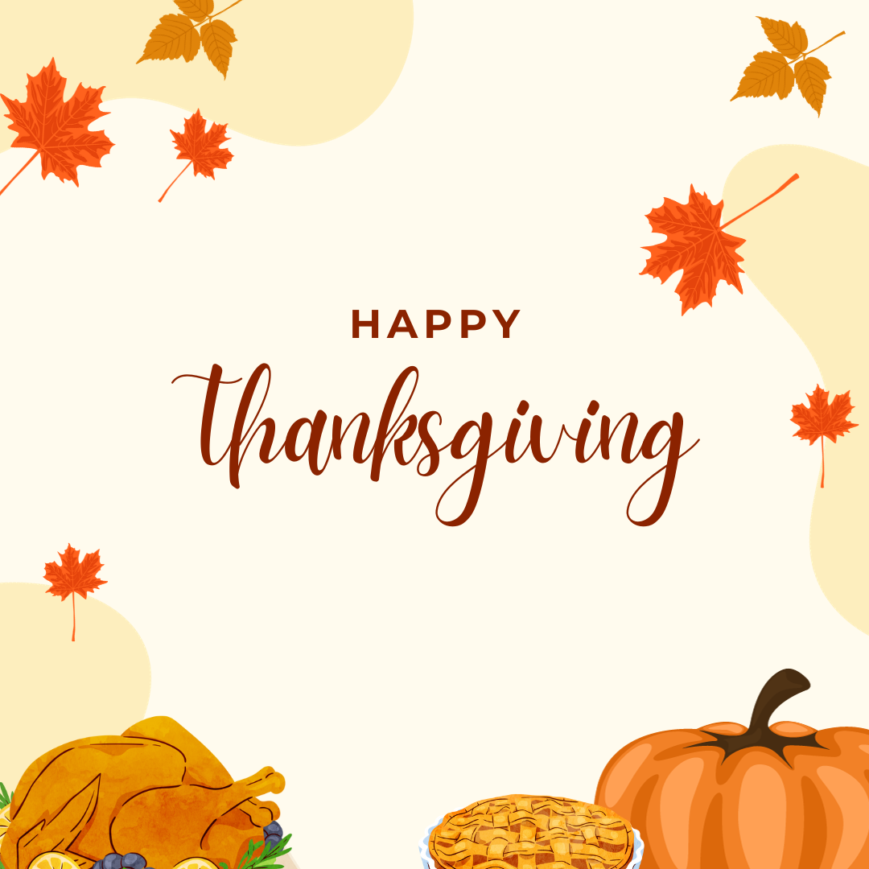
November
Sunday Monday Tuesday Wednesday Thursday Friday Saturday
Offering Tabulators

Dale Stahl
Lydia Stahl
 |  |  | 1  11:00am – Prayer Circle  @ home  6:00pm – Choir Practice  7:00pm – 2:11 N. Practice | 2  6:30pm – Men’s & Women’s Bible Studies | 3 | 4
5 Daylight saving time  ends  Holy Communion  All Saints day  9:00am –  Sunday School  10:30am –  Worship Service | 6 | 7  6:30pm – Prayer Circle @ home | 8  11:00am – Prayer Circle  @ home  6:00pm – Choir Practice  7:00pm – 2:11 N. Practice | 9  6:30pm – Men’s & Women’s Bible Studies | 10 | 11  Veteran’s Day
12 Pennies From Heaven  9:00am –  Sunday School  10:30am –  Worship Service  Elizabeth Turner Preaching  Gift card orders due | 13 | 14  6:30pm – Prayer Circle @ home  6:30pm – Food Pantry Set-up  7:00pm–Administrative Council | 15  11:00am – Prayer Circle  @ home  4-5:30pm – Community  Dinner  4-6:00pm – Food Pantry  6:00pm – Choir Practice  7:00pm – 2:11 N. Practice | 16  6:30pm – Men’s & Women’s Bible Studies | 17  8:00 or 9:00am  Christmas Baskets canned food sorting | 18
19  9:00am –  Sunday School  10:30am –  Worship Service  Preschool sing | 20  Points to Ponder Items Due  6:00pm- Thanksgiving service meal  7:00pm-community thanksgiving service | 21  6:30pm – Prayer Circle @ home | 22  11:00am – Prayer Circle @ home  6:00pm – Choir Practice  7:00pm – 2:11 N. Practice | 23  Thanksgiving  Office Closed | 24  Black Friday  Office Closed | 25
26  9:00am –  Sunday School  10:30am –  Worship Service  Hanging of the Greens | 27 | 28  6:30pm – Prayer Circle @ home  7:00pm Trustees Meeting | 29  Phone Calls 9:00am-1:00pm for Christmas Baskets  11:00am – Prayer Circle @ home  6:00pm – Choir Practice  7:00pm – 2:11 N. Practice | 30  6:30pm – Men’s & Women’s Bible Studies
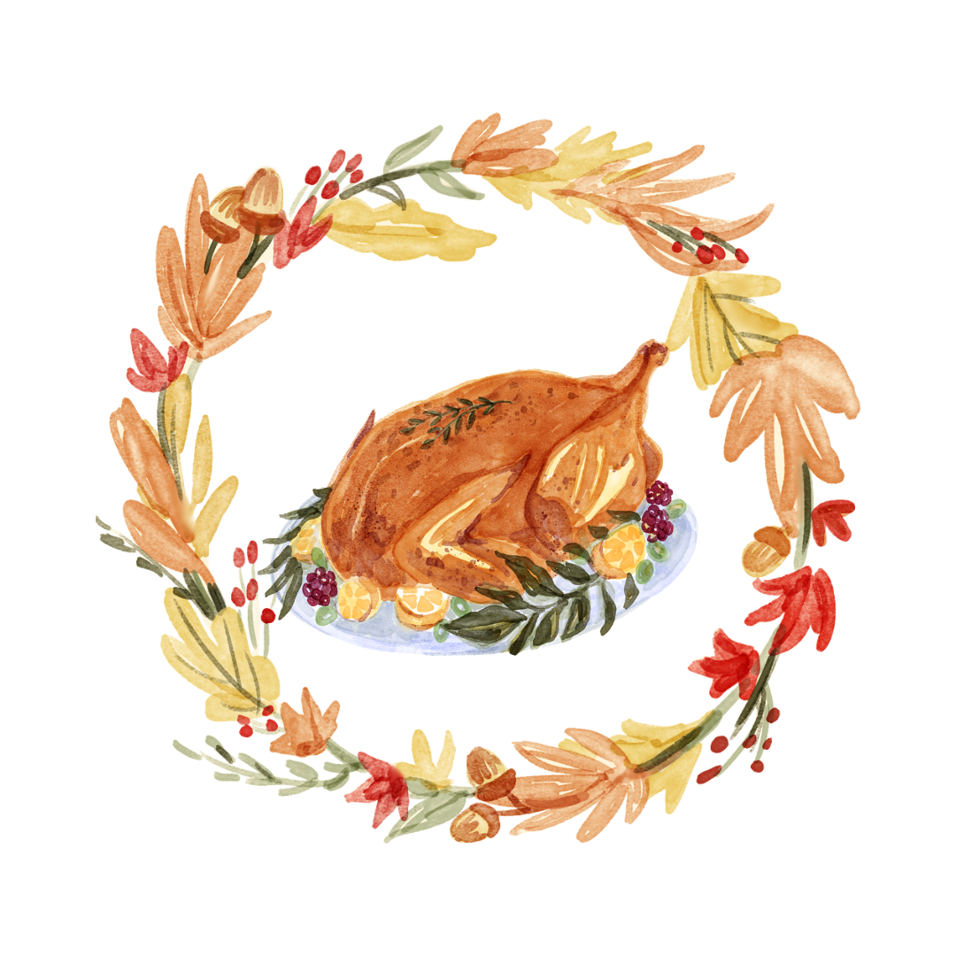

Rittman United Methodist Church
211 North Metzger Avenue
Rittman, OH 44270
Return Service Requested

POINTS to PONDER
November 2023
Vol. 55 No. 11
Kristen Buchs, Pastor
www.rittmanumc.org
330-925-4015
pastor@rittmanumc.org
UPCOMING EVENTS
Sun. Nov. 5th: Daylight Savings Ends

Sat. Nov. 11th: Veterans Day

Tue. Nov. 14th: 6:30pm – Set-up for Food
Pantry/Community Dinner

Tues. Nov. 14th:7:00pm-Administrative Council Meeting

Wed. Nov. 15th: 4-5:30pm – Community
Dinner
4-6:00pm – Food Pantry

Fri. Nov. 19th: Preschool sing

Mon. Nov. 20th: 6:00pm Thanksgiving
meal before service
7:00pm Community thanksgiving service

Thurs. Nov. 23rd: Thanksgiving

Fri. Nov. 24th: Office Closed

Sun. Nov. 26th: Hanging of The Greens

Tues. Nov. 28th: 7:00pm Trustees Meeting
office@rittmanumc.org

Sunday School @ 9:00am
Fellowship @10:00am
Worship Service @ 10:30am

Office Hours
8:00 a.m. – 1:00 p.m.
Mondays – Fridays

Living Our Faith through Word and Action

“Oh give thanks to the Lord, for he is good, for his steadfast love endures forever!" (Psalm 107:1)

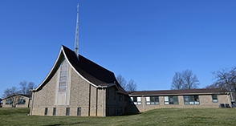
Rittman United Methodist Church Points to Ponder – November 2023
Volume 55 – Issue No. 11
Kristen Buchs, Pastor
Larissa Richards, Taylor Klingerman, Sheila Stoll – Editors

