Administrative Council Meeting Highlights
(You can find the full Administrative Council Meeting packet on the hallway bulletin board by the office.)
SPRC: (Mary W.)
- SPRC/DC Consult forms were submitted on time.
- Larissa is leaving. Her last work day is October 27th, and her last Sunday is October 29th.
- SPRC is working on how to hire someone as an Administrative Assistant.

Finance: (Sherri L. / Joanna S.)
- To see the approved Finance Reports, check the Administrative Council packet on the Bulletin Board in the hallway by the office.
- We will be paying Orville Trinity for Pastor Kristen’s housing.

Pastor Kristen:
- October 1st is World Communion Sunday.
- UMVIM Team Leader Training is October 1st from 1-7 p.m. Betty and Pastor Kristen will be going.
- There is a Christmas Basket Planning meeting on October 8th at 12 p.m.
- Orrville Trinity’s Trunk or Treat is October 8th from 3-5 p.m.
- Charge Conference is October 28th at 10 a.m. at Kent UMC. Paperwork for Charge Conference is due October 1st. We need at least two laypeople at Charge Conference.
- Rittman UMC’s Trunk or Treat is October 28th from 3-6 p.m.
- We will be having a combined service with Orrville Trinity on October 29th here at Rittman UMC. The service will begin at 10 a.m. We will be hosting the meal after the service, as well. The New Hope class will be leading the organization and sign-up of this.
- Orrville Trinity will host March’s combined service.
- All Saints Sunday will be pushed to November 5th. We will also be having communion and two baptisms on this day.
- George Langley from Calvary’s Love wants to play here. They are asking for a generous love offering. We will call and set a date for them to come after Easter.
- Pastor Kristen will be in Delaware, Ohio for class on October 13th and 14th.

Preschool: (Lydia S.)
- Preschool started September 12th.
- The Preschool Open House had a good turnout.
- We currently have 15 students.

Missions: (Martha B.)
- Do not forget to start thinking about our Shoebox collection for Operation Christmas Child.

The next meeting will be Tuesday, October 10, 2023, @ 7:00 p.m.
Larissa Richards, Secretary

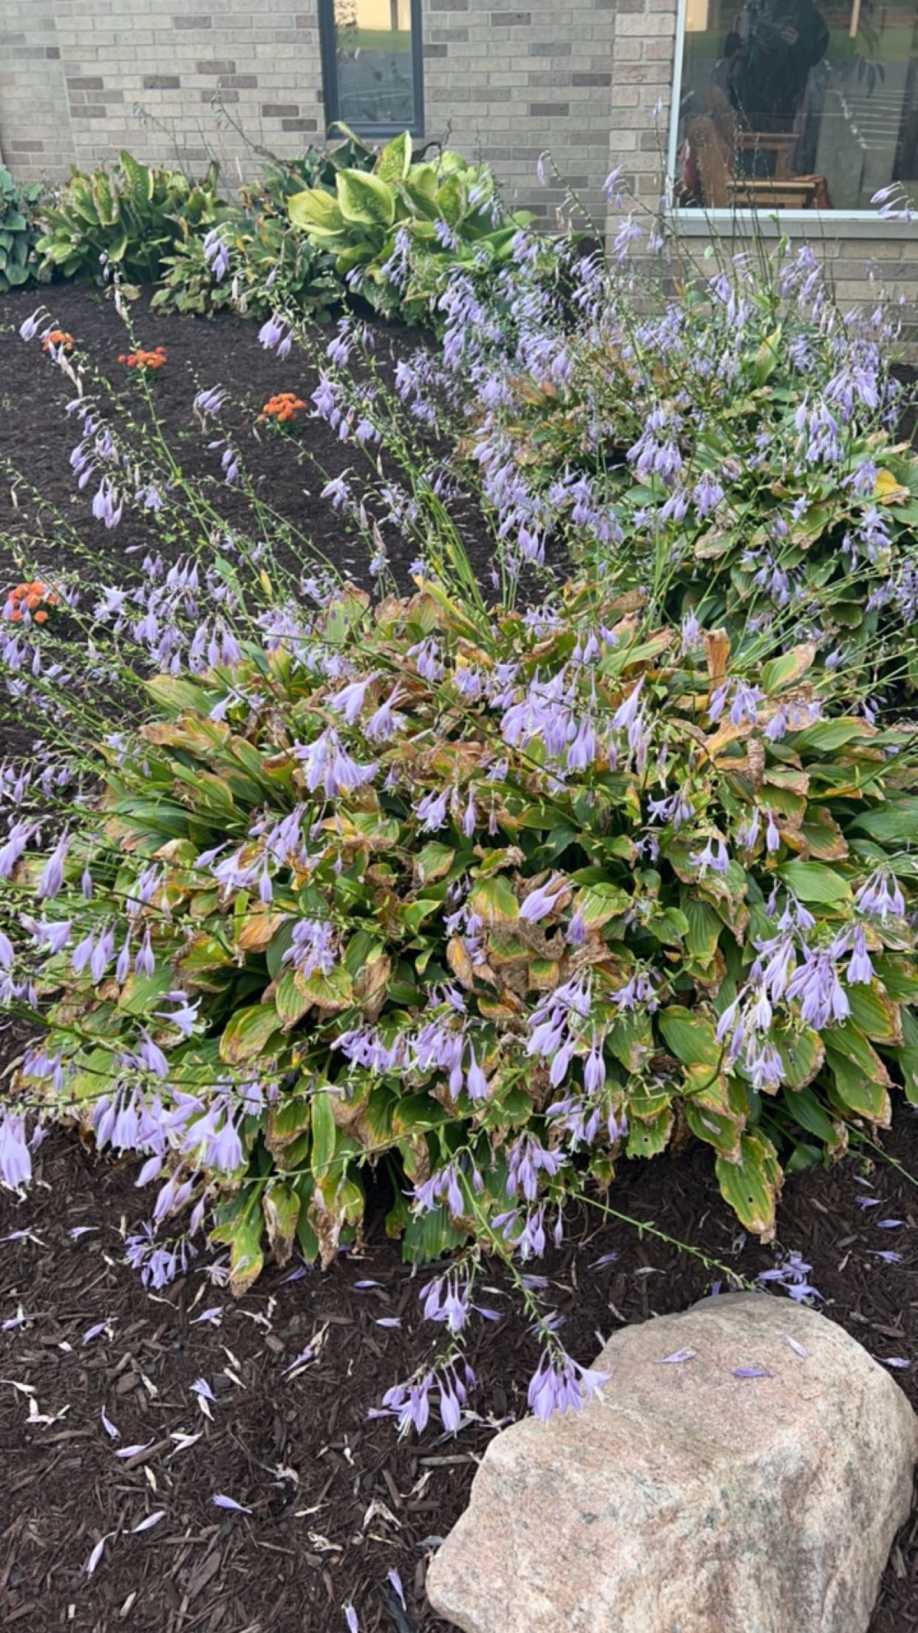
Thank you to everyone who has been working outside on the church. Thank you to Bruce, his grandson, and his friends from Dover High School. Thank you to Brenda and Martha. Thank you to the multitude of others who go unrecognized for the amount of work you put in. We appreciate you!

Singing in the Park
Community Christ Unity
Sponsored by the Dale and Joanne Widmer Foundation

It was a great event. The weather was perfect. There was Christian music with many different beats. There was food and ice cream, and I saw some old friends. There was music from all over Rittman: music from the Free Will Baptist Church, the Apostolic church Chorale, a wife and husband from Rittman, and music from the South Main Street Church of God.

A young lady named Julie gave her testimony about many difficult experiences she has had in her life. She said the devil took everything away from her. In rehab, she asked God to take her back, and He did. She sang “Amazing Grace” to end her story.

Thanks to Pastor Jeff Ball for organizing this event and the people from his church for preparing and serving the food.

It was an amazing way to spend a Sunday afternoon in the park.
-Sheila Stoll
You or Me in heaven –
God: You’re about the get your wings.
Me: Garlic, parmesan, or honey BBQ?

Mary’s Meanderings

It's been a little busy lately with SPRC and Women Rekindled, in which I have been heavily involved. SPRC is now in the process of hiring a new administrative assistant as our dedicated and very competent Larissa is leaving for Columbus. We will miss her greatly but are excited for her as she steps into a new chapter of her life. At the point of this writing, we have received many applications for the
job advertised on Indeed.com. Please spread the word if you know of any potential candidates with superior computer skills and be in prayer for the right candidate for the job. This would be ideal for a mother seeking part-time work while her children are at school.

We are busy putting the final touches on our first-ever one-day women's retreat (at least that I know of). Women Rekindled has been promoted and is receiving registrations but we would love to have more. Please sign up and invite all of your friends. It will be a fun day of refreshment and renewal with a talented speaker and vendors to tickle your fancy! A Continental Breakfast and delicious lunch are on the menu. Inspirational praise music and meaningful prayer round out the day. It will fill you with a fresh desire to know, love, and serve God.

A new Women's Bible Study will be beginning in October. Our studies provide so much wisdom from which to learn and grow our faith. I'm not sure what the men's Bible Study is up to but it's a great way for our men to bond, mature in their faith, and share men's concerns.

So, fall into fall and rekindle the warmth of your relationship with Jesus. It only takes a spark to get a fire going!

Fireside Chat

Fireside Chat with the Finance Chair
Dear family and friends,

It is the time of year when we slow down our summer activities and the days get shorter. The leaves change color and fall, and flowers die and need to be cut back. Halloween will slide in and out over the last days of October. At the same time, we begin to think about the Thanksgiving and Christmas holidays. These holidays require much planning and preparation both in the Church and in our homes. The planning and preparation that we've done in the past is on autopilot for many of us because we've done it so many times. I am happy to say that the thankfulness I feel doing a Thanksgiving meal at Food Pantry cancels the exhaustion I feel when I get home afterward. The same goes for collecting, sorting, and packing food and gifts for the community Christmas boxes. While we are giving time and money for these projects, we must not forget to give our tithes and offerings to RUMC regularly so that our budget needs are covered and we can continue into the new year with thanksgiving and Christ in our hearts.

With love and thanksgiving for all of you,

Martha Baillis, Finance Chair

“Life Gives You Choices”
The choices you make determinates
the life you have!

Joys
Denny V. is in remission after many years of cancer! | Annibale & Mohr families, Mary Lynn - Improving

Concerns
Doris (Lydia S.’s brother-in-law’s sister) – bone cancer | Pam H. – kidney dialysis / health
Eleanor Y. – stroke, fall | Jeff B. – health
Jake H. – renewed life | Terry I.’s son – renewed life
Dale S. – recovery from surgery | Celia T. – heart surgery, in ICU
Anita (& Don) V. – health, continued recovery | Jerry C. – health
Fall Women Rekindled Day | Angie R. – health
Lucy S. – health | Laiken (Sheila S.’s great-granddaughter) – Type 1 diabetes
Dave S.’s mother, Mary – recovery from cancer surgery | Tom W. (Pam H.’s caseworker) – cancer
Josie D. – heart problems | Dick D. – ICU
Donald S. – cancer;  Lizzie S. – strength | Dale S.’s brother-in-law – stage 4 cancer
Denny V. (Carol & family) – cancer | Chris B.’s father – hospice care
Vicky, Mary W.’s ex-sister-in-law – cancer | Kathy (Heather R.’s friend) – breast cancer
Connie (Mark T.’s friend) – CT scan results | Margaret M.’s great-nephew – surgery recovery
Sheila S.’s friends, Gary & Cindy – facing serious illness | Harry & Nancy B. – health
Ken Z. – health | Duane S. – health
Ana M.’s grandpa, Tim | Leigh L.’s sister, Loretta – recurrence of cancer
Pat M. & Robin K. – health | Dorothy & Dick G.
John L. | Pat S.
Lovell, Bruce Lindenmuth’s sister – cancer | Debbie B. (& her husband, Rev. David Baker) – stroke recovery & cancer
Dick B. – dialysis treatments | Disaster & Violence victims
Traveling mercies | Ukraine/Russia War
Katrina’s Parents | Our country & area communities
Those with RSV, Flu, & Covid

Our sympathy to the family & friends of:
Jay Wolf
Pastor Joyce Williams
Linda Nolt – Rittman Cares Director

Those in Care Centers:
Altercare Wadsworth – Nancy McMillian
Apostolic Christian Home – Anne Salyer & Ruth Schumacher
Autumnwood Care Center – Marcy Taylor
Liberty Residence II – Pauline Rastorfer
The Avenue, Wooster – Marilyn Hofacre
Westview Manor, Wooster – Dick & Dorothy Gillman
Windsor House @ Doylestown – Paula Burkhart
“Therefore I tell you, whatever you ask in prayer, believe that you have received it, and it will be yours.”
Mark 11:24

Trustee’s Corner

Items since last month:
- Preschool had Dunn Right clean preschool carpets, the pastor’s office carpet, the library carpet, and entryway carpets.
- Martha weeded and planted 6 hosta plants at the South entrance.
- Bruce installed plastic shims & silicone caulk at the base of the new West preschool toilet.
- Martha and Brenda dug up weeds at the entryway. Bruce weedeated around all the remaining shrubs.
- JSG Landscaping (Bruce’s grandson and Dalton football teammates) spread 5.5 yards of mulch around the church, trees, and the bell.
- Brenda planted 10 mums along the entryway. Martha assisted and has been watering them.
- Randy Brown repaired a broken step at the parsonage basement Bilco doors.
- The parsonage bedroom circuit lost neutral. Bruce finally found the loose wire in an outlet near the stairs.
- Bruce and his grandson Ryan repaired and glued six preschool chairs. Dale and Lydia painted all 24 wooden chairs.
- There was a donation to the church for an electric sign outside of the church. A proposal quote was $20,700 four years ago. The leftover money will be put into the General Fund.

“Christ Shares a Meal”
Our September Food Pantry/Community Dinner went very well. We had 25 families (1 new family), 49 people, and 28 sets of food.
Thanks to Denny and Carol for the cabbage rolls and all who helped to prepare them. Also, thank you to others for the additional food dishes.
It is difficult for a few to do it all. The next Food Pantry/Dinner is Wednesday, October 18th from 4:00-6:00 p.m. There is a need for helpers to carry out food bags for the people who come. We would appreciate any additional help that you can give! Clean-up lasts for as long as we have work to do. However, with the majority of our helpers being members of our choir & praise band who have to leave no later than 6:00, we need others to stay if the clean-up isn’t finished. The more helpers we have, the less time is taken to do the work! We have a great time of fellowship & food through this time of service, too!
October
1st – Bob Hopton 2nd – Marilyn Hofacre
Butch McMillian 4th – Anna McClain
Anne Salyer 7th – Jim Baker
9th – Lisa Winchell 11th – Sherri Lance
16th – Ron Yoss 21st – Scott Rosenberg
22nd – Anita Vohar 23rd – Lydia Stahl
28th – AJ Baillis

October
11th – Don & Anita Vohar
19th – Ron & Cindy Yoss

Bible Studies
A group of women meet on Thursdays at 6:30 p.m. and are led by Betty Winchell and Sara Ullman.
There is always room for more to attend!
We will be starting In the Middle of the Mess by Sheila Walsh this month. Let Betty know if you need a book for this study. We would love to have you.
Men’s Bible Study meets on Thursdays at 6:30 p.m. They will be studying Before Amen by Max Lucado.
Keep an eye out for announcements on our next studies. We would love to have you!
A Humble Request
Oh, soothing
moon, on this summer night,
give relief from daylight’s scorching heat.
Allow the stars to dance while the sun is sleeping,
showering the earth with renewed strength
so nature may share its
cooling shade
when dawn’s sunlight creeps in.
Give us comfort with a calming breeze
in the silence of darkness while you cast your glow
upon us as a respite blanket before we toil again
in the sun.
By Diane “Dee” Bowlin

The preschool kicked off their school year by having an Open House on the evening of Thursday, September 7th, with all families in attendance! We currently have 15 children enrolled, 8 in pre-k and 7 in preschool. There were a few tears shed on the first day but that of course is quite normal, even if some of those tears were from the parents.
We used the first week to help establish routines with the children and then we jumped right into preparing the children for kindergarten and helping them to know the word of God. We will be using The Read and Share Bible by Tommy Nelson. This Bible has more than 200 Bible stories with illustrations and age-appropriate text. This is the same Bible that we purchased last year as a gift for our students who would be attending kindergarten in the fall. We are hoping to purchase these Bibles each year to give to those students who will be “graduating” from our program to help encourage a love for reading God’s word.
We would also like to thank Bruce Lindenmuth for all his hard work and dedication to not only the preschool but the church in general. At our last preschool committee meeting, a scholarship was put in place in his honor so that a child whose family falls on hard times can still bring their child to preschool. Thank you, Bruce!!

knock and the door will be opened to you.” We do need to remember that sometimes the answer is “No.”
Finally, the “T” – give Thanks in all circumstances. Paul is not saying that we should thank God for everything that happens to us, but in everything that happens to us. There is evil in the world and believers are not immune to it. However, when evil strikes, we can still be thankful for God’s presence in our lives and for the good that He will accomplish in spite of the evil. Paul writes “And we know that in all things God works for the good of those who love Him, who have been called according to His purpose.”
I hope you find RPT useful as a reminder that it can be well with our souls, even if it is not with our circumstances.
- Pastor Kristen Buchs
The new Bruce Lindenmuth Scholarship Fund of the Rittman United Methodist Church Preschool was announced on Sunday, September 10th, 2023. It is to help preschool parents who may have financial problems during the school year. Bruce has served the church’s preschool since the school started in 1975. Bruce and Ruthanne have supported the school from its beginning in every way possible. Thanks so much.

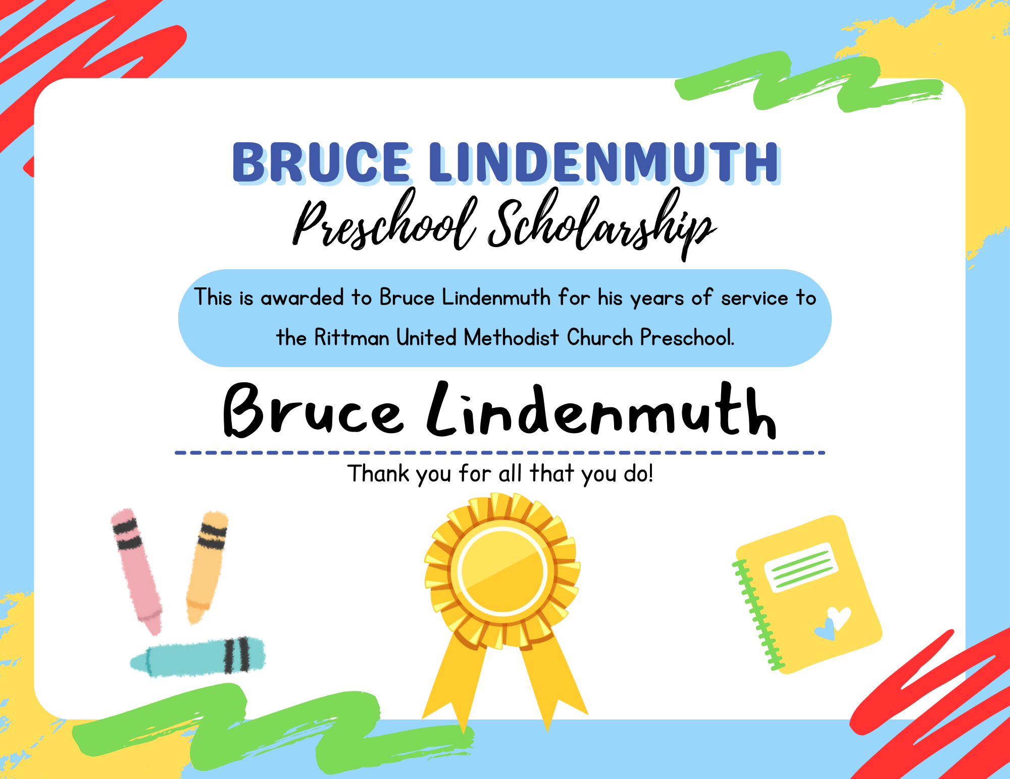

OPERATION CHRISTMAS CHILD 2023

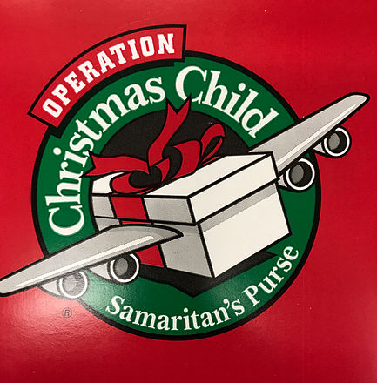
Operation Christmas Child brings joy & hope to children in desperate
situations worldwide through gift-filled shoeboxes and the Good News
of God’s love. Here are some ways you can make a difference in the lives of those children:
Pray – please pray that God will touch the heart of every child who receives a shoebox gift and that it will bring many children and families to faith in Christ.
Pack a Gift – a shoebox filled with small toys and other gifts can open hurting hearts to God’s love. Instructional brochures can be found in each shoebox. Also, as an optional resource, Operation Christmas Child now also has an Amazon storefront with additional lists of quality items that are recommended for shoeboxes. You can also build a shoebox online for $25. For additional information: samaritanspurse.org As you shop, don’t forget to ask God to lead you to what will particularly delight the heart of a child!
Give – please remember to include $10 or more per box to cover shipping and other project costs.

Boxes are due Sunday, November 12th.

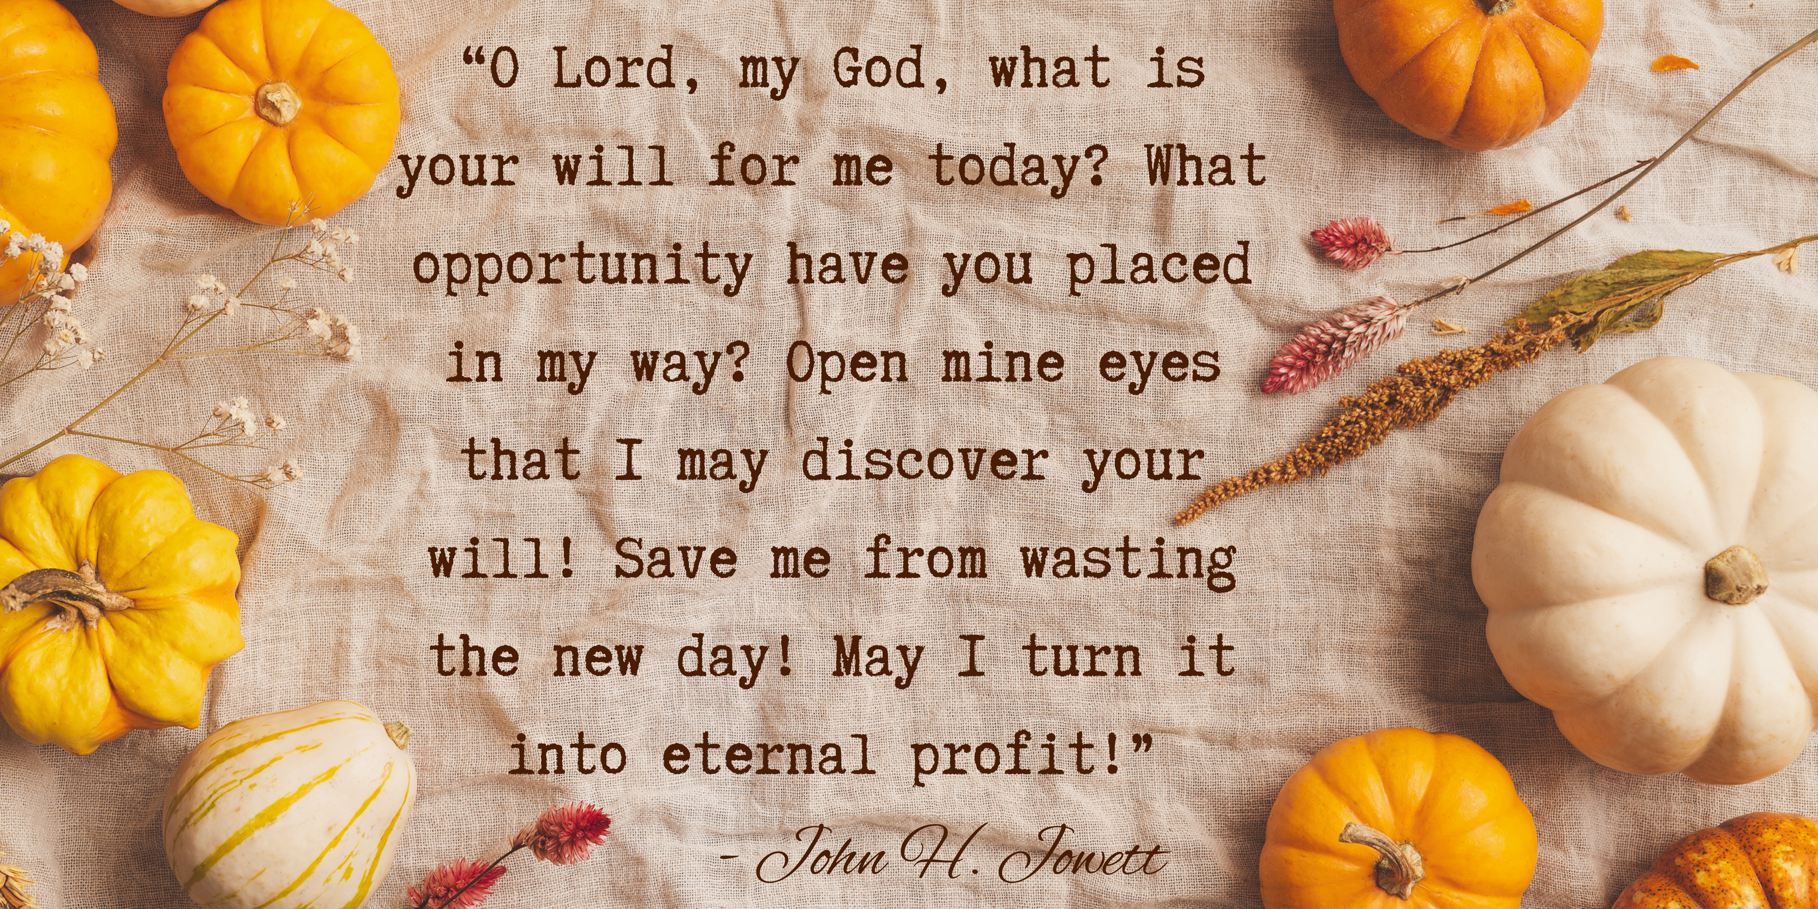

“Rejoice always, pray continually, give thanks in all circumstances;
Announcements / Keep Watch

October 1st: UMVIM Team Leader Training – 1-7 p.m. at First United Methodist Church in New Philadelphia; CHARGE CONFERENCE PAPERWORK DUE

October 8th: Trunk-or-Treat at Orrville Trinity UMC – 3-5 p.m.

October 21st: 8 a.m. Check-in, 9:00 a.m. start –
Women Rekindled
with speaker Robyn Dykstra

October 28th: Charge Conference at Kent UMC – 10 a.m.;
Trunk-or-Treat at Rittman UMC – 3-6 p.m.
A bonfire will follow RUMC’s Trunk-or-Treat!

October 29th: Combined Service with Orrville Trinity at Rittman UMC –
10 a.m. (Fellowship to follow)
for this is God’s will for you in Christ Jesus.”
(1 Thessalonians 5:16-18 NIV)
In this era of texting, we are all familiar with three-letter acronyms. Three-letter abbreviations substituted for longer phrases usually made up of the first letter from each word of the phrase being abbreviated. For example, IDK is a substitute for “I Don’t Know,” BTW for “By The Way,” and so on. They are a simple way to represent and remember longer phrases. I have a new three-letter acronym to help us remember those things that God asks of all who love and follow Him – RPT. This comes from 1 Thessalonians 5:16-18.
The first letter is R – REJOICE ALWAYS!
The second letter is P – PRAY CONTINUALLY!
The third letter is T – give THANKS IN ALL CIRCUMSTANCES!
RPT – Rejoice always; Pray continually; give Thanks in all circumstances for this is God’s will for you in Christ Jesus.
First the “R” – Rejoice always. It’s easy to rejoice when everything is wonderful and life is good. It’s altogether different when we are going through the dark and trying times. Yet it is in those difficult times when we need to look at the cross and remember that through Christ’s death and resurrection, WE gain the victory with Him and through Him. Jesus says, “In this world, you will have trouble, but take heart! I have overcome the world!” With His reassurance, we can rejoice always!
Now the “P” – Pray continually. We can’t spend all our time on our knees, but we can go through our day with a prayerful attitude. This is built upon acknowledging our dependence on God, realizing His presence within us, and making the choice to obey Him fully. God knows us better than we know ourselves. He alone can provide the answers to our prayers – but He likes to be asked! Jesus tells us, “Ask and it will be given to you; seek and you will find;

October
Sunday Monday Tuesday Wednesday Thursday Friday Saturday
Offering Tabulators

Sandy Gasser
1 World Communion  Sunday  9:00am –  Sunday School  10:30am –  Worship Service | 2 | 3  6:30pm – Prayer Circle  @ home | 4  11:00am – Prayer Circle  @ home  6:00pm – Choir Practice  7:00pm – 2:11 N. Practice | 5  6:30pm – Men’s & Women’s Bible Studies | 6 | 7
8 Pennies from Heaven  9:00am –  Sunday School  10:30am –  Worship Service  Christmas Basket Meeting (Food Provided) – 12 p.m. | 9 | 10  6:30pm – Prayer Circle  @ home  7:00pm – Administrative Council | 11  11:00am – Prayer Circle  @ home  6:00pm – Choir Practice  7:00pm – 2:11 N. Practice | 12  6:30pm – Men’s & Women’s Bible Studies | 13 | 14
15  9:00am –  Sunday School  10:30am –  Worship Service | 16 | 17  6:30pm – Prayer Circle  @ home  6:30pm – Food Pantry  Set-up | 18  11:00am – Prayer Circle  @ home  4-5:30pm – Community  Dinner  4-6:00pm – Food Pantry  6:00pm – Choir Practice  7:00pm – 2:11 N. Practice | 19  6:30pm – Men’s & Women’s Bible Studies | 20 | 21  Women Rekindled  Check-in & Continental Breakfast – 8 a.m.  Event – 9 a.m.
22  9:00am –  Sunday School  10:30am –  Worship Service  Fellowship following Worship | 23  Points to Ponder Items Due | 24  6:30pm –  Prayer Circle  @ home  6:15pm –  Preschool Board  7:00pm –  Trustees Meeting | 25  11:00am – Prayer Circle  @ home  6:00pm – Choir Practice  7:00pm – 2:11 N. Practice | 26  6:30pm – Men’s & Women’s Bible Studies | 27 | 28  10 am –  Charge Conference at Kent UMC  3-6 pm –  Trunk-or-Treat  Bonfire following  Trunk-or-Treat
29 Combined Service  w/ Orrville Trinity at RUMC  9:00am –  Sunday School  10:00am –  Worship Service  Fellowship following Worship | 30 | 31  6:30pm –  Prayer Circle  @ home

Rittman United Methodist Church
211 North Metzger Avenue
Rittman, OH 44270
Return Service Requested

POINTS to PONDER
October 2023
Vol. 55 No. 10
Kristen Buchs, Pastor
www.rittmanumc.org
330-925-4015
pastor@rittmanumc.org
office@rittmanumc.org

UPCOMING EVENTS
Sun. Oct. 8th: 12:00pm – Christmas
Baskets Meeting

Tue. Oct. 10th: 7:00pm – Administrative
Council

Tue. Oct. 17th: 6:30pm – Set-up for Food
Pantry/Community Dinner

Wed. Oct. 18th: 4-5:30pm – Community
Dinner
4-6:00pm – Food Pantry

Sat. Oct. 21st: Women Rekindled

Tue. Oct. 24th: 6:15pm – Preschool Board
Meeting

Tue. Oct. 24th: 7:00pm – Trustee’s
Meeting

Sat. Oct. 28th: 10:00am –
Charge Conference @ Kent UMC

Sun. Oct. 29th: 10:00am – Combined Service with Orrville Trinity at RUMC
Sunday School @ 9:00am
Fellowship @10:00am
Worship Service @ 10:30am

Office Hours
8:00 a.m. – 1:00 p.m.
Mondays – Fridays

Living Our Faith through Word and Action

“The Lord will indeed give what is good and our land will yield its harvest.”
Psalm 85:12

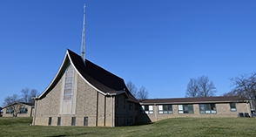
Rittman United Methodist Church Points to Ponder – October 2023
Volume 55 – Issue No. 10
Kristen Buchs, Pastor
Larissa Richards, Sheila Stoll – Editors

