Administrative Council Meeting Highlights
SPRC: (Mary W.)
- The Meeting has been rescheduled for May 6th at 7 pm

Finance: (Sherri L. / Joanna S.)
- Both Sherri and Joanna were excited to say that they are completely in sync with their numbers.
Preschool: (Lydia S.)
- Registration has begun.
- Spring break is April 2-4.
- Tuition has been raised to $110.
- We currently have 16 students.
Trustees:
- Found the wedding policy from 2008, they will review and revise it, then Pastor Kristen will revise it.
- On 2-22 Bruce signed a contract with Medina Signs and gave the check for the down payment.
- Trustees will support the money needed for the Car Show.
The next meeting will be Tuesday, April 12, 2024, @ 7:00 p.m.
Taylor Klingerman, Administrative Assistant

Events for 2024
- June 22nd – Car Show
- July 27th – Community Cookout
- November 2nd – Women Rekindled
Prayer
“Prayer will make a man cease from sin; or sin will entice a man to cease from prayer.” -Bunyan
“I exhort therefore, that, first of all, supplications, prayers, intersessions and giving of thanks be made for all men.” I Tim. 2:1
“I cants do what I used to do, but I still care. I still pray.” -Myriel Evens- Williams- 90 years old
“Prayer cuts through all our superficiality, right down to the heart of getting real about our need for God. This is where grace abounds.” Rev. Adrian Dannhauser, who stand outside her New York City church weekly with a sign: “ask me for a blessing. God’s grace is meant to be shared.”

Mary’s Meanderings

This month I am sharing something from Guideposts entitled 6 Best Bible Verses about Spring Cleaning. Use these Bible verses to energize and inspire your spring-cleaning routine. Use them to guide you and deepen your prayers as you go.

- Psalm 51:10 - A Clean Heart. Create in me a clean heart, O God, and renew a right spirit within me. It's April and spring is in the air. Time to wash the windows. With the bottle of Windex, I reach around and squirt the outside of our ancient casement windows. I grab a paper towel and wipe the drips quickly.
- Psalm 51:7 - Wash Me. Purge me with hyssop, and I shall be clean. Wash me, and I shall be whiter than snow. I study my paper towel. How satisfying to see all the dirt I've cleaned off from the outside. A minor triumph on a day when I don't feel I've accomplished much. At least this is something that got done.
- Proverbs 20:9 - Pure. Who can say I have made my heart clean? I am pure from sin. Squirt, squirt. I attack the inside of the windows now. I grab another paper towel and wipe the splotches of Windex. Think of how our view of the trees and bushes outside will improve when I'm done. It makes me wonder how many Bible verses about spring cleaning there are in Scripture.
- Matthew 23:26 - A Clean Inside First. Blind Pharisee! First clean the inside of the cup so that the outside of the cup will be clean too. I look down at the paper towel. Here is a holy mystery of housecleaning: How is it that the inside of my windows are almost as dirty as the outside? What does it say about our general housekeeping? What does it say about us? There must be microscopic dirt that floats inside.
- Romans 14:14 - Nothing Unclean. There is nothing unclean of itself but to him that sees anything unclean, to him it is unclean. Wow, the windows look fabulous. I can see right through them. I should have done this chore weeks ago. Maybe winter wouldn't have seemed as dreary or dark if my windows had been clean.
- 1 Corinthians 13:12 - See Through. For now, we see through a glass darkly, but then face to face. Now I know in part but then shall I know even as also I am known. I put away the Windex and the roll of paper towels, feeling clean both inside and out. The work was purifying like prayer.
Author: Rick Hamlin
~Mary

Fireside Chat

Fireside Chat with the Finance Chair
Dear Friends,
I don't know about you, but I am ready for spring and warmer weather. I have managed to use some of my inside days in the basement cleaning out boxes of goodies from my parents' house that were brought to my house when Dad died and the home, I grew up in was sold to take care of Mom's nursing home bills. We were serving in Rittman at the time and there was too much stuff to deal with at the time with the kids still in school so the stuff I couldn't deal with was packed and moved here to then be moved to the next charge, and the next, etc. until we finally retired and it came back to Rittman and into the basement. Two years later Ken and I had his Mom move in with us and cleaned out her house for sale. Before we could sell it, she got sick and had to go into a nursing home for a short time before she too died. His Mom was able to go through some of her things and tell us who was to get what and that was taken care of, but there where boxes of letters, papers, pictures other personal things that she wasn't able to finish going through that were stored in the basement. I've slowly been trying to go through those things. I say slowly because they bring back family memories and I tend to get lost in those as I remember tales of both sets of parents.
After Ken died (It will be 10 years April 14.) I had all of his things to go through. As those of you who were here when he was pastor of RUMC, you may remember that he was a record keeper. And he was a fund raiser. We always paid our bills on time, put a new roof on the church, supported several missionaries, etc. He also kept the records from his other churches and had a collection of VBS plans, fund raising plans, special services, etc. He filled two 4 drawer and a 2-drawer file cabinet with these records. I have cleaned out 1 of the 4 drawer cabinets and the 2-drawer file cabinet. I am now working on the second large file cabinet. The latest drawer contained budget raising plans and as your Finance Chairperson I took a few more minutes (like maybe 60 or so) to see if there was anything there that we might use in our church if needed come fall.
One of those budget programs was called "You have Response-Ability”. Yes, we do have the ability to respond to the needs of our God through the church and so far, you - we - have tried to do that. So why wait until Fall to think of our Response-Ability. Let’s continue doing it this spring, summer, fall and forever. If we do, I and Ad. Bd. will not have to use some special program that cost money to do and I won't be sorry that I threw all of Ken's old plans in the recycle bin.
Glory be! One more drawer empty.
Martha Baillis, Finance Chair
Joys
Concerns
Prayer Concerns
Nancy B- health | Lynn T- Colon Cancer | Sue B’s Brother- Dr. Michael Knapic- passed prayers for friends and family | Nancy M- health and comfort | (Martha) Joe W’s father – Friends and Family | Brenda’s Cousin – Mental health | Dale – knee healing | Dick G Friends and Family | Dale S sister – Husband passed prayers for family | Mary W’s Niece- Cancer | Rick S – passed | AJ’s friend Melissa – husband passed | Jonathan B – Stomach Cancer | Brenda’s Cousin Christine- Pregnant with twins | Chuck’s cousin Mat- throat cancer | Brenda’s friend Tom W – Malignant tumor | Paul – liver cancer | Lucy S. – health | Anita (health) & Don V. | Ginger – needs kidney replacement | Dexter – healing & time of transition | Rhonda R. – cancer | Denny V. (Carol & family) – cancer | Steve B. – cancer |

Asking Continued Prayer for
Valerie Hawks- Cancer | Larissa’s friends Donald – cancer, Lizzie – strength | Vicky, Mary W.’s ex-sister-in-law–cancer | Pat M. & Robin K. | Matt & Ana M. | Bob H. | Judy B.’s mom, Faye, & family | Rita B. | Eleanor W. | Pat S. | John L. | Darrell C. | Brianna R. | Harry B.’s brother, Sam | Nancy B.’s sister | Travelers | UM Church | Pastor Kristen | Missionaries & Ministries | Troops & families | Our Nation | World Peace | World situations | Victims of Disasters & Violence | Unspoken Requests | Israeli Conflict |

Our sympathy to the family & friends of:
Dick Baker
Dick and Dorothy Gillman
Mary Smith
Eleanor Yoss

Those in Care Centers:
Altercare Wadsworth – Nancy McMillian
Apostolic Christian Home – Anne Salyer, Ruth Schumacher, & John Lunter
Liberty Residence II – Pauline Rastorfer
The Avenue, Wooster – Marilyn Hofacre
Windsor House @ Doylestown – Paula Burkhart

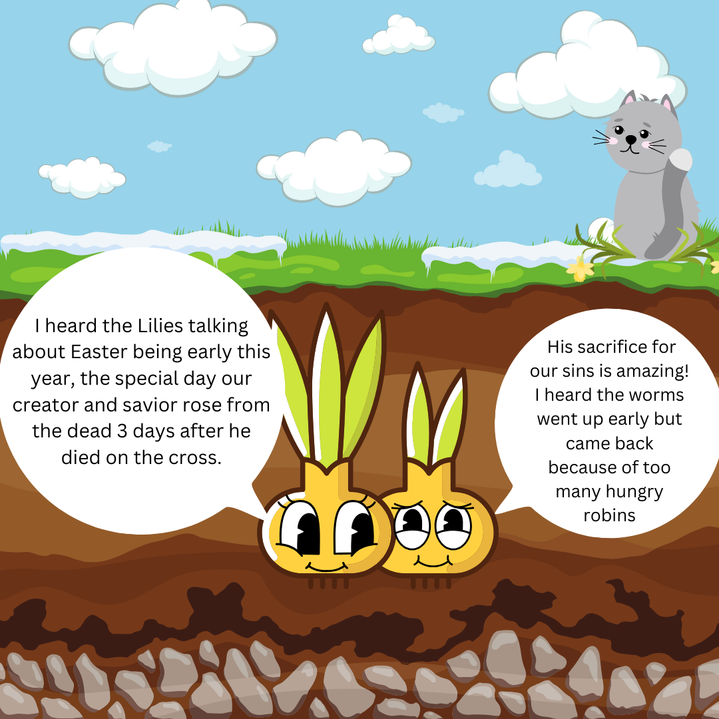

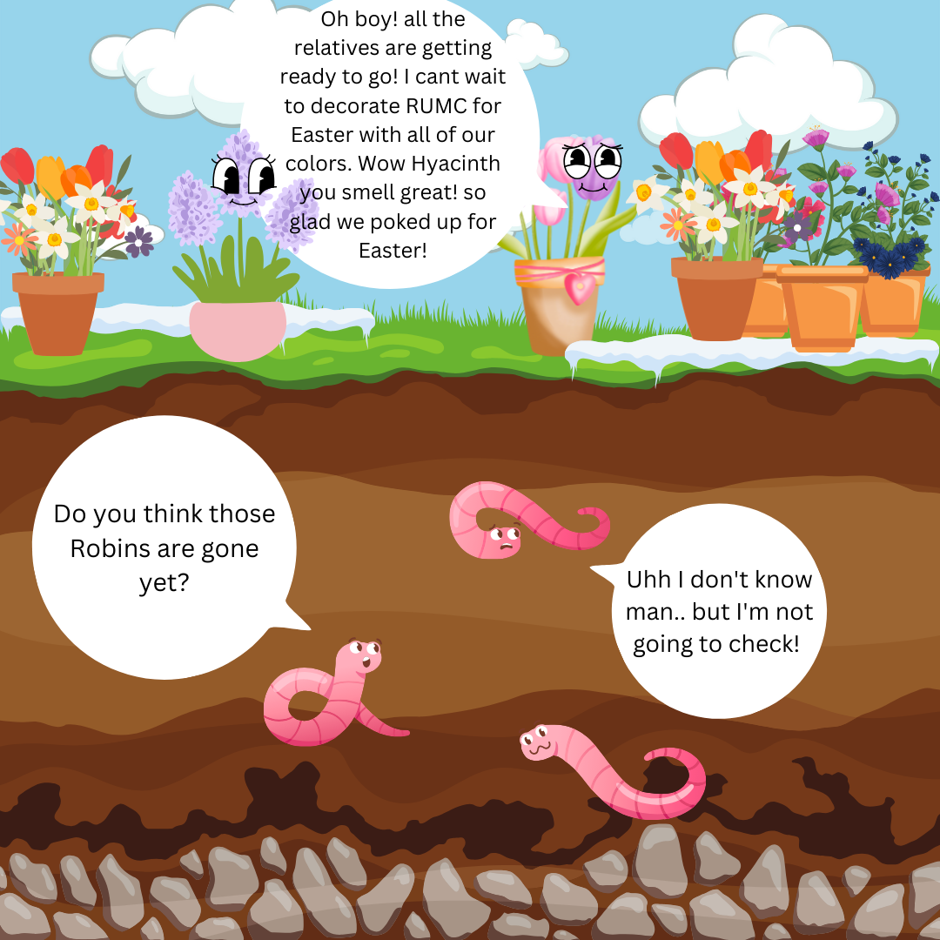

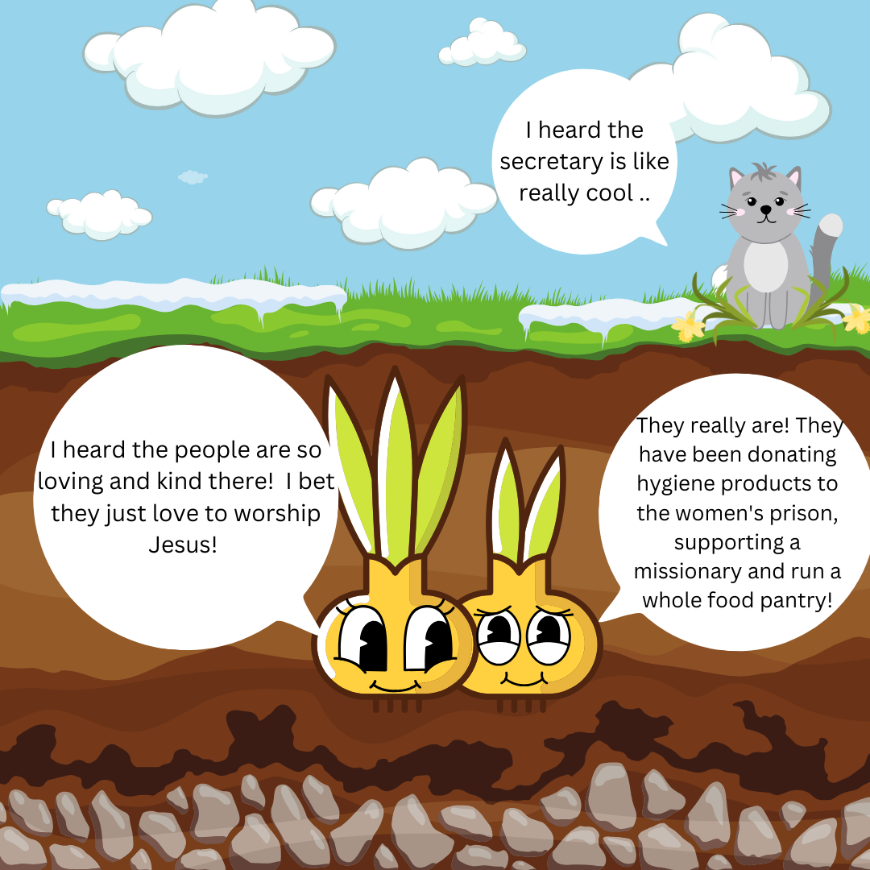
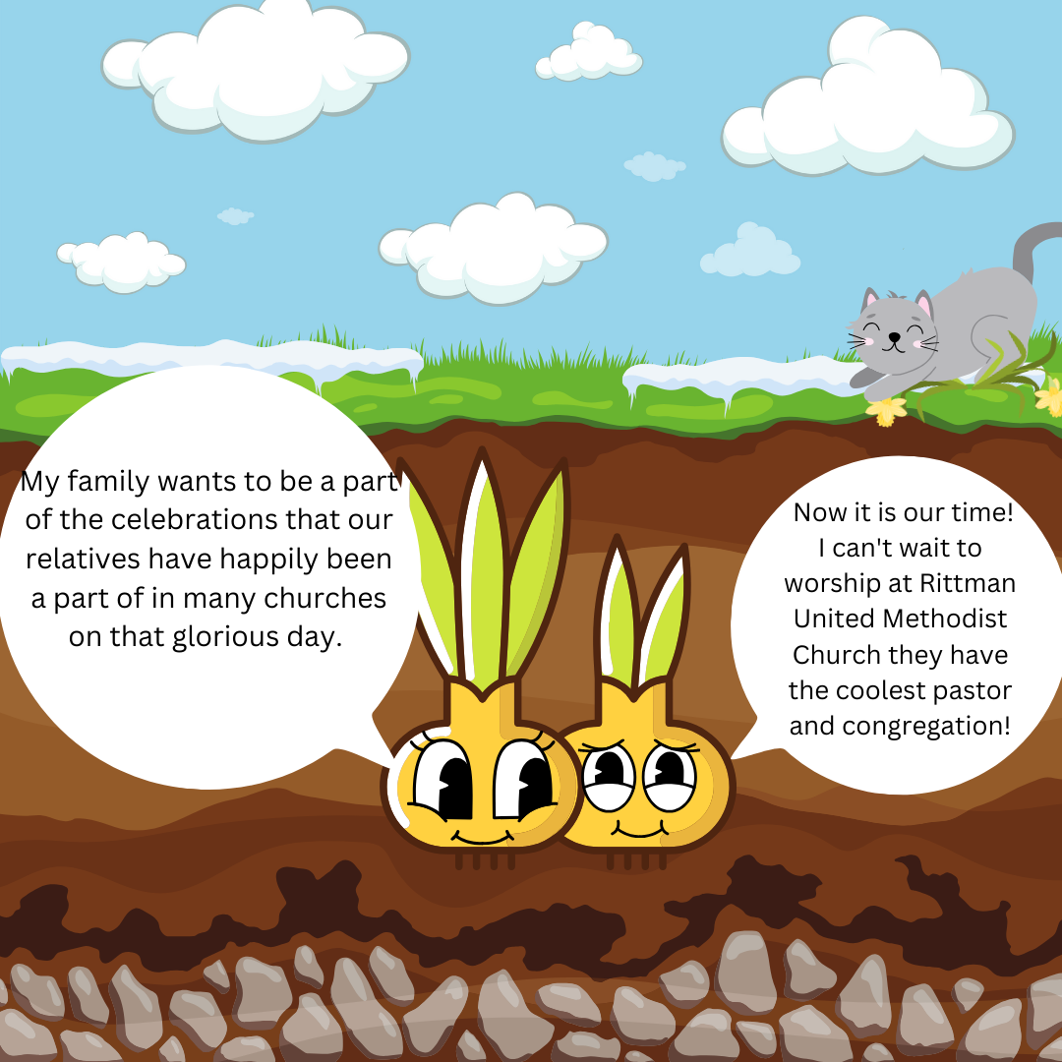

April Birthdays
3rd – Heather Richards 5th – Andy Baillis
6th – Brooke Britton 11th – Joanna Shankland
20th – Ruthanne Lindenmuth 23rd – Zachary Richards
24th – Emily Cook 27th – Mickey Shankland
Chad Gasser Lucinda Yoss
Sheila Stoll
29th – Bryan Yoss

April Anniversaries
5th – Dale & Nancy Booth 1975
Chad & Sandy Gasser 2003

Flowers
How does Moses make his coffee???
Where could you find Solomons temple??
What is big and yellow and comes in the morning to brighten many Mother’s Day?
Thank you to everybody who decorated the church with Easter flowers! They were absolutely Gorgeous and smelled amazing!

“A Prayer For Tuesday”
Father in Heaven, who brings the rain, who gives us water so cool and clean, who made the great ocean so blue, the wondering river, the bubbling spring, the whispering brook in the glen; for water from Heaven to water the Earth, Dear Father, we thank thee. Amen

Turn page for answers

This month we spent 3 weeks talking to the children about Easter. This can be a hard topic for the children to understand so we wanted to break it up into smaller segments to help them understand the importance of Easter. Yes, they still talk about getting candy from the Easter bunny and coloring Easter eggs, but they also know that Jesus died on the cross for US and that three days later he rose from the dead.
We had a visit this month from the Akron Zoo mobile. The children were able to see Millie the millipede, Sparky the bearded dragon, and Chloe the kinkajou (honey bear). During the visit, the children learned what all living things need to grow and survive (food, water, air, and shelter).
We also started our guest reader program this month. We invited all families to sign up for a day to read to the children. The families are encouraged to bring a favorite book from home to read to the children or they can choose one of our books from the learning room.
We will be on Spring Break from April 2-4. The children will return to school on April 9th. We will be in our final 6 weeks of school when they return.

April Fools Day
- Foolish History
April Fools Day dates back over 400 years; its even older than Thanksgiving (true! No joke!). Which means there have been lots of chances for good mischief. Here’s a history of the day.
By Bill Hangley JR. and David Colton
- Fool’s Gold
In 1582, Pope Gregory XIII introduced the Gregorian calendar, moving the start of the new year to January from April. Those who kept celebrating the old new year were ridiculed as “April Fools,” which led to a new unofficial holiday, historians suggest.
- A Wild Start
The first documented April fools prank took place in London. A clever Brit announced a special event at the Tower of London: “See the Lions washed.” No such public cleansing of jungles cats was planned, but the announcement drew a crowd of rubes.
- The Jokes in the New World
The Earliest recorded American April Fools prank took place in Middletown Connecticut, where a handbill promised a market place for “fools coats.” It said sellers should bring of various coats, yellow to “predominate,” with lots of tin bells and tassels.

(From page 42 AARP Bulletin March 2024 Witty & Wise)

A School Bus!
Food Pantry Dates

January 17th July 17th

February 21st August 21st

March 20th September 18th

April 17th October 16th

May 15th November 20th

June 19th

On the side of his head!

Hebrews it!

“Christ is risen! He is risen indeed!” This grand and glorious news, good news that changes everything for everyone for all time, is what we proclaim and celebrate on Easter each and every year. But what comes next? How do we live that out in our lives not just on Easter, but each and every day of our lives?
For Christians, Easter is not just one day – it’s a season of fifty day, a week of weeks, derived in its length from the fifty days between Passover and Pentecost (which means fiftieth) in Judaism. It is more than an extended celebration of the resurrection of Jesus. The original purpose of the Easter season was to continue the formation of new Christians in the faith – new Christians who began their journey during Lent as they learned to live the way of Jesus and prepared for baptism on Easter Sunday.
One of the miraculous lessons of Easter is this: through Jesus’ death on the cross and His resurrection, we all are granted a second chance to continue building our relationships with God as we follow His Son, Jesus Christ. We have permission to leave our old lives behind and focus each day on the new day, with all its potential for joy and choices that honor God.
Our God is the God of “do-overs,” second, (and third and fourth and one thousandth) chances, fresh starts and new beginnings. Our loving, merciful and gracious God sets no limits on the number of chances, fresh starts and new beginnings we can have. Because Jesus lives, we can have a new attitude toward ourselves, and that gives us a new attitude toward others. We can live amazed by His great love for us, and share His great love with others. Because Jesus died for our sins and is alive today, we can grow closer to Him and be changed by His Word and His Spirit each and every day.
Because, for Christians, Easter is not a holiday. It’s our identity. We are Easter People! When we really accept that fact into our souls as truth, the result that will be released into the world, and into our spirits, is joy. Joy results when we comprehend that the resurrection is not a day on a calendar, but an ever-present reality. Jesus is the resurrection. He is the life. We will know that we are living in the power of His resurrection when we walk in joy. The world, with its trials and tribulations, its sufferings and sorrows, cannot steal our joy, because the world did not give us our joy to begin with – our joy comes from Jesus. And He wants us to exhibit joy – He wants us to show the world what joy that comes from Jesus looks like.
Joy is not just a privilege; it’s a responsibility. The kind of God-given joy that came on the first Easter morning walks with the power of Christ’s resurrection. And that kind of joy – joy that shines through suffering, sparkles in a cemetery, and gleams in an emergency room – is ours.
of pain, that God isn’t there. For in His hands, suffering and glory always go together. With well and may we live each day as His people, Easter people, with newness of live and great joy!

-Pastor Kristen Buchs

April
Sunday Monday Tuesday Wednesday Thursday Friday Saturday
Offering Tabulators

Lori Ullman
Bruce Lindenmuth
 | 1 | 2 | 3  11am prayer circle at home  6pm choir practice  7pm 2:11 North practice | 4  6:30pm The Chosen Bible study | 5 | 6
7 | 8 | 9  7pm Admin Council meeting  6:30pm prayer circle at home | 10  11am prayer circle at home  6pm choir practice  7pm 2:11 North practice | 11  6:30pm The Chosen Bible study | 12 | 13
14  Worship committee Meeting after church | 15 | 16  6:30pm prayer circle at home  6:30pm food pantry set up | 17  11am prayer circle at home  6pm choir practice  7pm 2:11 North practice  4-6pm food pantry  4-5:30 community dinner | 18  6:30pm Men & Women’s Bible study | 19 | 20
21 | 22  Earth Day | 23  7pm Trustees Meeting  6:30pm prayer circle at home | 24  11am prayer circle at home  6pm choir practice  7pm 2:11 North practice | 25  6:30pm Men & Women’s Bible study | 26 | 27
28 | 29 | 30  6:30pm prayer circle at home

Rittman United Methodist Church
211 North Metzger Avenue
Rittman, OH 44270
Return Service Requested

POINTS to PONDER
April 2024
Vol. 56 No. 4
Kristen Buchs, Pastor
www.rittmanumc.org
330-925-4015
pastor@rittmanumc.org
office@rittmanumc.org

Sunday School @ 9:00am
Fellowship @10:00am
Worship Service @ 10:30am

Office Hours
8:00 a.m. – 1:00 p.m.
Mondays – Fridays
UPCOMING EVENTS

Tues. March 9th: Admin Council Meeting

Sun. April 14th: Worship Committee Meeting

Tues. April 16th: Food Pantry set up 6:30pm

Wed. April 17th: Food Pantry 4-6pm
Community Dinner 4-5:30pm

Mon. April 22nd: Earth Day

Tues. April 23rd: Trustees Meeting

Mon. April 22nd: Points to Ponder Items Due

Living Our Faith through Word and Action

“The flowers appear on the earth, the time of singing has come, and the voice of the turtledove is heard in our land.”
(Song of Solomon 2:12)

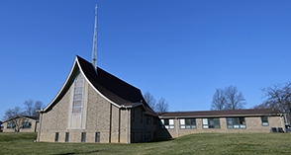
Rittman United Methodist Church Points to Ponder – April 2024
Volume 56 – Issue No. 4
Kristen Buchs, Pastor
Taylor Klingerman, Sheila Stoll – Editors

