Administrative Council Meeting Highlights
SPRC: (Mary W.)
- A request was put in to pray for our church a little bit extra during this time of lent, pray our summer activities go over well, pray for growth in the church, and pray that we are able to raise money for the food pantry with our activities this summer.
- The safe sanctuary policy has been updated to state that Susan Baker is the churches attorney, the date was also updated.
Finance: (Sherri L. / Joanna S.)
- If anybody would like a box of envelopes for offering, please let Joanna or the office know.
Pastor Kristen:
- We received a letter about Lay servant classes, please see Betty or Lydia for more information.
- Maundy Thursday is March 28th at Orrville Trinity UMC at 7pm
- Neither Rittman or Trinity will host a Good Friday service but information will be provided, when available about any community services offered.
- We are having a combined Easter Sunrise service at Trinity this year at 7 am. Breakfast to follow at Trinity.
- Orrville Trinity will host March’s combined service.
- Pastor will tell a short Easter story at the Easter egg hunt.
Preschool: (Lydia S.)
- Registration begins in March.
- We currently have 16 students.
Missions: (Martha B.)
- There was some concern that we would fall behind but that concern was gone after February’s offerings.
The next meeting will be Tuesday, March 12, 2024, @ 7:00 p.m.
Taylor Klingerman, Administrative Assistant

Events for 2024
- March 3rd - 10 am combined service at Orrville Trinity
- March 3rd – Valentines day dinner
- March 9th - Rittgers special worship service at Orrville Trinity
- March 28th – Maundy Thursday, Combined service at Orrville Trinity at 7 pm
- March 30th – 10 am Rittman United Methodist Community Easter Egg Hunt
- March 31st – Easter Sunday! 7:00 am combined sunrise service at Trinity United Methodist, continental breakfast after, 10:30 am Easter worship at Rittman United Methodist
- June 22nd – Car Show
- July 27th – Community Cookout
- November 2nd – Women Rekindled

Mary’s Meanderings

Courage is fear that has said its prayers. Courage is something that we gain based on deep convictions about what is good, true and worth our risking. Sometimes we think that courage is only for those attempting to do something above and beyond the tasks of daily living. David, Joshua and Caleb, Daniel, Esther. Firemen running toward the fire. EMS workers heading to an accident. Soldiers in war. But for many, it takes courage just to live from day to day. A child on their first day of school. Standing up for a friend who is being picked on. Smiling through pain, whether physical or emotional. To get up and go to work one more day. To volunteer for something you have never done before. To say "I am a Christian" when it is not popular in the culture.
Where can we find courage as a Christian? How do we face persecution, job stress, a dreaded diagnosis, death of a loved one, and other storms in life? What is the source of courage? After the death of Moses the Lord told Joshua "As I was with Moses, so I will be with you. I will never leave you nor forsake you. Be strong and very courageous." Joshua 1:5 & 7. Daniel told the king "My God sent His angel and he shut the mouths of the lions." Joshua 6:22. God told Jacob " Do not be afraid to go down to Egypt...I myself will go down with you to Egypt and I will bring you up again." Genesis 46:3 & 4. There are so many examples of courage in the Bible in the face of great danger, the one we are reflecting now in the season of Lent is Jesus Himself. How he wept and prayed that this cup would be taken away from Him, but continued on in obedience to the Father.
How can we give courage to others? How can we help them face the trials of life? En comes from the Latin word for in so encourage is to help someone to move on in courage. We can give them a kind word. We can listen to them and value their ideas and opinions. Give them a gift or a heartfelt note with a scripture in it. Exodus 14 says Fear not, the Lord will fight for you. Psalm 23 shows how the Lord restores our souls. Matthew 10:31 says "Do not be afraid. You are worth more than many sparrows." As we once again go through this time of Lenten reflection on the last days of Christ we see His humanity and that of His disciples and how they exemplified both fear and courage. Look at present day examples as that of Alexei Navalny as he paid the price for taking a stand against corruption in Russia.
Let us encourage one another. Encourage children. Everyone needs it and everyone can give it.
Happy Easter!
~Mary

Fireside Chat

Fireside Chat with the Finance Chair
Dear Friends,
The chair is out for cleaning this month, check back next month for any updates and a clean chair.
Blessings,
Martha Baillis, Finance Chair
A True Story:
My grandson Mitchell’s 10 year old border collie, Tilly, became very ill and had to go be put to sleep. The adults in the family took him to the vets office. Then they brought Tilly home for a burial in the backyard with their 4 year old son, my great grandson Walker. Everyone was very sad and upset. Walker’s mommy hugged him and said everything would be better for Tilly because he was with Jesus now. Walker looked at her, then the mound of dirt, and asked, “Does Jesus live in the ground?”
-S. Stoll

Joys

Concerns
Prayer Concerns
Nancy M- health and comfort | (Martha) Joe W – Friends and Family | Brenda’s Cousin – Mental health | Dale – knee healing | Dick G Friends and Family | Jim B sister – Cardiac Arrest | Dale S sister – Husband passed prayers for family | Mary W’s Niece- Cancer | Rick S – Cancer | AJ’s friend Melissa – husband passed | Jonathan B – Stomach Cancer | Leigh L’s father & mother passed- prayers for her and family | Brenda’s Cousin Christine- Pregnant with twins | Chuck’s cousin Mat- throat cancer | Leigh L’s mother passed- prayers for her and family | Mary – Healing for foot | Brenda’s friend Tom W – Malignant tumor – higher survival rate | Cindy – complete recovery – wisdom for doctors | Paul – liver cancer | Duane H. – cancer surgery difficulties | Lucy S. – health | Matt – health | Anita (health) & Don V. | Jim B. – healing | Doris (Lydia S.’s brother-in-law’s sister) – bone cancer | Terry I’s son – renewed life | Jake H. – renewed life | Jerry C. – health | Angie R. – health | Donny & April B | Kathy (Heather R.’s friend) – cancer | Ginger – needs kidney replacement | Dexter – healing & time of transition | Rhonda R. – cancer | Larissa’s friends Donald – cancer, Lizzie – strength | Nancy & Harry B. – health | Denny V. (Carol & family) – cancer | Vicky, Mary W.’s ex-sister-in-law–cancer | Ana McClain’s grandpa – Tim – (& Steve) B. – cancer |

Asking Continued Prayer for
Pat M. & Robin K. | Matt & Ana M. | Bob H. | Judy B.’s mom, Faye, & family | Bruce’s sister Lovell & family | Mary Lynn Annibale – continued healing | Rita B. | Eleanor W. | Pat S. | John L. | Darrell C. | Brianna R. | Harry B.’s brother, Sam | Nancy B.’s sister | Travelers | UM Church | Pastor Kristen | Missionaries & Ministries | Troops & families | Our Nation | World Peace | World situations Victims of Disasters & Violence | Unspoken Requests | Israeli Conflict

Our sympathy to the family & friends of:
Dick Baker
Dick and Dorothy Gillman
Mary Smith
Eleanor Yoss

Those in Care Centers:
Altercare Wadsworth – Nancy McMillian
Apostolic Christian Home – Anne Salyer, Ruth Schumacher, & John Lunter
Liberty Residence II – Pauline Rastorfer
The Avenue, Wooster – Marilyn Hofacre
Windsor House @ Doylestown – Paula Burkhart

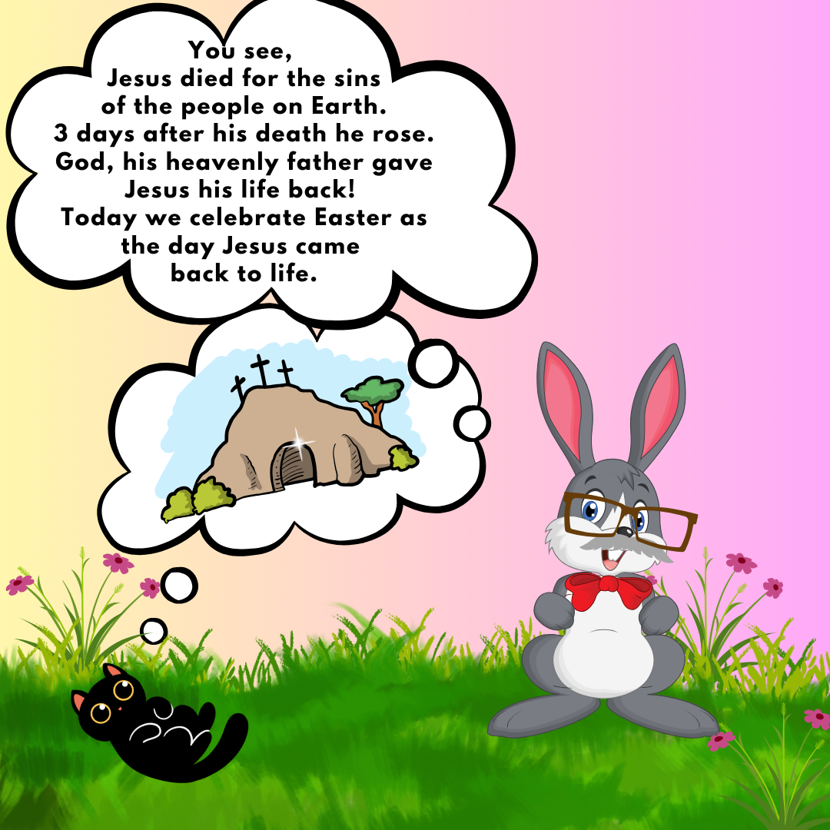

March Birthdays
6th – Emily Peresie 20th – Sarah Parker
10th – Kyle Lunter 26th – Connie Baillis
16th – Bill hopton 27th – Judy Britton
31st – Laura Sharp

March Anniversaries
5th- Ted & Melanie Schumacker

ALIVE, ANGEL, APOSTLES, BELIEVE, BETRAYAL, CHURCH, CROSS, CROWN, CRUCIFY, DIED, DISCIPLES, FAITH, FORGIVEN, GOOD FRIDAY, JERUSALEM, JESUS CHRIST, LAMB, LAST SUPPER, LENT, MARY, MIRACLE, NEW TESTAMENT, PENANCE, PENTECOST, PILATE, PRAYER, REDEMPTION, RESURRECTION, RISEN, SACRIFICE, SAVIOR, SIN, SON, STONE, SUNDAY, THORNS, TOMB

Complete this cut it out and leave it in the office for a prize!
Name:

© 2023 Kim White Steele LLC LLC - All rights reserved. Permission to copy for
single classroom, facility, or home use only. Not for public display. © 2023 puzzles-to-print.com
Trustees Corner

Items since last month:
- Sterling Farm Equipment, annual mower maintenance, $392
- Replaced both bulbs in center pole parking lot lights- Rod
- Replaced 5 bulbs in sanctuary chandeliers
- Installed/programed new keypad for parsonage garage door
- Cut down tall grass by social hall & trimmed off Hosta plants by entryway

“A Prayer For Monday”
From the book “The Best Loved Prayers of Childhood
Dear God, my window frames for me
each sunrise you send;
and sunset like a golden sea
when day comes to an end
Then when the busy day is done,
and stars begin to peep:
how welcome is your darkness, God;

The month of February has been very busy in the preschool. In addition to our weekly Bible stories and songs, we have been learning our letters of the week, practicing rhyming, gaining more phonemic awareness by using the Heggerty Phonemic Awareness Curriculum, practicing number recognition, counting, and reviewing our colors and shapes. We have also celebrated birthdays, Valentine’s Day, and Dental Health Month.

As we look towards the month of March, we will be discussing Easter with the children. We will be spending two weeks helping them understand the concept of Jesus’s death and resurrection and why it is so important to us. We will also be having the Akron Zoo Mobile visit us.

Ash Wednesday
Ash Wednesday service was very meaningful and special. Friends from the Orrville Trinity United Methodist Church joined us for the beginning of Lent with singing, scripture reading, Pastor Kristin’s message, Holy Communion and ashes.

Thank you

Thank you all for the soap. We are able to provide 109 bars of soap to the We Care ministry. In March we are going to continue to collect bars of soap. Can we beat 109 bars this month? Your donations are greatly appreciated. Thank you for all your love and support of this wonderful ministry.
- Betty Winchell

HOLY WEEK WORSHIP

March 24: 10:30 Worship PALM Sunday
March 28: 7:00 MAUNDY THURSDAY - Combined Service with Trinity UMC AT TRINITY
March 31: EASTER SUNDAY - HE IS RISEN!
7:00 Combined Sunrise Worship Service with Trinity UMC in the Gazebo at Crown Hill Cemetery (across the street from Trinity UMC of Crown Hill Road)
7:45 Continental Breakfast at Trinity UMC in their Fellowship Hall
10:30 Easter Worship in the Sanctuary at Rittman UMC

- Pastor Kristen Buchs

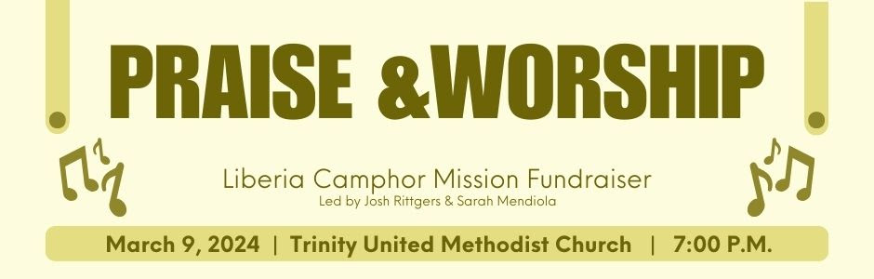
We would love for you to join us in a restful time of prayer and worship. Amid
our busy and chaotic lives, we hope this time is an opportunity to find rest and peace in the presence of God.
In addition, there will be a free-will offering for an exciting opportunity for Josh and Sarah.
They plan to serve on a 14 day long mission trip to Camphor Mission Station in Liberia with UMVIM this summer.
They will serve with a team providing education and meals to youth in Liberia.
They ask you to prayerfully consider supporting them. They would gratefully appreciate your financial support. Below is a link to donate online. There will also be an opportunity to donate in person. Help them collectively raise $6,000!
As we enter the last few weeks of Lent on our way to Holy Week and the passion, death and resurrection of our Lord Jesus Christ, may we turn our thoughts and reflections to some of the events that took place on that not-so-good Friday that changed everything in our world for all time.
Food Pantry Dates

January 17th July 17th

February 21st August 21st

March 20th September 18th

April 17th October 16th

May 15th November 20th

June 19th

There was a man named Simon, from Cyrene. He was forced by the Romans to carry Jesus’ cross after He had fallen three times, weakened by blood loss and in tremendous pain from the 39 lashes He received before He began His trek to Calvary. In carrying Jesus’ cross, Simon became the last person to add Jesus. He unwittingly modeled Jesus’ teaching that whoever wants to follow Him must take up their cross. In this case, it may not have been Simon’s cross, but it nevertheless cost him something. The cross was heavy and the road long. Yet, he walked with Jesus. And Jesus walked with him. Simon saw Jesus up close, broken and bruised, yet putting one staggering foot in front of the other and not uttering a word in protest. There was no way Simon would walk away from that encounter unchanged.
As Jesus hung on the cross, He saw His mother and the disciple whom He loved standing nearby. His words from the cross thus far had been focused on others. He asked His Father’s forgiveness for those who crucified Him. He welcomed a thief into paradise. Now, He takes care of Mary, His mother, and His disciple John. Even in the torture and humiliation, Jesus did not focus on Himself. He wanted to make sure His mother would be cared for and He entrusted His beloved disciple John with that important role.
On that fateful Friday, around three in the afternoon, Jesus cried out “My God, my God, why have You forsaken Me?” It was a cry from within the being of the Triune God. In those words, the utter desolation Jesus experienced comes through plainly. Jesus experienced the wrath that we deserved by bearing our sin. Jesus gave up His right of intimacy with His Father, so we wouldn’t have to.
Jesus then said, “It is finished.” With that, He bowed His head and gave up His spirit. Those three words – it is finished – are a declaration of victory. His sacrifice is for all time. He is for today. His sacrifice is for now. Jesus had completed the mission He had come for. It was completed to perfection. He had poured out His life even unto death. He made it possible for a sinful humanity to have an eternal relationship with a Holy God. Nothing needs to be added to it. No good works. No more sacrifice. This was the greatest victory of all time. Victory over sin and death.
The danger for us, when we read or hear about the crucifixion, burial and resurrection of Jesus, is to become so overly familiar with the story that it no longer amazes us or causes us to spontaneously burst into praise when we are reminded of all that He has done for us. As we commemorate Holy Week, may we take time to remember the Lord’s selfless sacrifice and thank Him for so great a salvation.
-Pastor Kristen Buchs

March
Sunday Monday Tuesday Wednesday Thursday Friday Saturday
Offering Tabulators

Sherri Lance
Dee Franks
 |  |  |  |  | 1 | 2
3  10am Combined Service at TUMC | 4  6pm Preschool Meeting | 5  6:30pm prayer circle at home | 6  11am prayer circle at home  6pm choir practice  7pm 2:11 North practice | 7  6:30pm Men & Women’s Bible study | 8 | 9  Liberia Camphor Mission Fundraiser at TUMC
10  Daylight Savings Time Begins | 11 | 12  7pm Admin Council meeting  6:30pm prayer circle at home | 13  11am prayer circle at home  6pm choir practice  7pm 2:11 North practice | 14  6:30pm The Chosen Bible study begins | 15 | 16
17  St. Patrick’s Day | 18 | 19  6:30pm prayer circle at home  6:30pm food pantry set up | 20  11am prayer circle at home  NO choir practice  7pm 2:11 North practice  4-6pm food pantry  4-5:30 community dinner | 21  6:30pm The Chosen Bible study | 22 | 23
24  Palm Sunday  31  Easter Day  “He Is Risen” | 25 | 26  6:30pm prayer circle at home  7pm Trustees meeting | 27  11am prayer circle at home  6pm choir practice  7pm 2:11 North practice  6pm Fill eggs for Saturday | 28  Maundy Thursday  Service at 7pm at TUMC | 29  Good Friday  (no service) | 30  10am RUMC Community Easter Egg Hunt
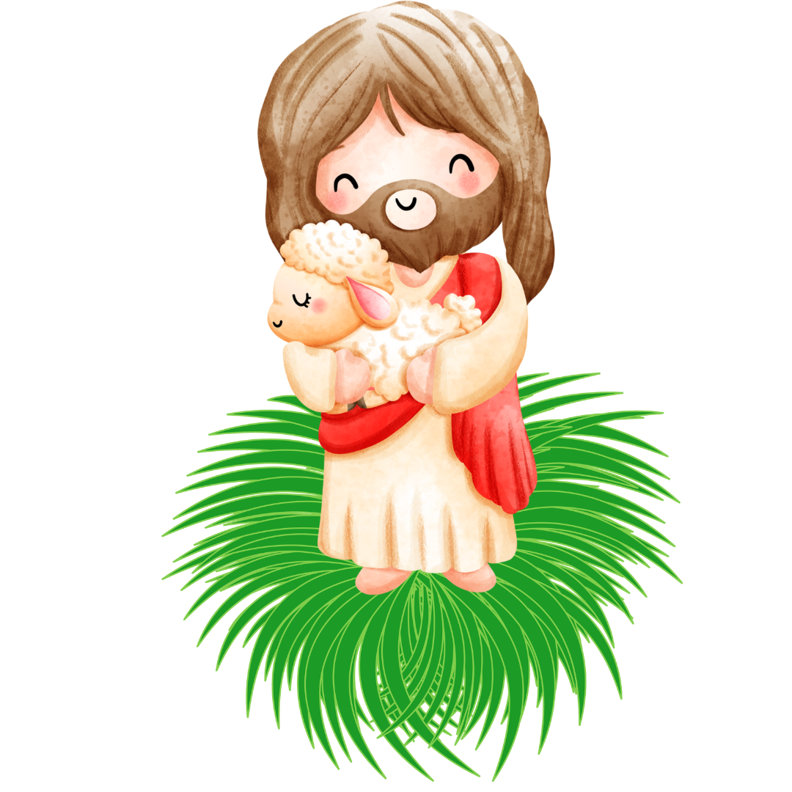

Rittman United Methodist Church
211 North Metzger Avenue
Rittman, OH 44270
Return Service Requested

UPCOMING EVENTS

Sun. March 3rd : Combined Service at Trinity United Methodist

Mon. March 4th: 6pm Preschool meeting

Sun. March 10th: Daylight Saving Time Begins

Tues. March 12th: Admin Council Meeting

Sun. March 17th: St. Patrick’s Day

Tues. March 19th: Food Pantry set up 6:30pm

Wed. March 20th: Food Pantry 4-6pm
Community Dinner 4-5:30pm

Sun. March 24th: Palm Sunday

Tues. March 26th: Trustees Meeting

Wed. March 27th: 6pm Fill Easter Eggs for Saturday

Thurs. March 28th: 7pm Maundy Thursday at TUMC

Fri. March 29th: Good Friday (no service)

Sat. March 30th: 10am RUMC Community Easter Egg Hunt

Sun. March 31st: Easter Sunday
7 am Combined Service at TUMC
7:45 am Continental breakfast at TUMC
10:30 am Easter Worship at RUMC

POINTS to PONDER
March 2024
Vol. 56 No. 3
Kristen Buchs, Pastor
www.rittmanumc.org
330-925-4015
pastor@rittmanumc.org
office@rittmanumc.org

Sunday School @ 9:00am
Fellowship @10:00am
Worship Service @ 10:30am

Office Hours
8:00 a.m. – 1:00 p.m.
Mondays – Fridays

Living Our Faith through Word and Action

“God sent his son into the world not to judge the world, but to save the world through him”
(John 3:17)

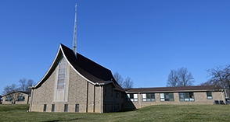
Rittman United Methodist Church Points to Ponder – March 2024
Volume 56 – Issue No. 3
Kristen Buchs, Pastor
Taylor Klingerman, Sheila Stoll – Editors

